FOR IMMEDIATE RELEASE
WEDNESDAY, JUNE 30TH

FLOWERKID SHARES NEW SINGLE
“IT'S HAPPENING AGAIN” FEAT. KUČKA'

LISTEN HERE | WATCH THE OFFICIAL VIDEO HERE

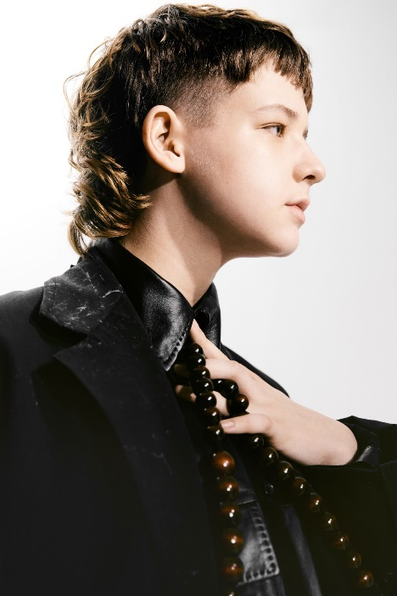
(Download Hi-Res Photos + Art HERE – Credit: Levon Baird)

PRAISE FOR FLOWERKID:

“Powerful” – NME

“Artist to Watch” – UPROXX

“Sant is set to blow up.” – OUT100

“an incredible voice and storytelling ability” – TRIPLE J

“A wise beyond his years artist willing to delve deep” – HUFFPOST

“Paired with contorted synths and relentless drums, ‘miss andry’ paints a painfully clear picture” – BILLBOARD

flowerkid, the moniker of 19-year-old singer, songwriter, and producer Flynn Sant, has shared his gripping new single and video, ‘It’s Happening Again’. Premiered via triple j, ‘It’s Happening Again’ is co-produced with Dave Hammer and features LA-based Australian-native KUČKA.

Watch the striking video directed by Braun Chatterjee HERE.

flowerkid shares: “This new single, featuring the beautiful KUČKA, and what will follow soon afterwards, has been everything I have thought about for a very long time. And this body of work is a feeling that has been bottled up inside me for all of my existence on this earth. This song is so very important to me.

My process of healing comes in three. ‘It’s Happening Again’ is my first step. I need to confront the very conniving voices that circle throughout my head. They tell me I can’t say what I'm about to say. So I know what I have to do, and that's to shout on the rooftops of every hardship I've ever had to climb. In the times of finding myself, I've had to lose myself first. And I’ve finally found that this loss of control was absolutely necessary.

I want us to lose ourselves hand in hand, on this ethereal, spiritual, and timeless musical journey I created for us. Please listen and watch, as my internal and external struggles flourish into bloom. I can’t wait for you to hear this excerpt of my heart and soul.”

‘It’s Happening Again’ follows a series of universally lauded singles including ‘miss andry’ and ‘boy with the winfields and the wild heart’, which scored huge support from triple j and BBC Radio 1, millions of streams across streaming and also won praise from Billboard, The Guardian, and NME. The impressive cuts revealed flowerkid as one of the most hotly tipped young songwriters in Australia.

While flowerkid floats between genres, the sentiment that connects everything is brutal honesty in his writing, and a sound that's full of emotion and full of life. It's been a journey to be this honest — with himself, and now with his audience — but Flynn says he can’t imagine making music any other way.

Watch this space for more from flowerkid, coming soon.

ABOUT FLOWERKID

As a child, flowerkid (the moniker of Flynn Sant) was drawn to music, and began teaching himself to play, write and produce after being gifted his aunt’s old Yamaha keyboard. Playing around on that, on the ukulele, and singing into the voice memos app on his iPod eventually lead to locking himself away in his room to pour his pent-up feelings into tracks like 'Late Night Therapy', a song whose title reflects what it offered for Flynn when he made it at age 16. In 2019, Flynn left the Catholic school that provided a daily struggle. He began writing as a way to process the overwhelming feeling of having so much love to give but not knowing what to do with it. This confessional, bared-soul approach would typify what flowerkid became, and with each release Flynn bravely opens himself up to an audience that’s grown significantly over the past two years.

'boy with the winfields and the wild heart' tapped into the spiritual connection Flynn has always felt with an uncle who took his own life before Flynn was born. The response to the song – which received glowing reviews on triple j Unearthed and has charted well over 3.5 million Spotify streams – has revealed to Flynn the potential and power in sharing his story, with listeners all over the world reaching out to him to share their own experiences of loss, depression and suicide.

‘miss andry’ created a similar opportunity for people to connect, even though creating it was confronting. Written and produced by flowerkid, the song grappled with difficult emotions borne of painful childhood experiences. Over propellant drums and distorted synths, he grabbed a hold of weighty ideas and forced his listeners to face them too.

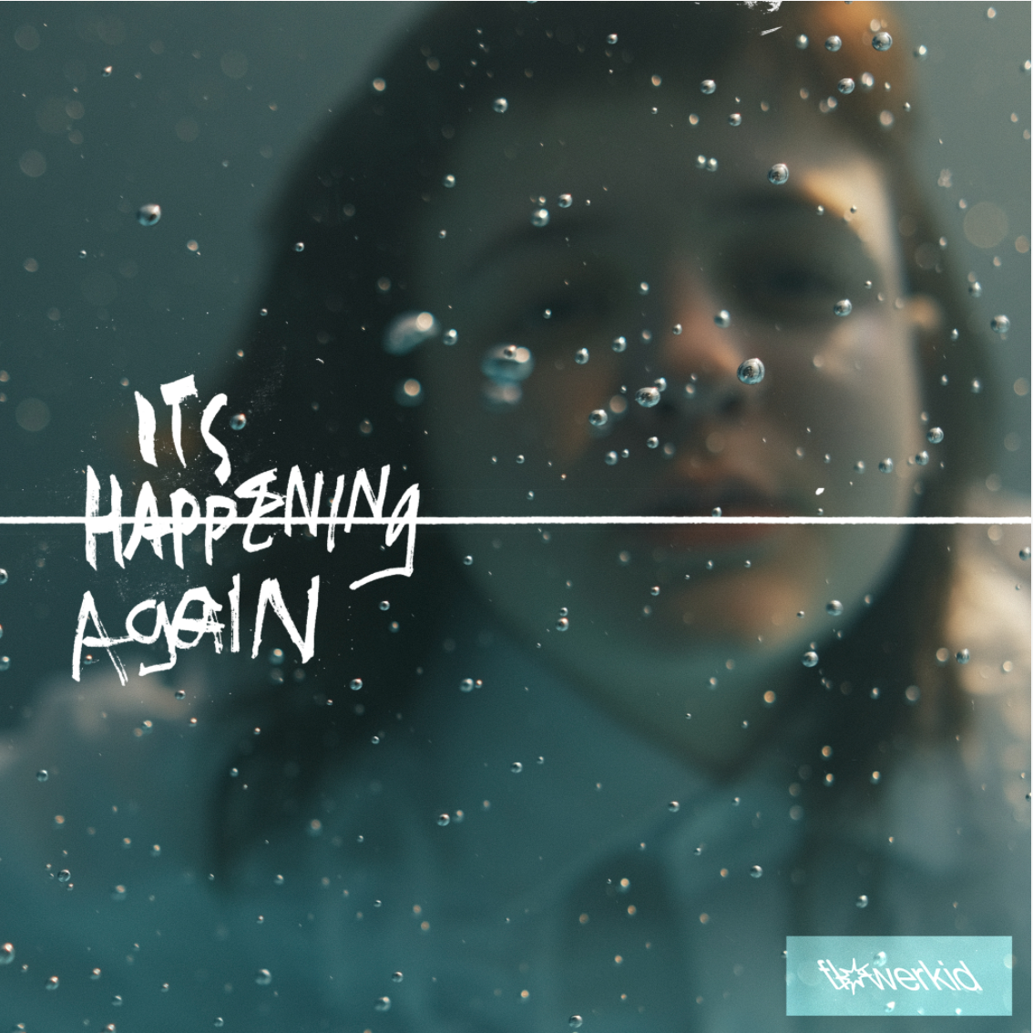

CONNECT:
PRESS ASSETS | INSTAGRAM | SPOTIFY | YOUTUBE | SOUNDCLOUD | FACEBOOK

CONTACT:
ANDREW.GEORGE@ATLANTICRECORDS.COM

