FOR IMMEDIATE RELEASE

FEBRUARY 4TH, 2021

**RISING UK SINGER-SONGWRITER KARL BENJAMIN UNVEILS HIS SECOND BREATHTAKING SINGLE “MOON,” ALONG WITH OFFICIAL VISUAL**

**WATCH THE “MOON” OFFICIAL VIDEO** [**HERE**](https://nam04.safelinks.protection.outlook.com/?url=https%3A%2F%2Fkarlbenjamin.lnk.to%2FMoonVideo&data=04%7C01%7CAlyssa.Reddish%40atlanticrecords.com%7C5ef5fcada1bf43ca15cb08d8c91ac0da%7C8367939002ec4ba1ad3d69da3fdd637e%7C0%7C0%7C637480464060283505%7CUnknown%7CTWFpbGZsb3d8eyJWIjoiMC4wLjAwMDAiLCJQIjoiV2luMzIiLCJBTiI6Ik1haWwiLCJXVCI6Mn0%3D%7C1000&sdata=a78fRLpV7WiZdeJ%2F8C2kba3zSgMtqk41pCce6FPTZcA%3D&reserved=0)

***ACCLAIMED DEBUT SINGLE, “APRICOT SKY,” AVAILABLE NOW***

**WATCH THE “APRICOT SKY” OFFICIAL VIDEO** [**HERE**](https://nam04.safelinks.protection.outlook.com/?url=https%3A%2F%2Fwww.youtube.com%2Fwatch%3Fv%3Dc8h_vlHQk-M&data=04%7C01%7CAlyssa.Reddish%40atlanticrecords.com%7C5ef5fcada1bf43ca15cb08d8c91ac0da%7C8367939002ec4ba1ad3d69da3fdd637e%7C0%7C0%7C637480464060293494%7CUnknown%7CTWFpbGZsb3d8eyJWIjoiMC4wLjAwMDAiLCJQIjoiV2luMzIiLCJBTiI6Ik1haWwiLCJXVCI6Mn0%3D%7C1000&sdata=jNk45Cie%2FKinbAS%2BAXx8YTxyN1qsVXvIJStQ8zNkFLQ%3D&reserved=0)



Atlantic Records’ (UK) own latest groundbreaking artist is singer-songwriter Karl Benjamin, the London native who today released his soulful new single, “Moon.” Accompanied by an official music video, “Moon” is a clear reminder of Karl’s budding talent, which led him to success back in 2020 with his debut single “Apricot Sky.” The song is a high-pitched melody, highlighting the singer’s feelings about a special love interest. Check out the official music video for “Moon” [HERE](https://nam04.safelinks.protection.outlook.com/?url=https%3A%2F%2Fkarlbenjamin.lnk.to%2FMoonVideo&data=04%7C01%7CAlyssa.Reddish%40atlanticrecords.com%7C5ef5fcada1bf43ca15cb08d8c91ac0da%7C8367939002ec4ba1ad3d69da3fdd637e%7C0%7C0%7C637480464060293494%7CUnknown%7CTWFpbGZsb3d8eyJWIjoiMC4wLjAwMDAiLCJQIjoiV2luMzIiLCJBTiI6Ik1haWwiLCJXVCI6Mn0%3D%7C1000&sdata=TKR3qxBmxJSeKAQAbOJUrLwWhoUiROKoHV3CTZPjq7I%3D&reserved=0); the single is now available via all DSPs [HERE](https://nam04.safelinks.protection.outlook.com/?url=https%3A%2F%2Fkarlbenjamin.lnk.to%2FMoon&data=04%7C01%7CAlyssa.Reddish%40atlanticrecords.com%7C5ef5fcada1bf43ca15cb08d8c91ac0da%7C8367939002ec4ba1ad3d69da3fdd637e%7C0%7C0%7C637480464060303488%7CUnknown%7CTWFpbGZsb3d8eyJWIjoiMC4wLjAwMDAiLCJQIjoiV2luMzIiLCJBTiI6Ik1haWwiLCJXVCI6Mn0%3D%7C1000&sdata=cBmJwiqCcw0e8XSvZt5oUocR%2FUCliycGiL2b4Li2SS0%3D&reserved=0). Fans can also expect the release of a project from Karl Benjamin later this year. *“This song represents the journey of a relationship. It represents the progress that two people can make, together rather than apart.”* Karl candidly speaks on the single. *“Moon, to me, is about the adventure you go through, to finally arrive at the most intimate moment within the relationship you treasure most."*

Recently named by [*The Line of Best Fit*](https://nam04.safelinks.protection.outlook.com/?url=https%3A%2F%2Fwww.thelineofbestfit.com%2Ffeatures%2Farticles%2Ffifty-artists-on-the-rise-2021&data=04%7C01%7CAlyssa.Reddish%40atlanticrecords.com%7C5ef5fcada1bf43ca15cb08d8c91ac0da%7C8367939002ec4ba1ad3d69da3fdd637e%7C0%7C0%7C637480464060303488%7CUnknown%7CTWFpbGZsb3d8eyJWIjoiMC4wLjAwMDAiLCJQIjoiV2luMzIiLCJBTiI6Ik1haWwiLCJXVCI6Mn0%3D%7C1000&sdata=djPzRFwkaoP0Pf9dDrtu9LzLXwpUnDRXB1jE1vowgl8%3D&reserved=0) as one of its “Fifty Artists On The Rise In 2021,” noting his “velvet-soft vocals and a honeyed-up delivery filled with vulnerability and a gentle swagger,” 24-year-old Karl Benjamin has quickly turned heads with his ambitious, eclectic approach to modern R&B. Having first attracted attention as an in-demand model, Benjamin made a stellar musical debut last fall with the premiere of his first single, “[Apricot Sky](https://nam04.safelinks.protection.outlook.com/?url=https%3A%2F%2Flnk.to%2FApricot-Sky&data=04%7C01%7CAlyssa.Reddish%40atlanticrecords.com%7C5ef5fcada1bf43ca15cb08d8c91ac0da%7C8367939002ec4ba1ad3d69da3fdd637e%7C0%7C0%7C637480464060313484%7CUnknown%7CTWFpbGZsb3d8eyJWIjoiMC4wLjAwMDAiLCJQIjoiV2luMzIiLCJBTiI6Ik1haWwiLCJXVCI6Mn0%3D%7C1000&sdata=lsBb1T03AYqIXfUF0T2qFgVFjUookNpQMnZz4tUkI7g%3D&reserved=0),” joined by an equally powerful music video, directed by Pip + Lib and streaming now at YouTube [HERE](https://nam04.safelinks.protection.outlook.com/?url=https%3A%2F%2Fwww.youtube.com%2Fwatch%3Fv%3Dc8h_vlHQk-M&data=04%7C01%7CAlyssa.Reddish%40atlanticrecords.com%7C5ef5fcada1bf43ca15cb08d8c91ac0da%7C8367939002ec4ba1ad3d69da3fdd637e%7C0%7C0%7C637480464060313484%7CUnknown%7CTWFpbGZsb3d8eyJWIjoiMC4wLjAwMDAiLCJQIjoiV2luMzIiLCJBTiI6Ik1haWwiLCJXVCI6Mn0%3D%7C1000&sdata=21Rlee1fdlWN4g%2Bv%2F%2BiaurGZtj6sb8W224%2FnE9pHhfo%3D&reserved=0). Produced by HYNLU with additional production from PRGRSHN, the track proved an instant smash, scoring placement on a wide range of top playlists while also being ranked among Shazam’s hugely influential “Predictions 2021” list showcasing artists on the verge of viral fame.

What’s more, “Apricot Sky” was met by immediate critical acclaim, with [*The FADER*](https://nam04.safelinks.protection.outlook.com/?url=https%3A%2F%2Fwww.thefader.com%2F2020%2F11%2F17%2Fkarl-benjamin-apricot-sky-premiere&data=04%7C01%7CAlyssa.Reddish%40atlanticrecords.com%7C5ef5fcada1bf43ca15cb08d8c91ac0da%7C8367939002ec4ba1ad3d69da3fdd637e%7C0%7C0%7C637480464060323473%7CUnknown%7CTWFpbGZsb3d8eyJWIjoiMC4wLjAwMDAiLCJQIjoiV2luMzIiLCJBTiI6Ik1haWwiLCJXVCI6Mn0%3D%7C1000&sdata=2NMjs2Z4A2FtVcfWTV1X05soVX%2FvZgXQ10bMFr8rNO8%3D&reserved=0) hailing it for “(mixing) gospel and G-funk influences alongside the Londoner's velvet-soft vocals to create a reflective but uplifting slice of pop-soul.” “(Karl Benjamin) has crafted something beautiful for his latest release,” raved [*CLASH*](https://nam04.safelinks.protection.outlook.com/?url=https%3A%2F%2Fwww.clashmusic.com%2Fnews%2Fkarl-benjamin-soars-with-new-single-apricot-sky&data=04%7C01%7CAlyssa.Reddish%40atlanticrecords.com%7C5ef5fcada1bf43ca15cb08d8c91ac0da%7C8367939002ec4ba1ad3d69da3fdd637e%7C0%7C0%7C637480464060333471%7CUnknown%7CTWFpbGZsb3d8eyJWIjoiMC4wLjAwMDAiLCJQIjoiV2luMzIiLCJBTiI6Ik1haWwiLCJXVCI6Mn0%3D%7C1000&sdata=fje6Cb0HRa%2BqnQeyz0SDPESm3E91lXWBfir2Z3aw5js%3D&reserved=0), “a soulful return that moves deep inside. It's a song about transformation, how shifts in your inner world can result in profound changes to your life…a sublime piece of music.” Indeed, Benjamin was recently featured in [*GQ*](https://nam04.safelinks.protection.outlook.com/?url=https%3A%2F%2Fwww.gq.com.au%2Fentertainment%2Fmusic%2F21-breakout-musicians-to-know-in-2021%2Fimage-gallery%2F9cd84f7fd477351554093aee7f597f22%3Fpos%3D17&data=04%7C01%7CAlyssa.Reddish%40atlanticrecords.com%7C5ef5fcada1bf43ca15cb08d8c91ac0da%7C8367939002ec4ba1ad3d69da3fdd637e%7C0%7C0%7C637480464060333471%7CUnknown%7CTWFpbGZsb3d8eyJWIjoiMC4wLjAwMDAiLCJQIjoiV2luMzIiLCJBTiI6Ik1haWwiLCJXVCI6Mn0%3D%7C1000&sdata=AdDRuRZAb55vSHwU5nHrl0RHm38%2FFYqgpHv%2BIuqJsrw%3D&reserved=0)’s “21 Breakout Musicians To Know In 2021,” writing, “Not to be confused with the American painter, this Karl Benjamin is a London-based purveyor of silky-smooth hits that fall into a similar sonic territory to Chance the Rapper.”

After starting singing with his sister, Benjamin went on to front various RnB/soul bands while studying at Brighton University.  Scouted by an agent while at Secret Garden Party for a gig with the ensemble, Benjamin then began modelling for the likes of Vivienne Westwood, Nicholas Daley, Converse and more. After moving back to London, Benjamin began a solo career.  On his upcoming single ‘Apricot Sky’, with a rich, velvety vocal that harks to gospel roots but still feels uniquely modern, it’s clear that Karl’s taste is eclectic, broad and ambitious. Describing his sound as “relatable, honest and pretty, but in an unconventional way”. Karl is inspired by the likes of Frank Ocean, Tyler the Creator, Chairlift, Octavian, Chance the Rapper, Kanye West, Smino and A$AP Rocky. Black-dreadlocked and adorned with jewellery, his own striking aesthetic is pretty immediate too. “My music comes with a bright energy, but definitely with undertones of darkness”, he explains and he’s full of ideas of how to convey that visually and expand even further into the future with his fashion background too: “I’d love to eventually be able to incorporate the two worlds.”

2021 will see Benjamin building upon “Apricot Sky” with a series of new singles, including the newly released “Moon” followed by a project later this year. Join us in welcoming him to the Atlantic Records roster of talent!

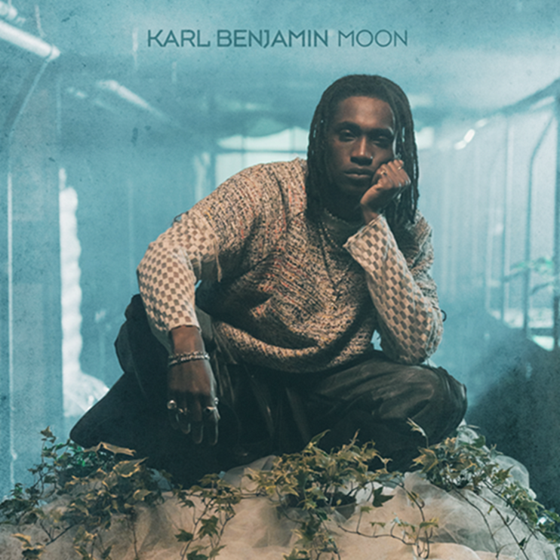

**SOCIAL HANDLES:**

[INSTAGRAM](https://nam04.safelinks.protection.outlook.com/?url=https%3A%2F%2Fwww.instagram.com%2Fkarlbenjaminn%2F&data=04%7C01%7CAlyssa.Reddish%40atlanticrecords.com%7C5ef5fcada1bf43ca15cb08d8c91ac0da%7C8367939002ec4ba1ad3d69da3fdd637e%7C0%7C0%7C637480464060343468%7CUnknown%7CTWFpbGZsb3d8eyJWIjoiMC4wLjAwMDAiLCJQIjoiV2luMzIiLCJBTiI6Ik1haWwiLCJXVCI6Mn0%3D%7C1000&sdata=7ybRcAcUsJnCgb1%2F7nQDcGu4mRWn4x%2B04iBF7nbjffE%3D&reserved=0)

[TWITTER](https://nam04.safelinks.protection.outlook.com/?url=https%3A%2F%2Ftwitter.com%2Fkarlbenjaminn&data=04%7C01%7CAlyssa.Reddish%40atlanticrecords.com%7C5ef5fcada1bf43ca15cb08d8c91ac0da%7C8367939002ec4ba1ad3d69da3fdd637e%7C0%7C0%7C637480464060343468%7CUnknown%7CTWFpbGZsb3d8eyJWIjoiMC4wLjAwMDAiLCJQIjoiV2luMzIiLCJBTiI6Ik1haWwiLCJXVCI6Mn0%3D%7C1000&sdata=LhARGJveERZZdN1t8sC8wpViRTToCecOwR1NpDttzIw%3D&reserved=0)

[FACEBOOK](https://nam04.safelinks.protection.outlook.com/?url=https%3A%2F%2Fwww.facebook.com%2FKarlBenjaminMusic%2F&data=04%7C01%7CAlyssa.Reddish%40atlanticrecords.com%7C5ef5fcada1bf43ca15cb08d8c91ac0da%7C8367939002ec4ba1ad3d69da3fdd637e%7C0%7C0%7C637480464060353462%7CUnknown%7CTWFpbGZsb3d8eyJWIjoiMC4wLjAwMDAiLCJQIjoiV2luMzIiLCJBTiI6Ik1haWwiLCJXVCI6Mn0%3D%7C1000&sdata=QUakUkpTCeUNhEZQes32BAgBxUCIgSCOxiTZu7YFD5s%3D&reserved=0)

[YOUTUBE](https://nam04.safelinks.protection.outlook.com/?url=https%3A%2F%2Fwww.youtube.com%2Fchannel%2FUCJqmEEQni7U4ympKBZ_tDSw&data=04%7C01%7CAlyssa.Reddish%40atlanticrecords.com%7C5ef5fcada1bf43ca15cb08d8c91ac0da%7C8367939002ec4ba1ad3d69da3fdd637e%7C0%7C0%7C637480464060353462%7CUnknown%7CTWFpbGZsb3d8eyJWIjoiMC4wLjAwMDAiLCJQIjoiV2luMzIiLCJBTiI6Ik1haWwiLCJXVCI6Mn0%3D%7C1000&sdata=UPbXFKmn%2F6FzRGTqqEJw6QtlcP5sCtZVak%2BZzPjrYUQ%3D&reserved=0)

**FOR ALL INQUIRIES, CONTACT**

ARIANA WHITE

[ARIANA.WHITE@ATLANTICRECORDS.COM](mailto:ARIANA.WHITE@ATLANTICRECORDS.COM)