FOR IMMEDIATE RELEASE
JANUARY 28, 2022

ROYAL & THE SERPENT RELEASES IF I DIED WOULD ANYONE CARE

RIAA CERTIFIED GOLD ARTIST RELEASES PROVOCATIVE EP

EAGERLY AWAITED PROJECT FEATURES RECENT SINGLES “I’M NOT SORRY” AND “PHUCKBOI REJECTS”
+ STANDOUT TRACK “BETTER”

LISTEN TO IF I DIED WOULD ANYONE CARE HERE
WATCH THE MUSIC VIDEO FOR EP TRACK “BETTER” HERE
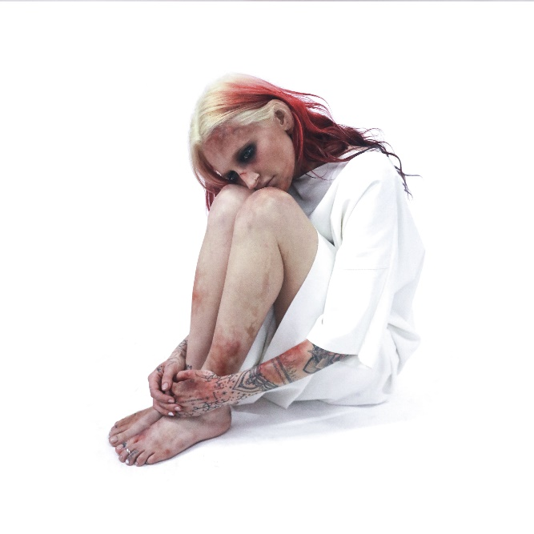
DOWNLOAD ARTWORK HERE

“…one of the most spirited songwriters of 2020.” -BILLBOARD

“Dangerously addictive” -REFINERY 29

“…it’s immediately apparent that the success of “Overwhelmed” was no fluke.” -IDOLATOR

RIAA certified Gold, LA singer/songwriter Royal & the Serpent has released her highly anticipated EP IF I DIED WOULD ANYONE CARE. The pop punk infused project is streaming now HERE. Watch the official music video for emotional EP track “BETTER,” which stars Royal, HERE.

The most visionary output yet from Royal & the Serpent, IF I DIED WOULD ANYONE CARE transforms one of the lowest periods of her life into a high-concept and deeply immersive body of work. “I’d been struggling with depression and feeling like there was no more purpose for me to be here, and I decided to depict that as a state of purgatory,” says Royal. “It’s a place where I’m just one step away from being able to interact with the outside world, but I’m stuck there alone and can’t connect to anyone. To me that’s a pretty strong metaphor for what depression feels like.”

IF I DIED WOULD ANYONE CARE features recent singles “PHUCKBOI REJECTS” and “I’M NOT SORRY” as well as four brand new tracks including “BETTER,” a shout-out-along-worthy anthem which fans have been eagerly awaiting since Royal first performed it live on tour. BETTER’s opening lines perfectly embody the EP’s ultra vivid confession (“I haven’t washed my hair in two weeks/Been getting mental-health texts from my friends to check if I’m alright/They never show this shit in movies”). As the six-track project unfolds, Royal explores everything from anxiety and lack of self-worth to the brutal pain of unrequited love, ultimately arriving at the defiant self-acceptance of “I’M NOT SORRY.” “That’s my ‘I don’t give a fuck anymore’ song,’” she notes. “It’s me deciding I’m just gonna be who I am, and walk through this world without caring what other people think.”

True to the wild complexity that’s always animated her music, the sonic landscape of IF I DIED WOULD ANYONE CARE shifts from frenetic and blistering to moody and delicate, tapping into such disparate genres as hyperpop, pop-punk, and experimental alt-rock. And as Royal reveals, that unrestrained sound reflects a heightened confidence in her artistry—as well as a newfound clarity on her overall mission. “Instead of making music I thought other people would like, I focused on making something I really loved,” she says. “It’s the first time I fully let my walls down and got completely honest, which hopefully is helpful for anyone who’s going through something similar. Depression isn’t something to take lightly, and I hope these songs remind everyone to be gentle with themselves and with the people in their lives, and to take good care of each other.”

The 6-track project follows her viral hit, and Atlantic Records debut, “Overwhelmed,” which spent 22 weeks on Billboard’s Alternative Airplay chart and is now RIAA- certified gold.

Recently named one of SiriusXM’s class of 2021, Royal & the Serpent is an acclaimed live performer, wrapping her first cross-America this fall. Supporting PVRIS and playing at Firefly festival and EMO NITE Vegas, Royal is quickly becoming known for her show stopping, high energy live performance. This year, you can catch Royal & the Serpent live at the When We Were Young festival in Las Vegas, Bottlerock festival in Napa Valley, and supprting grandson on his DEATH OF A TOUR 2022 tour. See full routing below and visit www.royalandtheserpent.com for more details and tickets.

Royal & the Serpent on Tour
*supporting grandon’s DEATH OF A TOUR

February 26th – El Rey Theatre – Los Angeles, California
February 27th – El Rey Theatre – Los Angeles, California
March 1st – Wonder Ballroom – Portland, Oregon
March 2nd – The Crocodile – Seattle, Washington
March 4th – The Complex – Salt Lake City, Utah
March 5th – Gothic Theatre – Denver, Colorado
March 7th – Van Buren – Phoenix, Arizona
March 8th – Sunshine Theatre – Albuquerque, New Mexico
March 12th – Paper Tiger – San Antonio, Texas
March 13th – Scout Bar – Houston, Texas
March 15th – The Plaza Live – Orlando, Florida
March 16th – The Orpheum – Tampa, Florida
March 22nd – The Underground – Charlotte, North Carolina
March 23rd – Eastside Bowl – Nashville, Tennessee
March 25th – Sound Stage – Baltimore, Maryland
March 26th – Union Transfer – Philadelphia, Pennsylvania
March 30th – St. Andrews Hall – Detroit, Michigan
March 31st – Newport Music Hall – Columbus, Ohio
April 3rd – Bottom Lounge – Chicago, Illinois
April 5th – Varsity Theatre – Minneapolis, Minnesota
April 6th – The Waiting Room – Omaha, Nebraska
April 8th – Granada Theatre – Kansas City, Kansas

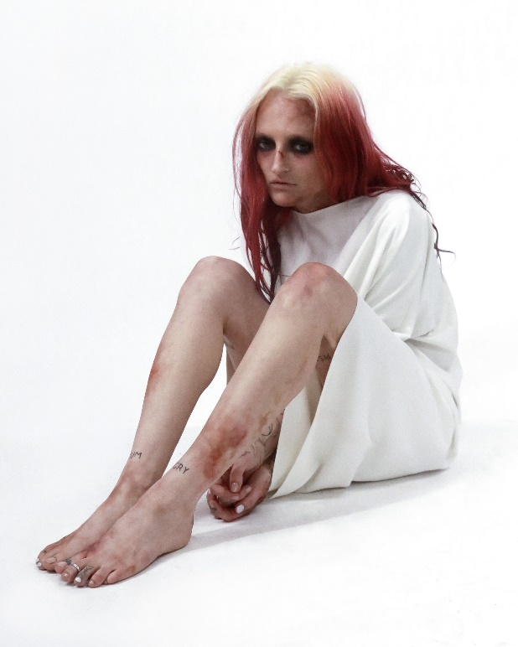
DOWNLOAD PRESS PHOTOS HERE

CONNECT WITH ROYAL & THE SERPENT:
OFFICIAL I INSTAGRAM I YOUTUBE I FACEBOOK I TWITTER

Press contacts:
Corey Brewer / Corey.Brewer@atlanticrecords.com
Jessica Nall / Jessica.Nall@atlanticrecords.com
Gabby Reese / gabrielle.reese@atlanticrecords.com

