ALT POP SINGER/SONGWRITER ROYAL & THE SERPENT RELEASES
“BAD KIDS” FT YOSHI FLOWER

LISTEN HERE: https://royalandtheserpent.lnk.to/badkidsPR
CURRENTLY ON YUNGBLUD’S ‘THE WEIRD TIME OF LIFE’ GLOBAL DIGITAL TOUR
“OVERWHELMED” IS #7 ON BILLBOARD’S ALT AIRPLAY CHART &
REACHES 69 MILLION GLOBAL STREAMS + OVER 4M CREATES ON TIKTOK

FOLLOWS ‘GET A GRIP’ EP RELEASED IN OCTOBER

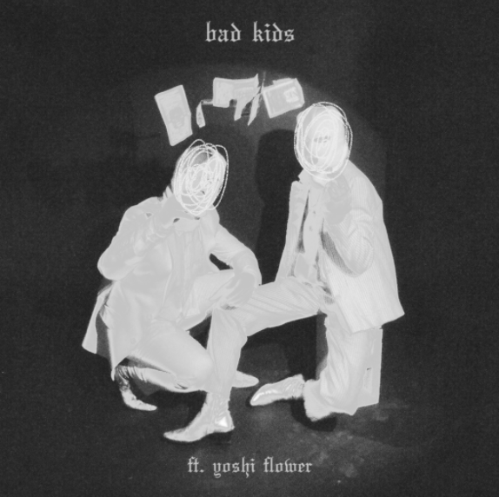
DL art here

“…one of the most spirited songwriters of 2020.” -BILLBOARD

“Dangerously addictive” -REFINERY 29

“…it’s immediately apparent that the success of “Overwhelmed” was no fluke.” -IDOALTOR

Following her October ‘get a grip’ EP that features current #7 Alt radio hit “Overwhelmed,” mystifying alt pop artist Royal & the Serpent releases her latest attention-grabbing single “bad kids” ft Yoshi Flower today. Listen HERE. Yoshi Flower and Royal have been performing the song during Royal’s set on YUNGBLUD’s Weird Time of Life global digital tour which kicked off last month. There are a few remaining US dates; tickets are on sale now HERE.

Last month, Royal released the ‘get a grip’ EP that includes 2 new tracks “Choke” and “Warn You,” “Overwhelmed” and a stripped version of the single. Watch the “Choke” official music video featuring Royal HERE and listen to ‘get a grip’ HERE.
Royal is currently on YUNGBLUD’s ‘The Weird Time of Life’ global digital tour, which kicked off November 16th, 2020 and spans 16 dates across the globe. Each show is a unique localized experience with full-scale production. Tickets are on sale now HERE. See full dates below. You can watch an FAQ video on the tour HERE.
Los Angeles-based Royal & the Serpent made her debut in 2017, earning acclaim for a series of self-released singles such as “MMXX,” “Salvador Dali,” and “Bad Bad Blood”, which was featured in the Season 6 trailer for ABC’s How To Get Away With Murder. In each piece of music she shares with the world, Royal reveals the wild duality at the heart of her artistry and speaks to the incredible power of embracing your true nature, in all its outrageous complexity. A Gemini to the core, she’s passionate but pensive, sensitive but self-possessed, enigmatic but an open book when it comes to exposing what’s inside her mind. “I definitely feel like I’m two people living in one body, where I can just slip at the drop of dime and become a totally different person,” notes Santiago, who equally identifies as a “sweet sunshine angel” (i.e., the Royal persona) and a “freaky devil maniac” (the Serpent).

“With boundary pushing lyrics and palpable energy, she has an onstage spirit that has fans referring to her as ‘Lady Cobain,’” wrote Ones To Watch. “The duality she expresses makes her both relatable and captivating, as she unapologetically shares a full spectrum of experience, from royal soul to luring serpent. Royal delivers the perfect combination of funk and grace in a sweet sound rich with hypnotic melodies.”

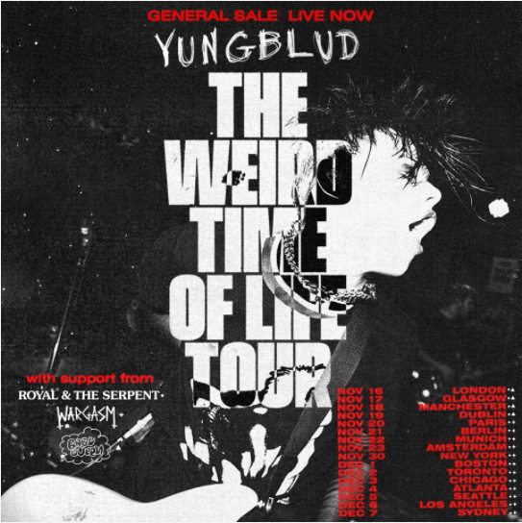

YUNGBLUD’S ‘WEIRD TIME OF LIFE’ 2020 HEADLINE TOUR
With Royal & the Serpent as Direct Support
November 20: Paris
November 21: Berlin
November 22: Munich
November 23: Amsterdam
November 30: New York
December 1: Boston
December 2: Toronto
December 3: Chicago
December 4: Atlanta
December 5: Seattle
December 6: Los Angeles
December 7: Sydney
CONNECT WITH ROYAL & THE SERPENT:
OFFICIAL I INSTAGRAM I YOUTUBE I FACEBOOK I TWITTER
Press contact: Corey.brewer@atlanticrecords.com

