ALT POP PRINCESS ROYAL & THE SERPENT RELEASES INTROSPECTIVE
‘SEARCHING FOR NIRVANA’ EP, OUT TODAY

WATCH THE “GIRLS” FT PHEM LYRIC VIDEO HERE

ROYAL TO SUPPORT PVRIS ON THEIR NORTH AMERICAN TOUR THIS SUMMER

DL EP Artwork here

“…one of the most spirited songwriters of 2020.” -BILLBOARD

“Dangerously addictive” -REFINERY 29

“…it’s immediately apparent that the success of “Overwhelmed” was no fluke.” -IDOLATOR

Attention-grabbing alt pop singer/songwriter Royal & the Serpent sings through toxic relationships, self- hate/love, questioning sexuality and acceptance of who you are in her latest self-reflective EP ‘searching for nirvana,’ out today via Atlantic Records. Listen HERE! EP track ‘girls’ ft phem also receives a lyric video today, featuring both artists. Watch HERE!

The EP follows Royal’s latest single “phuck u,” which received a glamorously grungy music video, directed by Kyle Cogan and featuring Royal. Watch HERE.

You can catch Royal live this summer as direct support on PVRIS’ North American tour, kicking off August 6th in Detroit and wrapping September 2nd in Los Angeles. Please see full routing below. Tickets are available here.

“phuck u” and the EP release succeed single “i can’t get high,” which Royal released in February and played in her set on YUNGBLUD’s ‘The Weird Time of Life’ global digital tour last year. Royal released the ‘get a grip’ EP in October 2020, which features her viral hit “Overwhelmed.” “Overwhelmed” spent 22 weeks on Billboard’s Alternative Airplay chart and has 144 million streams and counting.

Los Angeles-based Royal & the Serpent made her debut in 2017, earning acclaim for a series of self-released singles such as “MMXX,” “Salvador Dali,” and “Bad Bad Blood”, which was featured in the Season 6 trailer for ABC’s How To Get Away With Murder. In each piece of music she shares with the world, Royal reveals the wild duality at the heart of her artistry and speaks to the incredible power of embracing your true nature, in all its outrageous complexity. A Gemini to the core, she’s passionate but pensive, sensitive but self-possessed, enigmatic but an open book when it comes to exposing what’s inside her mind. “I definitely feel like I’m two people living in one body, where I can just slip at the drop of dime and become a totally different person,” notes Santiago, who equally identifies as a “sweet sunshine angel” (i.e., the Royal persona) and a “freaky devil maniac” (the Serpent).

“With boundary pushing lyrics and palpable energy, she has an onstage spirit that has fans referring to her as ‘Lady Cobain,’” wrote Ones To Watch. “The duality she expresses makes her both relatable and captivating, as she unapologetically shares a full spectrum of experience, from royal soul to luring serpent. Royal delivers the perfect combination of funk and grace in a sweet sound rich with hypnotic melodies.”

‘searching for nirvana’ track list:
- i can’t get high
- phuck you
- fanny pack
- gay interlude
- girls (ft. phem)
- freak flag
- i am

PVRIS NORTH AMERICAN TOUR
w/ Royal & the Serpent as support for all dates
August 6, 2021 Fri | Detroit | MI | The Majestic | https://www.ticketweb.com/event/pvris-majestic-theatre-tickets/10186965?pl=majestic
August 7, 2021 Sat | Chicago | IL | House of Blues | https://www.ticketmaster.com/event/0400585CC4C66D22
August 8, 2021 Sun | Columbus | OH | Express Live | https://www.ticketmaster.com/event/0500585BA2283AAC
August 10, 2021 Tue | Boston | MA | House of Blues | https://www.ticketmaster.com/event/01005ABCE3D14D24
August 11, 2021 Wed | New York | NY | Webster Hall | https://www.axs.com/events/404429/pvris-tickets?skin=websterhall
August 13, 2021 Fri | Philadelphia | PA | Union Transfer | https://www.etix.com/ticket/p/2202234/
August 14, 2021 Sat | Harrisburg | PA | Harrisburg Univ. | https://www.ticketmaster.com/event/02005853D4E91F01
August 17, 2021 Tue | Baltimore | MD | Rams Head | https://www.axs.com/events/394123/pvris-tickets
August 18, 2021 Wed | Charlotte | NC | Underground | https://concerts.livenation.com/pvris-charlotte-north-carolina/event/2D00585AD788B2DE
August 19, 2021 Thu | Atlanta | GA | Masquerade | http://www.ticketmaster.com/event/0E00585AAC164E53
August 21, 2021 Sat | Austin | TX | Emo's | https://emosaustin.frontgatetickets.com/event/fefutpdywnjzky46
August 22, 2021 Sun | Dallas | TX | Southside MH | https://www.axs.com/events/404530/pvris-tickets
August 24, 2021 Tue | Denver | CO | Summit | https://www.ticketmaster.com/event/1E005AC1D15033C7
August 25, 2021 Wed | Salt Lake City | UT | Complex | https://www.ticketmaster.com/event/1C00586127B38A80
August 27, 2021 Fri | Seattle | WA | Showbox | https://www.axs.com/events/395964/pvris-tickets
August 28, 2021 Sat | Portland | OR | Wonder Ballroom | https://www.etix.com/ticket/p/8772632/pvris-portland-wonder-ballroom
August 30, 2021 Mon | Sacramento | CA | Ace of Spades | https://www.ticketmaster.com/event/1C00586127B38A80
September 1, 2021 Wed | San Francisco | CA | Regency | https://www.axs.com/events/394202/pvris-tickets?skin=goldenvoice
September 2, 2021 Thu | Los Angeles | CA | Fonda Theatre | https://www.axs.com/events/394142/pvris-tickets

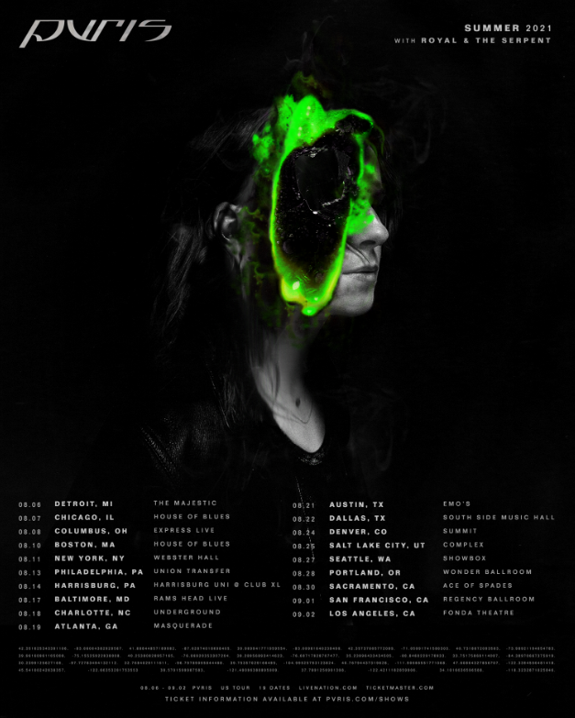
CONNECT WITH ROYAL & THE SERPENT:
OFFICIAL I INSTAGRAM I YOUTUBE I FACEBOOK I TWITTER
Press contact: Corey.brewer@atlanticrecords.com

