FOR IMMEDIATE RELEASE
FEBRUARY 4, 2021

ROZEI IS ON THE “CHASE”

VIRAL HITMAKER RETURNS WITH GENRE-BENDING NEW SINGLE

LISTEN TO “CHASE” HERE
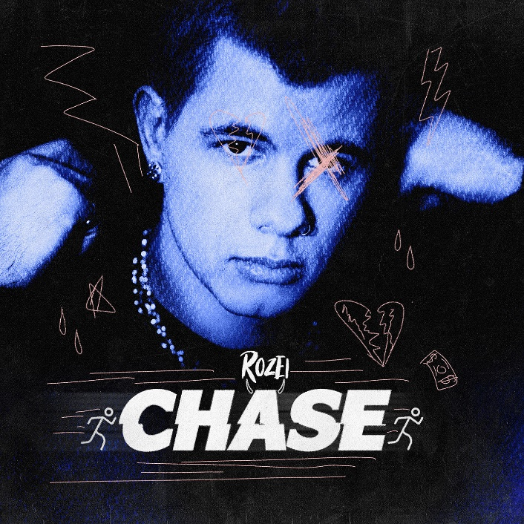
DOWNLOAD ARTWORK HERE

21-year-old rising singer/rapper/songwriter Rozei seals hip-hop bounce, alternative fluency, and pop zeal over one of his signature melodies on his latest single “Chase” – available everywhere now HERE.

“’Chase’ is the beginning of me showcasing my versatility as an artist,” Rozei shared. “I don’t want to be held down to any specific mood or genre & the vibe of this track speaks for that.”

The Pennsylvania native first made waves with his viral track “Ooo La La” which currently boasts over 25 million streams and has topped the Spotify Viral Charts in multiple countries. The track arrived alongside a FaZe Clan directed official video, starring Rozei and famous gamer FaZe Nikan and currently boasts over 1.3 million views.

“Chase” follows Rozei’s impressive singles “Droptop,” which was produced with Billboard Top 200 producer DJ Chose and co-written with multi-platinum, GRAMMY-winning songwriter London Jae (Cardi B, Beyoncé, Rihanna, Tinashe), and the upbeat summer track “Hollywood.” “Hollywood” was featured on LA Weekly’s “in rotation” series and praised as “a song that is gloriously appropriate both for the summer and for this region.” Known for his signature melodic crossover sound, Rozei draws from a range of genres with influences including Juice WRLD, Lil Skies and iann dior for a unique and unforgettable style and sound. With recent praise from Billboard, HipHopDX and more Rozei is not showing any signs of slowing down!

Stay tuned for more new music from Rozei coming soon!

FOLLOW ROZEI
OFFICIAL SITE | INSTAGRAM|TWITTER|SOUNDCLOUD|YOUTUBE

PRESS CONTACT:
Jessica Nall // Jessica.Nall@atlanticrecords.com

