FOR IMMEDIATE RELEASE

OCTOBER 16, 2020

**ROZEI RELEASES VIBEY NEW SINGLE “DROPTOP”**

**“DROPTOP” MARKS THE FOLLOW UP TO RISING STAR’S VIRAL HIT SINGLE, “OOO LA LA”**

**LISTEN TO “DROPTOP”** [**HERE**](https://rozei.lnk.to/DroptopPR)

**WATCH THE VIDEO** [**HERE**](https://rozei.lnk.to/DroptopVideoPR)

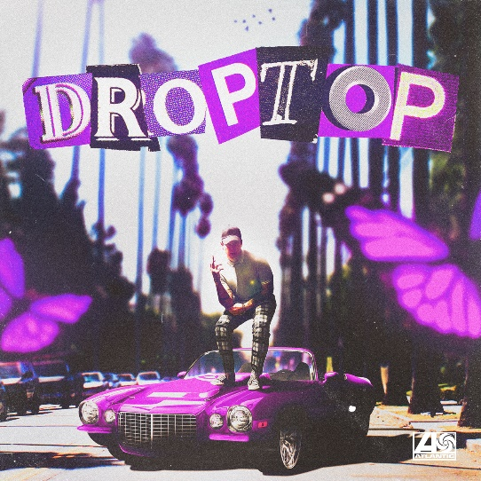

[DOWNLOAD ARTWORK HERE](https://press.atlanticrecords.com/rozei/)

21-year-old Atlantic Records recording artist **Rozei** seals hip-hop bounce, alternative fluency, and pop zeal on his latest feel-good single “Droptop” – available now [HERE](https://rozei.lnk.to/DroptopPR). The Pennsylvania native’s latest track was produced with Billboard Top 200 producer **DJ Chose** and co-written with multi-platinum, GRAMMY-winning songwriter **London Jae (Cardi B, Beyoncé, Rihanna, Tinashe**). The track arrives today alongside an [Overcast](https://www.instagram.com/overcastaz) directed video – streaming now [HERE](https://rozei.lnk.to/DroptopVideoPR).

*“I made ‘Droptop’ to be one of those songs you play on a late night drive with the windows down and the radio up,”* Rozei says*. “I feel like everyone can relate to a song like this, because everyone has gone through it. It’s actually about moving on from an ex, but not from the perspective of being sad or depressed. It’s more of a feel good, everything is going to be fine, take on it.”*

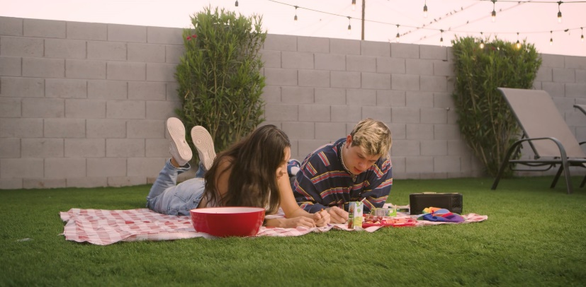

Known for his irresistible melodies, the rising rapper first made waves with his viral track “[Ooo La La](https://rozei.lnk.to/OooLaLa)” which currently boasts over **20 million streams** and has topped the **Spotify Viral Charts** in multiple countries. The track launched the emerging artist into an online phenomenon when it caught the attention of the international gaming community. The **FaZe Clan** directed [official video](https://www.youtube.com/watch?v=ATWJG9nFY2o&feature=youtu.be&src=Linkfire&lId=7700fa11-9739-468a-acf0-01f3faa14f6d&cId=243a20ab-c558-413d-a755-b68ba13bc941), starring Rozei alongside famous gamer **FaZe Nikan**, currently has over **1 million views** and continues to climb. Earlier this month, Rozei tapped RIAA Gold certified R&B player **Luh Kel** for a remix of the catchy track – listen [HERE](https://rozei.lnk.to/OooLaLaRemixPR).

“Droptop” follows Rozei’s upbeat summer track “[Hollywood](https://rozei.lnk.to/Hollywood)” which [LA Weekly](https://www.laweekly.com/in-rotation-rozeis-hollywood/) featured on their “in rotation” series and praised as “a song that is gloriously appropriate both for the summer and for this region.” Known for his signature melodic crossover sound, Rozei draws from a range of genres with influences including Juice WRLD, Lil Skies and iann dior for a unique and unforgettable style and sound. With recent praise from Billboard, HipHopDX and more the rising rapper is not showing any signs of slowing down!

Stay tuned for more new music from Rozei coming soon!

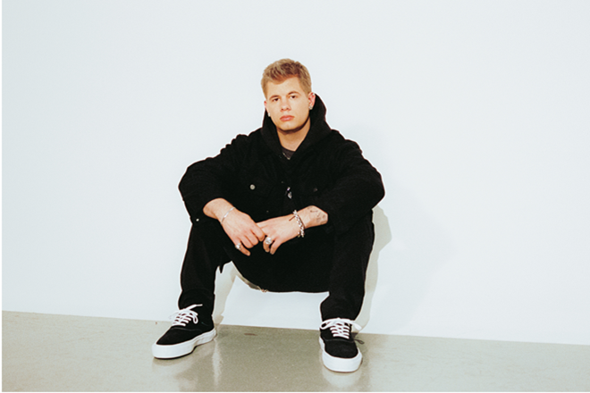

[DOWNLOAD PRESS PHOTO HERE](https://nam04.safelinks.protection.outlook.com/?url=https%3A%2F%2Fwarnermusicgroup.box.com%2Fs%2F33272tibq6mjnntkjgqu18e5d7cbg9k6&data=02%7C01%7CMegan.Rasmussen%40atlanticrecords.com%7Cdc6e8f706ad64bfd2fc908d818860273%7C8367939002ec4ba1ad3d69da3fdd637e%7C0%7C0%7C637286311148823211&sdata=bO12an%2FFP8zASEQATuPsbZEIpFr7Z2BjpZJAxdso1FA%3D&reserved=0)

**FOLLOW ROZEI**

[OFFICIAL SITE](http://rozeimusic.com) | [INSTAGRAM](https://nam04.safelinks.protection.outlook.com/?url=https%3A%2F%2Fwww.instagram.com%2Frozeimusic%2F%3Fhl%3Den&data=02%7C01%7CMegan.Rasmussen%40atlanticrecords.com%7Cdc6e8f706ad64bfd2fc908d818860273%7C8367939002ec4ba1ad3d69da3fdd637e%7C0%7C0%7C637286311148823211&sdata=DMbHkae1OLuPjhS3gR717VfbL92d%2Fl1w9Aw%2BRETD7es%3D&reserved=0)|[TWITTER](https://nam04.safelinks.protection.outlook.com/?url=https%3A%2F%2Ftwitter.com%2FRozeiMusic%3Fref_src%3Dtwsrc%255Egoogle%257Ctwcamp%255Eserp%257Ctwgr%255Eauthor&data=02%7C01%7CMegan.Rasmussen%40atlanticrecords.com%7Cdc6e8f706ad64bfd2fc908d818860273%7C8367939002ec4ba1ad3d69da3fdd637e%7C0%7C0%7C637286311148833206&sdata=fM%2BXEM0anBebp0zTTSbsCNUM5AnwVGF0r1xbnHDfEew%3D&reserved=0)|[SOUNDCLOUD](https://nam04.safelinks.protection.outlook.com/?url=https%3A%2F%2Fsoundcloud.com%2Frozei&data=02%7C01%7CMegan.Rasmussen%40atlanticrecords.com%7Cdc6e8f706ad64bfd2fc908d818860273%7C8367939002ec4ba1ad3d69da3fdd637e%7C0%7C0%7C637286311148833206&sdata=KkVl2oS%2BGFPEdudq%2FcHe4vPzxfTgJIiVJj916tJAj6Q%3D&reserved=0)|[YOUTUBE](https://nam04.safelinks.protection.outlook.com/?url=https%3A%2F%2Fwww.youtube.com%2Fchannel%2FUCEkgFVFZd8dsrYvIJZH1Cug&data=02%7C01%7CMegan.Rasmussen%40atlanticrecords.com%7Cdc6e8f706ad64bfd2fc908d818860273%7C8367939002ec4ba1ad3d69da3fdd637e%7C0%7C0%7C637286311148843201&sdata=3zsPHipU3rzzMrAoqTTDIZfKmACjh%2B2YYoumetm6KJs%3D&reserved=0)

**PRESS CONTACT:**

Jessica Nall // [Jessica.Nall@atlanticrecords.com](mailto:Jessica.Nall@atlanticrecords.com)