FOR IMMEDIATE RELEASE
AUGUST 20, 2021

ROZEI SHARES “FEVER DREAMS”

GENRE-BENDING VIRAL HITMAKER UNVEILS ECSTATIC NEW SINGLE

LISTEN TO “FEVER DREAMS” HERE
WATCH THE LYRIC VIDEO HERE
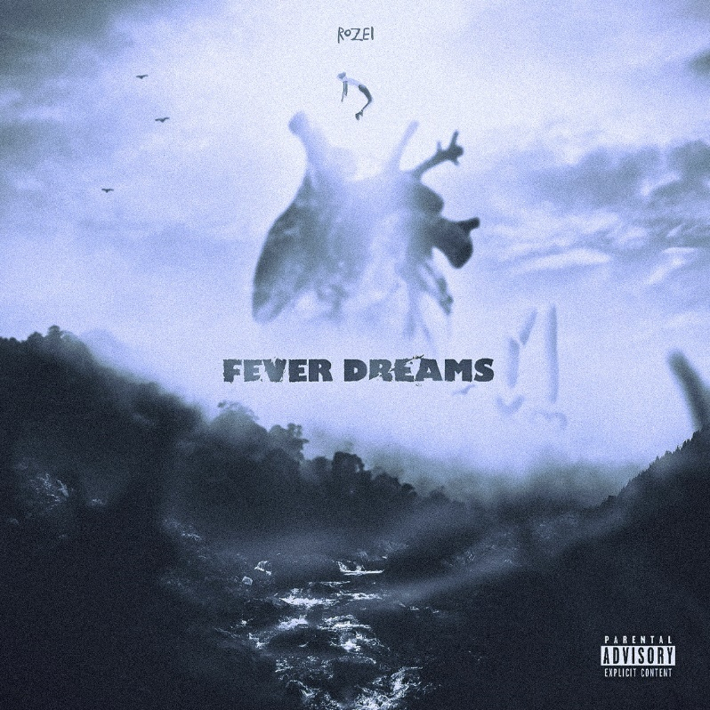
DOWNLOAD HI-RES PHOTOS + ARTWORK

“Rozei is a singer, rapper, producer, and artist all in one, and he’s here to make an impact in the music industry. Blending the genres of hip-hop, alternative, R&B, and pop into one melting pot, the Erie, Pennsylvania native croons lyrics inspired by real-life experiences, over an animated sonic backdrop that’s as vibrant as his personality.”
– FLAUNT

Genre-blurring singer-songwriter-producer Rozei has released his latest single “Fever Dreams,” available now HERE. Produced by Colin ‘DOC’ Brittain (5 Seconds of Summer, All Time Low, Papa Roach) and Perish (Dream), “Fever Dreams” arrives with an official lyric video streaming now HERE.

Named by Alternative Press as one of “40 New Artists You Need To Hear,” Rozei earned raves for his most recent single, “The World Is Over.” Produced by Colin ‘DOC’ Brittain, “The World Is Over” “sees the 21-year-old showcasing his skillsets once again,” declared FLAUNT, “this time singing about love and a certain female who can’t fathom leaving his life.” “Pulsing with alternative rock energy, Rozei’s new song ‘The World is Over’ is meant to be a comfort to those who feel alone, specifically after a rough break-up,” wrote Glasse Factory. “Drawing from a range of genres and experiences, the 21 year old artist is crafting a unique sound that embodies a musical style all his own that evolves with definition with each release.”

“The World Is Over” added to the recent string of impressive releases from Rozei, including “Heartbreak Hotel” and “Chase.” “Chase” received online applause upon its February premiere, with Banger Of The Day raving, “It’s super impressive how (Rozei) is blending a variety of sounds here, from early-2000’s rock to a Juice WRLD-esque delivery, and layers of eclectic, speaker-knocking production…An absolute bop!” “‘Chase’ is different from previously released singles from Rozei,” wrote Early Rising, “but still somehow fits in perfectly with his discography…Not wanting to be held down to a specific mood or genre of music, Rozei breaks out of the shell.”

Rozei first made waves with last year’s viral smash, “Ooo La La,” which topped the Spotify Viral Charts in multiple countries and currently boasts over 35M worldwide streams and counting. “Ooo La La” was joined by an official music video – directed by FaZe Clan’s Youssef Ali and co-starring famed gamer FaZe Nikan – now with close to 1.6M views.

Known for melding powerful alternative energy with tantalizing pop zeal his own trademark brand of hip-hop bounce, Rozei draws from a range of genres to create a unique and unforgettable musical style all his own. The 21-year-old, Erie, PA-based artist has earned high profile media attention from such national outlets as Billboard, LA Weekly, HipHopDX, and more.

Rozei is currently hard at work crafting more innovative, emotionally resonant music, with additional new releases due later this year.

# # #

FOLLOW ROZEI
OFFICIAL SITE | INSTAGRAM|TWITTER|SOUNDCLOUD|YOUTUBE

PRESS CONTACT:
Jessica Nall // Jessica.Nall@atlanticrecords.com

