FOR IMMEDIATE RELEASE

NOVEMBER 6, 2020

**ROZEI IS THE “MEAN ONE”**

**RISING STAR DROPS GRINCH-INSPIRED HOLIDAY BANGER**

**LISTEN TO “MEAN ONE”** [**HERE**](http://rozei.lnk.to/MeanOne)

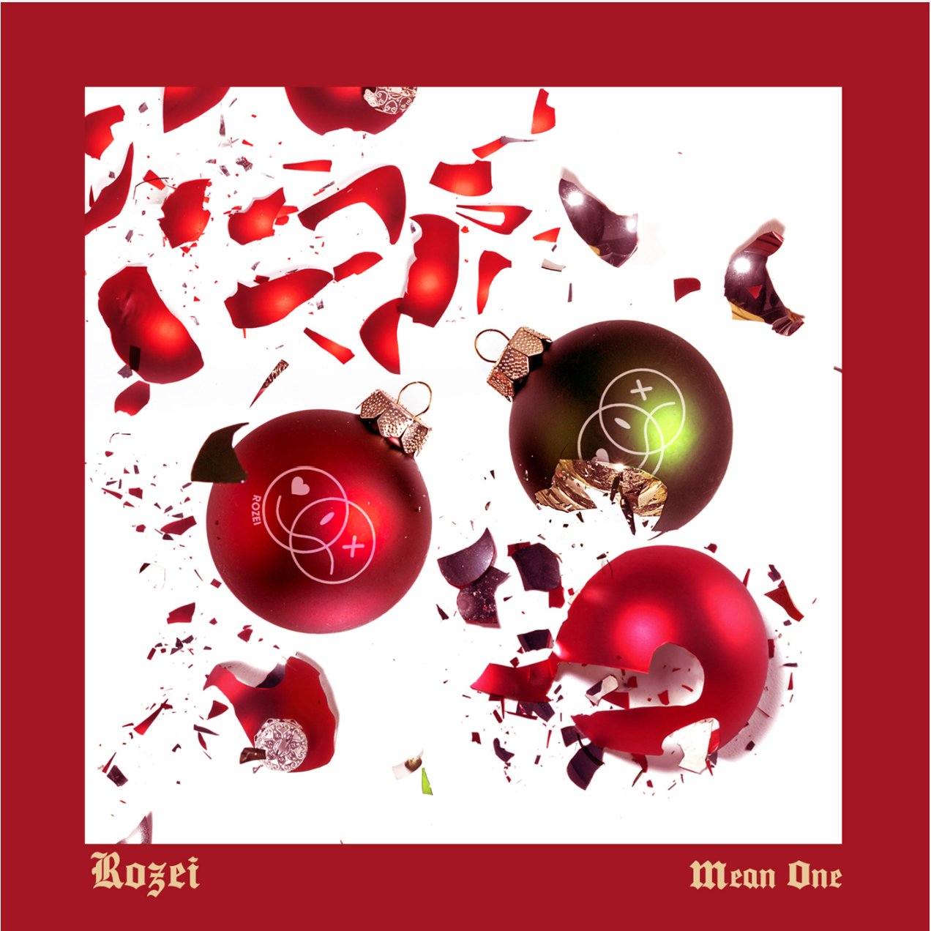

[DOWNLOAD ARTWORK HERE](https://press.atlanticrecords.com/rozei/)

Atlantic Records recording artist **Rozei** puts a holiday spin on his iconic hip-hop bounce, alternative fluency, and pop zeal on his latest release “**Mean One**” – available now [HERE](http://rozei.lnk.to/MeanOne). Inspired by “You’re a Mean One Mr. Grinch,” Rozei takes on the alias of “The Mean One” in this perfect addition to your holiday playlist!

The Pennsylvania native’s latest track follows an impressive string of singles including “[Droptop](https://rozei.lnk.to/DroptopPR),” which was produced with Billboard Top 200 producer **DJ Chose** and co-written with multi-platinum, GRAMMY-winning songwriter **London Jae (Cardi B, Beyoncé, Rihanna, Tinashe**), as well as his viral hit “[Ooo La La](https://rozei.lnk.to/OooLaLa)” which currently boasts over **20 million streams** and has topped the **Spotify Viral Charts** in multiple countries.

Known for his irresistible melodies, the rising rapper was launched into online stardom when “Ooo La La” caught the attention of the international gaming community. The **FaZe Clan** directed [official video](https://www.youtube.com/watch?v=ATWJG9nFY2o&feature=youtu.be&src=Linkfire&lId=7700fa11-9739-468a-acf0-01f3faa14f6d&cId=243a20ab-c558-413d-a755-b68ba13bc941), starring Rozei alongside famous gamer **FaZe Nikan**, currently has over **1.2 million views** and continues to climb. Earlier this year, Rozei tapped RIAA Gold certified R&B player **Luh Kel** for a [remix](https://rozei.lnk.to/OooLaLaRemixPR) of the catchy track.

Known for his signature melodic crossover sound, Rozei draws from a range of genres with influences including Juice WRLD, Lil Skies and iann dior for a unique and unforgettable style and sound. With recent praise from Billboard, HipHopDX, LA Weekly and more the rising rapper is not showing any signs of slowing down!

Stay tuned for more new music from Rozei coming soon!



[DOWNLOAD PRESS PHOTO HERE](https://nam04.safelinks.protection.outlook.com/?url=https%3A%2F%2Fwarnermusicgroup.box.com%2Fs%2F33272tibq6mjnntkjgqu18e5d7cbg9k6&data=02%7C01%7CMegan.Rasmussen%40atlanticrecords.com%7Cdc6e8f706ad64bfd2fc908d818860273%7C8367939002ec4ba1ad3d69da3fdd637e%7C0%7C0%7C637286311148823211&sdata=bO12an%2FFP8zASEQATuPsbZEIpFr7Z2BjpZJAxdso1FA%3D&reserved=0)

**FOLLOW ROZEI**

[OFFICIAL SITE](http://rozeimusic.com) | [INSTAGRAM](https://nam04.safelinks.protection.outlook.com/?url=https%3A%2F%2Fwww.instagram.com%2Frozeimusic%2F%3Fhl%3Den&data=02%7C01%7CMegan.Rasmussen%40atlanticrecords.com%7Cdc6e8f706ad64bfd2fc908d818860273%7C8367939002ec4ba1ad3d69da3fdd637e%7C0%7C0%7C637286311148823211&sdata=DMbHkae1OLuPjhS3gR717VfbL92d%2Fl1w9Aw%2BRETD7es%3D&reserved=0)|[TWITTER](https://nam04.safelinks.protection.outlook.com/?url=https%3A%2F%2Ftwitter.com%2FRozeiMusic%3Fref_src%3Dtwsrc%255Egoogle%257Ctwcamp%255Eserp%257Ctwgr%255Eauthor&data=02%7C01%7CMegan.Rasmussen%40atlanticrecords.com%7Cdc6e8f706ad64bfd2fc908d818860273%7C8367939002ec4ba1ad3d69da3fdd637e%7C0%7C0%7C637286311148833206&sdata=fM%2BXEM0anBebp0zTTSbsCNUM5AnwVGF0r1xbnHDfEew%3D&reserved=0)|[SOUNDCLOUD](https://nam04.safelinks.protection.outlook.com/?url=https%3A%2F%2Fsoundcloud.com%2Frozei&data=02%7C01%7CMegan.Rasmussen%40atlanticrecords.com%7Cdc6e8f706ad64bfd2fc908d818860273%7C8367939002ec4ba1ad3d69da3fdd637e%7C0%7C0%7C637286311148833206&sdata=KkVl2oS%2BGFPEdudq%2FcHe4vPzxfTgJIiVJj916tJAj6Q%3D&reserved=0)|[YOUTUBE](https://nam04.safelinks.protection.outlook.com/?url=https%3A%2F%2Fwww.youtube.com%2Fchannel%2FUCEkgFVFZd8dsrYvIJZH1Cug&data=02%7C01%7CMegan.Rasmussen%40atlanticrecords.com%7Cdc6e8f706ad64bfd2fc908d818860273%7C8367939002ec4ba1ad3d69da3fdd637e%7C0%7C0%7C637286311148843201&sdata=3zsPHipU3rzzMrAoqTTDIZfKmACjh%2B2YYoumetm6KJs%3D&reserved=0)

**PRESS CONTACT:**

Jessica Nall // [Jessica.Nall@atlanticrecords.com](mailto:Jessica.Nall@atlanticrecords.com)