FOR IMMEDIATE RELEASE
MAY 4, 2020

ROZEI RELEASES GROUNDBREAKING, GAMING THEMED “OOO LA LA” VIDEO
FEATURING CAMEO BY FAZE NIKAN OF GAMING GIANT FAZE CLAN

DIRECTED BY YOUSSEF ALI WHO HELMS FAZE CLAN’S DIGITAL TEAM
WITH A SPECIAL APPEARANCE BY GAMING PHENOMENON FAZE NIKAN

“OOO LA LA” HAS RECEIVED MASSIVE SUPPORT FROM FORTNITE PLAYERS
AND THE GLOBAL GAMING COMMUNITY

LISTEN TO “OOO LA LA” HERE
WATCH THE VIDEO HERE

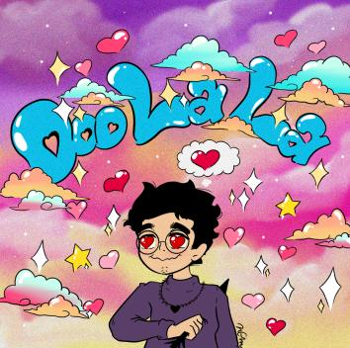

21 year-old Atlantic Records recording artist Rozei has dropped the official video to his viral smash, “Ooo La La” – WATCH HERE. The futuristic video stars the up-and-coming singer/rapper/songwriter/producer alongside famous gamer FaZe Nikan from FaZe Clan, the world’s most prominent and influential gaming organization. The video was directed by Youssef Ali who helms the digital team at FaZe Clan and has produced and directed videos with Chris Brown, Lil Wayne, RiceGum. “Ooo La La” is available now at all DSPs and streaming services HERE via Atlantic Records.

“I had the melody stuck in my head for about a week before even laying any vocals down onto the record, even before picking out a beat for it,” Rozei tells Billboard. “I knew I wanted to make something catchy and upbeat but also make it true to myself and who I am as an artist. I put some lyrics to the melody and wrote it about a summer crush I had the past year. Everything just came together naturally until “Ooo La La” was born. I finished the track and immediately put it out onto SoundCloud & DSPs and never looked back.”

The track immediately caught the attention of the international gaming community which launched the song into an online phenomenon. Within a day of Rozei posting the full track, over 100 gaming videos featured “Ooo La La” and received support from mega-popular gamers Serpent AU, members of the FaZe Clan, as well as popular gaming channels like BH Motion and Promoting Sounds. “Ooo La La” has since gone on to top the Spotify Viral Charts in multiple countries and has amassed over 15 million streams to date, showing no signs of slowing down.

Rozei plans to continue to release new music and release his debut EP later this year.

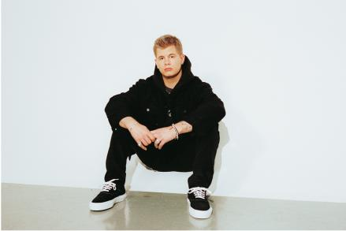
DOWNLOAD PRESS PHOTO HERE

ABOUT ROZEI
For Rozei, melody seals hip-hop bounce, alternative fluency, and pop zeal all together as one. The Erie, PA-born singer, rapper, producer, and artist spins relatable real-life stories above an animated sonic backdrop as vibrant as his persona. Streamed more than 10 million times independently in less than six months, and praised by DopeCauseWeSaid, Vents Magazine, and more, he provokes slick and shiny sing-a-longs with a message.

Rozei introduced his sizzling signature style on the 2018 single “Buzzin’.” As he continued releasing music, his track “Bad Romance” [feat. 27CLUB] caught fire and organically tallied over half a million Spotify streams. After catching the attention of the gaming world, he teased “Ooo La La” on Twitter that incited a flurry of retweets and anticipation. Within a day of posting the full track, over 100 gaming videos popped up using the song. Backed by mega-popular gamers Serpent AU, members of the Faze Clan as well as popular channels like BH Motion and Promoting Sounds. On the track, glistening keys glow beneath an unshakable chant punctuated by beeper blips, doorbell dings, and car alarm chirps as he croons, “Ooo la la, she hella bad.”

With more music up ahead, Rozei’s melodies will ultimately resonate far and wide.

ABOUT FAZE CLAN
Since its inception in 2010, FaZe Clan has established itself as the world’s most prominent and influential gaming organization known for its disruptive original content and hyper-engaged global fanbase of 215 million combined across all social platforms. FaZe Clan holds an unrivaled position at the epicenter of gaming, sports, culture and entertainment, driving how the next generation consumes content, plays and shops. Their roster of 85 influential personalities consists of world-class gamers, engaging content creators and a mix of talent beyond the world of gaming, including NBA star Ben Simmons, NFL star Juju Smith-Schuster and global superstar artists Offset and Lil Yachty. The organization’s unmatched esports division includes seven competitive teams in Fortnite, FIFA, PUBG, PUBG Mobile, Rainbow Six, Call of Duty League (Atlanta FaZe) and CS:GO with dozens of world championship trophies among them. In addition, FaZe Clan has become a sought-after fashion and lifestyle brand through an inspired apparel line and limited-edition collaborations with partners including Champion, NFL, Manchester City FC, Lyrical Lemonade, Kappa, CLOT, LA Kings and more. Follow us @FaZeClan and @FaZeApparel.

FOLLOW ROZEI
INSTAGRAM|TWITTER|SOUNDCLOUD|YOUTUBE

PRESS CONTACT:
Jessica Nall
Jessica.Nall@atlanticrecords.com

