FOR IMMEDIATE RELEASE
JULY 30, 2021

SAINT PHNX STRIP BACK RISING SINGLE “HAPPY PLACE”

ACCLAIMED ALT-POP BROTHER DUO RELEASE NEW ACOUTSIC VERSION
OF MOVING ODE TO THE LATE FATHER

NEW PERFORMANCE VIDEO OUT NOW

LISTEN TO “HAPPY PLACE (ACOUSTIC)” HERE
WATCH THE PERFORMANCE VIDEO HERE
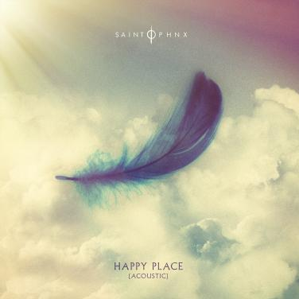
DOWNLOAD ARTWORK HERE

“A group whose creative approach to pop music is finding new paths towards melody.” – CLASH

Glasgow, Scotland-based alt-pop brother duo SAINT PHNX have released a stripped-back acoustic version of their rising single, “Happy Place.” A touching ode to their late father, “Happy Place” marked an impressive label debut for the acclaimed band. Listen to “Happy Place (Acoustic)” HERE.

“Happy Place” has received widespread support, both from the duo’s friends, including YUNGBLUD, Lewis Capaldi, Catie Turner, Jamie Miller, who all shared their happy places with the band (watch HERE), but also from publications such as American Songwriter which stated, “With a palpably uplifting energy, “Happy Place” has an incredibly unique vibe to it. With such a distinctive message of hope, grounded by the profound sadness of losing a parent, the song boasts an incredibly complex emotional palette, marrying the joys and sorrows of life into a single, beautiful expression.”

SAINT PHNX – a.k.a. Stevie and Alan Jukes – have earned millions of worldwide streams and spent much of the past decade in the studio or on the road, lighting up festivals and traveling alongside like-minded artists YUNGBLUD, Lewis Capaldi and Imagine Dragons.

2020 saw the acclaimed independent release of SAINT PHNX’s debut album, DDMN, with plans to be followed by the band’s biggest world tour thus far. Just as SAINT PHNX began to rise, the Jukes brothers’ dad was diagnosed with pulmonary fibrosis, a terminal lung condition. Though doctors encouraged a move to a warmer climate, he instead built a house in Scotland’s isolated Tinto Hills, turning the room above the garage into a studio where Stevie and Alan could write, record, and remain close to him. It was there that SAINT PHNX wrote and recorded “Happy Place” as their dad cheered them on.

When their father was sent to intensive care, the Jukes brothers were called in to say goodbye. They played him the nostalgic, stadium sized “Happy Place,” instilling him with pride before he passed away. Now SAINT PHNX are proud to share their song with the world.

DOWNLOAD PRESS PHOTOS HERE

# # #

CONNECT WITH SAINT PHNX
SAINTPHNX.COM | INSTAGRAM | TWITTER | FACEBOOK | YOUTUBE

For press inquiries, please contact:
Jessica Nall // Jessica.Nall@atlanticrecords.com

