FOR IMMEDIATE RELEASE

SEPTEMBER 17, 2021

**SAINT PHNX TAP DEEPEND FOR NEW SPIN ON “HAPPY PLACE”**

**ACCLAIMED GLASGOW-BASED TEAM UP WITH DUTCH DJ FOR UPBEAT REMIX ON**

**ATLANTIC RECORDS DEBUT SINGLE**

**MOVING AND UPLIFTING ODE TO THE ALT-POP BROTHER DUO’S LATE FATHER**

**INVITES EVERYONE TO THEIR HAPPY PLACE**

**LISTEN TO “HAPPY PLACE (DEEPEND REMIX)”** [**HERE**](https://saint-phnx.lnk.to/HappyPlaceDeependRemixPR)

**WATCH THE VISUALIZER** [**HERE**](https://SAINT-PHNX.lnk.to/HappyPlaceDeependRemixVisualizer)

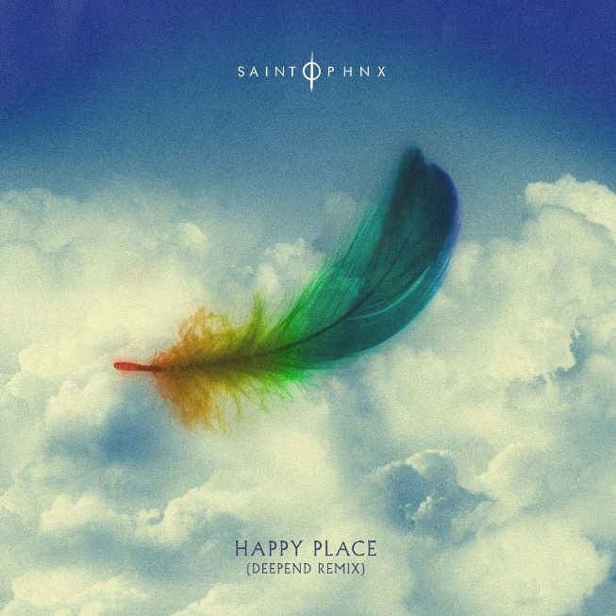

[**DOWNLOAD ARTWORK HERE**](https://press.atlanticrecords.com/saint-phnx)

***“A group whose creative approach to pop music is finding new paths towards melody.”* – CLASH**

Acclaimed Glasgow, Scotland-based alt-pop brother duo **SAINT PHNX** have tapped Dutch DJ **Deepend** (Ava Max, Robin Shultz) for a new spin on their touching ode to their late father, “**Happy Place (Deepend Remix)**” is available now [HERE](https://saint-phnx.lnk.to/HappyPlaceDeependRemixPR). The track is accompanied by a visualizer, streaming now [HERE](https://SAINT-PHNX.lnk.to/HappyPlaceDeependRemixVisualizer).

“[Happy Place](https://saint-phnx.lnk.to/HappyPlace)” arrived earlier this summer and received widespread support, from the duo’s friends, including **YUNGBLUD,** **Lewis Capaldi**, **Catie Turner**, **Jamie Miller**, who all shared their happy places with the band (watch [HERE](https://warnermusicgroup.app.box.com/s/n7vjsa1qldlzajfzrurm2hwwn8y0zghd/folder/138428232371)), as well as from publications such as **American Songwriter** which stated, *“With a palpably uplifting energy, “Happy Place” has an incredibly unique vibe to it. With such a distinctive message of hope, grounded by the profound sadness of losing a parent, the song boasts an incredibly complex emotional palette, marrying the joys and sorrows of life into a single, beautiful expression.”*

SAINT PHNX – a.k.a. **Stevie and Alan Jukes** – have earned millions of worldwide streams and spent much of the past decade in the studio or on the road, lighting up festivals and traveling alongside like-minded artists **YUNGBLUD, Lewis Capaldi** and **Imagine Dragons**.

Just as SAINT PHNX began to rise, the Jukes brothers’ dad was diagnosed with pulmonary fibrosis, a terminal lung condition. Though doctors encouraged a move to a warmer climate, he instead built a house in Scotland’s isolated Tinto Hills, turning the room above the garage into a studio where Stevie and Alan could write, record, and remain close to him. It was there that SAINT PHNX wrote and recorded “Happy Place” as their dad cheered them on.

When their father was sent to intensive care, the Jukes brothers were called in to say goodbye. They played him the nostalgic, stadium sized “Happy Place,” instilling him with pride before he passed away. Now SAINT PHNX are proud to share their song with the world.

[DOWNLOAD PRESS PHOTOS HERE](https://press.atlanticrecords.com/saint-phnx)

# # #

**CONNECT WITH SAINT PHNX**

[SAINTPHNX.COM](http://saintphnx.com/) | [INSTAGRAM](https://www.instagram.com/saintphnx/) | [TWITTER](https://twitter.com/saintphnx) | [FACEBOOK](https://www.facebook.com/saintphnx/) | [YOUTUBE](https://www.youtube.com/c/SAINTPHNX/featured)

For press inquiries, please contact:  
Jessica Nall // [Jessica.Nall@atlanticrecords.com](mailto:Jessica.Nall@atlanticrecords.com)