FOR IMMEDIATE RELEASE
DECEMBER 3, 2021

SAINT PHNX RECRUIT JASMINE THOMPSON FOR “HAPPY PLACE”

ACCLAIMED ALT-POP BROTHER DUO TAP ATLANTIC RECORDS LABELMATE FOR BEAUTIFUL RENDITION OF MOVING ODE TO THEIR LATE FATHER

TRACK FEATURED ON UPCOMING HAPPY PLACE EP OUT JANUARY 14, 2022
PRE-SAVE HERE

LISTEN TO “HAPPY PLACE (FEAT JASMINE THOMPSON)” HERE
WATCH THE PERFORMANCE VIDEO HERE
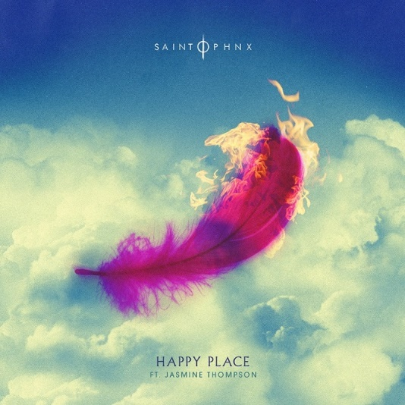
DOWNLOAD ARTWORK HERE

A touching ode to their late father, “Happy Place” marks an impressive Atlantic Records label debut for the acclaimed Glasgow, Scotland-based alt-pop brother duo SAINT PHNX and now they have recruited their friend Jasmine Thompson for a new version of the record which is streaming now HERE. The track comes with a beautiful performance video starring the band and Thompson, watch it now HERE.

The new rendition comes with the announcement of the duo’s upcoming Happy Place EP, due out January 14, 2022. The project will include rising track as well as a beautiful self-written holiday song “Peace,” which was released last month on Atlantic Records’ yearly holiday compilation. Pre-save the EP HERE.

“Happy Place” has received widespread support, both from the duo’s friends, including YUNGBLUD, Lewis Capaldi, Catie Turner, Jamie Miller, who all shared their happy places with the band (watch HERE), but also from publications such as American Songwriter which stated, “With a palpably uplifting energy, “Happy Place” has an incredibly unique vibe to it. With such a distinctive message of hope, grounded by the profound sadness of losing a parent, the song boasts an incredibly complex emotional palette, marrying the joys and sorrows of life into a single, beautiful expression.”

The rising track continues to grow, amassing over 7.8 million streams and currently charting in the top 20 on Shazam in multiple cities. Keeping up its momentum, daily streams of “Happy Place” continue to skyrocket in the UK and the track has been added to UK radio.

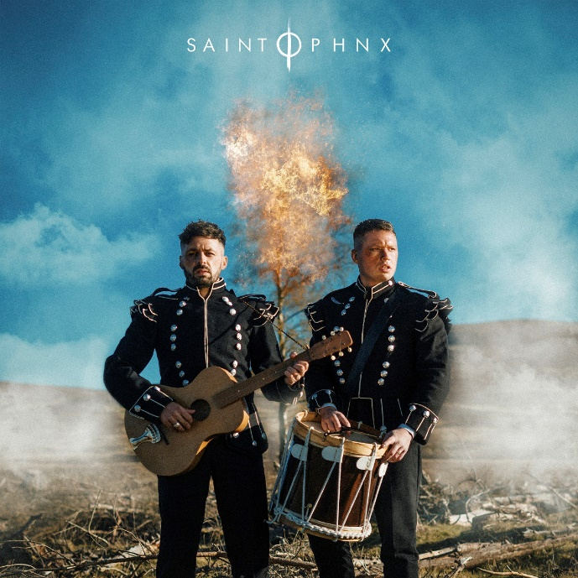

HAPPY PLACE EP TRACKLIST
- Happy Place
- Angel
- Invisible
- Blue Feather
- Peace
- Happy Place (ft. Jasmine Thompson)

ABOUT SAINT PHNX
A brotherly bond drives the music of SAINT PHNX. The Glasgow duo of Stevie and Alan Jukes feel everything twice as hard together. Those mutual feelings inform the pair’s skyscraping alternative pop uplifted by towering hooks, eloquent songcraft, and energetic instrumentation. Since 2016, they’ve hustled hard, performed countless gigs, and even touched down on U.S. soil to write in Las Vegas. The duo served up their single “KING” and eventually garnered over 19 million Spotify streams and counting. In between touring with Yungblud and opening for everyone from Lewis Capaldi to Imagine Dragons, they unveiled their independent full-length debut, DDMN, in 2020. In the middle of their international rise, their dad was diagnosed with pulmonary fibrosis, which is a terminal lung condition. The boys had initially encouraged him to move to a warmer client, but he chose to stay in Glasgow, bought land in the Tinto Hills, and built a house. He turned the room above the garage into a studio where Stevie and Alan wrote, recorded, and remained close to him. During this time, they recorded “Happy Place” as dad cheered them on. They played it for him on his death bed, and now it tells their story together on the grandest scale possible. After gathering tens of millions of streams, touring with some of the biggest bands in the world, and receiving acclaim from Clash, Alternative Press, and more, the group welcome everyone into their family on a series of 2021 singles for Atlantic Records.

CONNECT WITH SAINT PHNX
SAINTPHNX.COM | INSTAGRAM | TWITTER | FACEBOOK | YOUTUBE

ABOUT JASMINE THOMPSON
Jasmine’s booming YouTube presence and captivating vocals helped lead to a major label deal with Atlantic Records at the age of just 13. Now 21, the London-based singer-songwriter has enjoyed a musical growth that’s taken her from viral covers to her own WONDERLAND and COLOUR EPs. Thompson kicked off summer 2021 with the acclaimed single “already there,” which was soon followed by “after goodbye” and the joyful “happy for you.” Most recently, Jasmine Thompson joined forces with multi-platinum-selling, chart-topping UK singer-songwriter Calum Scott for the heartfelt new single “love is just a word,” joined by an official music video directed by Jackson Ducasse (Dua Lipa, New Order) and streaming now at YouTube HERE. Since her debut, Thompson has become even more beloved, earning more than 3B global streams and over 5M monthly Spotify listeners worldwide. Her blockbuster YouTube channel has also grown by leaps and bounds, accruing over 680M YouTube views and more than 3.6M subscribers thus far.

Along with her acclaimed solo work, Thompson has made chart-topping appearances on a pair of global blockbuster hit singles. Her collaboration with German DJ/producer Robin Schulz on “Sun Goes Down (Feat. Jasmine Thompson)” earned 1B worldwide streams along with a slew of international gold and platinum certifications and Top 5 and Top 10 chart runs in Europe, Australia, and South America. German DJ Felix Jaehn’s billion-streaming “Ain’t Nobody (Loves Me Better)” remix was an even greater smash, ascending to the top 10 on the iTunes Store’s “Top Dance Songs” chart while earning gold and platinum certifications in a range of countries. 2020 saw Thompson teaming with GRAMMY® award-winning artist/DJ/producer Zedd for the hit single, “Funny,” available now at all DSPs and streaming services HERE. Currently boasting over 230M global streams to date, the track is joined by an official companion video streaming now via YouTube HERE.

CONNECT WITH JASMINE THOMPSON
WEBSITE | TWITTER | YOUTUBE | FACEBOOK | INSTAGRAM | ATLANTIC RECORDS

# # #

For press inquiries, please contact:
Jessica Nall // Jessica.Nall@atlanticrecords.com

