FOR IMMEDIATE RELEASE
OCTOBER 29, 2021

SAINT PHNX SEARCH FOR “PEACE”

ATLANTIC RECORDS GLASGOW-BASED DUO RELEASE SELF-WRITTEN HOLIDAY SONG

TRACK PART OF ATLANTIC RECORDS’ HOLIDAY COMPILATION

LISTEN TO “PEACE” HERE
WATCH THE LYRIC VIDEO HERE
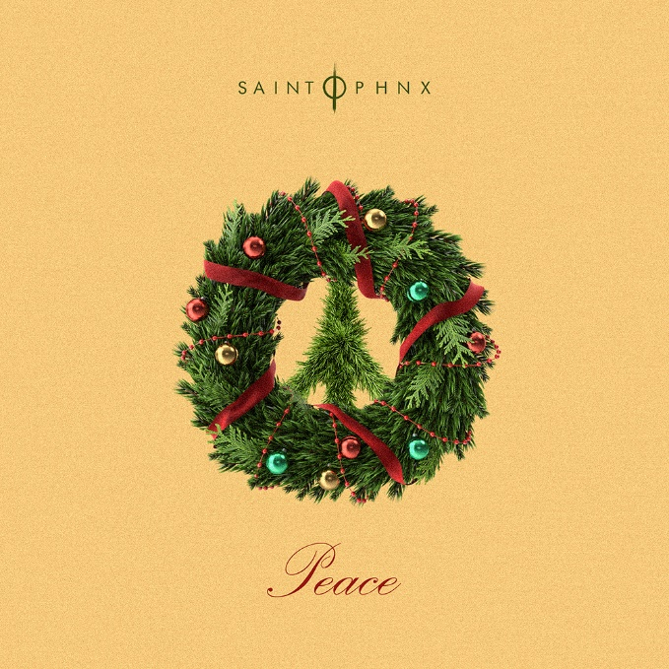
DOWNLOAD ARTWORK HERE

Acclaimed Glasgow, Scotland-based alt-pop brother duo SAINT PHNX have released their self-written holiday song, “Peace,” available now HERE. Part of Atlantic Records’ yearly holiday compilation, the track describes finding peace in this crazy world. “Peace” arrives today with a lyric video HERE.

The duo’s label-debut single, “Happy Place,” arrived earlier this year and received widespread support, from the duo’s friends, including YUNGBLUD, Lewis Capaldi, Catie Turner, Jamie Miller, who all shared their happy places with the band (watch HERE), as well as from publications such as American Songwriter which stated, “With a palpably uplifting energy, “Happy Place” has an incredibly unique vibe to it. With such a distinctive message of hope, grounded by the profound sadness of losing a parent, the song boasts an incredibly complex emotional palette, marrying the joys and sorrows of life into a single, beautiful expression.”

The moving track continues to grow, amassing over 5.8 million streams and is currently charting in the top 20 on Shazam in multiple cities across Scotland. Keeping up its momentum, daily streams of “Happy Place” grew 39% in the UK in just this past week and has been added to UK radio.

SAINT PHNX – a.k.a. Stevie and Alan Jukes – have earned millions of worldwide streams and spent much of the past decade in the studio or on the road, lighting up festivals and traveling alongside like-minded artists YUNGBLUD, Lewis Capaldi and Imagine Dragons.

DOWNLOAD PRESS PHOTOS HERE

# # #

CONNECT WITH SAINT PHNX
SAINTPHNX.COM | INSTAGRAM | TWITTER | FACEBOOK | YOUTUBE

For press inquiries, please contact:
Jessica Nall // Jessica.Nall@atlanticrecords.com

