SURF CURSE DEBUT TRAVIS BARKER REMIX OF “FREAKS”
KILO KISH AND BRUTUS VIII ALSO OFFER NEW VERSIONS
LISTEN HERE
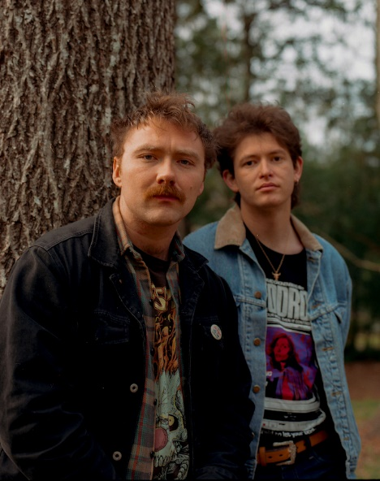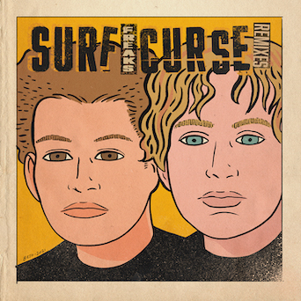
Press photo: Julien Sage, Artwork: Gilbert Hernandez
November 5, 2021—L.A. duo Surf Curse debut three remixes of their wildly popular track “Freaks” today—listen to new versions featuring Travis Barker, Kilo Kish and Brutus VIII here and check out the cover art by legendary cartoonist Gilbert Hernandez above.
“Freaks”—originally independently released on their 2013 LP Buds and a rapturous fan favorite at sold out shows worldwide since—has taken the world by storm this year: exploding on TikTok, hitting the Top 10 at Alternative Radio, climbing charts at Spotify and racking up more than 300 million streams worldwide. Watch the self-directed video, which debuted earlier this year, here.
While a surprise, the new attention to the track has been welcomed by the duo of Nick Rattigan and Jacob Rubeck, who made a much-lauded live return this fall with two very special, intimate shows at the Masonic Lodge at Hollywood Forever in Los Angeles and Warsaw in Brooklyn. Currently in the studio, more music and a proper return to the road are imminent.
Surf Curse is the duo of Nick Rattigan (drums, vocals) and Jacob Rubeck (guitar, vocals). First meeting in middle school in their hometown of Las Vegas, Nevada, Rattigan and Rubeck called their collaboration a number of names (Buffalo 66, named for the Vincent Gallo film, was a highlight) before forming Surf Curse after a move to Reno so Rattigan could attend college there. In between Rattigan’s classes and Rubeck’s shifts as a dishwasher at a senior center, the two made ten-hour drives to LA for gigs at iconic DIY venues like The Smell downtown. Eventually relocating to LA, they’ve since released three acclaimed albums—2013’s Buds, 2017’s Nothing Yet (both recorded in a single week at The Smell) and 2019’s Heaven Surrounds You, produced by Jarvis Taveniere of Woods. They’ve gone on to tour worldwide, with a rabid and dedicated international fanbase.

