FOR IMMEDIATE RELEASE
MARCH 1, 2022

SIR CHLOE SEARCH FOR “MERCY”

RISING GARAGE-ROCK BAND FOLLOW BREAKTHROUGH HIT, “MICHELLE,”
WITH CATHARTIC NEW SINGLE

SIR CHLOE ANNOUNCE NORTH AMERICAN HEADLINE TOUR KICKING OFF AT
NEW YORK’S LEGENDARY BOWERY BALLROOM ON MAY 6, 2022
+ US TOUR SUPPORTING ALT-J & PORTUGAL. THE MAN CURRENTLY UNDERWAY

LISTEN TO “MERCY” HERE
WATCH THE LYRIC VIDEO HERE
DOWNLOAD ARTWORK + PRESS PHOTO HERE

Acclaimed garage-rock band Sir Chloe has shared their eagerly awaited new single, “Mercy.” Produced by GRAMMY® Award-winner John Congelton (St. Vincent, Sharon Van Etten) and mastered by Heba Kadry (Big Thief, Courtney Barnett), “Mercy” sees the New York-based band unleashing an instant spooky rock classic about grief. Kicking off with lead singer, guitarist, songwriter, and multi-instrumentalist Dana Foote alone on vocals and guitar, the song soon builds into an eruption of vicious, desperate catharsis. Stream “Mercy” now HERE and watch the lyric video HERE.

Sir Chloe will celebrate “Mercy” on their first headline North American tour, set to begin on May 6 at New York’s legendary Bowery Ballroom. The band is currently on tour supporting alt-J and Portugal. The Man on their North American co-headline tour. For updates and ticket availability, please see www.sirchloemusic.com.

“Mercy” follows Sir Chloe’s acclaimed EP, Party Favors, still boasting over 1.5M weekly streams more than one year after its initial 2020 release. The EP is highlighted by the breakthrough hit single, “Michelle,” which has proven an undisputed smash with more than 275K TikTok video creates and over 150M streams thus far in the US alone.

ABOUT SIR CHLOE
Sir Chloe was born and raised in a yellow house. Formerly a knife salesman, she learned to play guitar by eating one of her fathers guitar picks. She began to write songs after repeatedly dreaming of choirs of dogs.

Sir Chloe debuted on Atlantic Records in early 2022 with “Mercy,” a song about grief. Produced by John Congelton (St. Vincent, Sharon Van Etten) and mastered by Heba Kadry (Big Thief, Courtney Barnett), the track is disrespectful in tone but inquisitive in lyrics. Sir Chloe’s debut full-length record is due the moment it comes out.

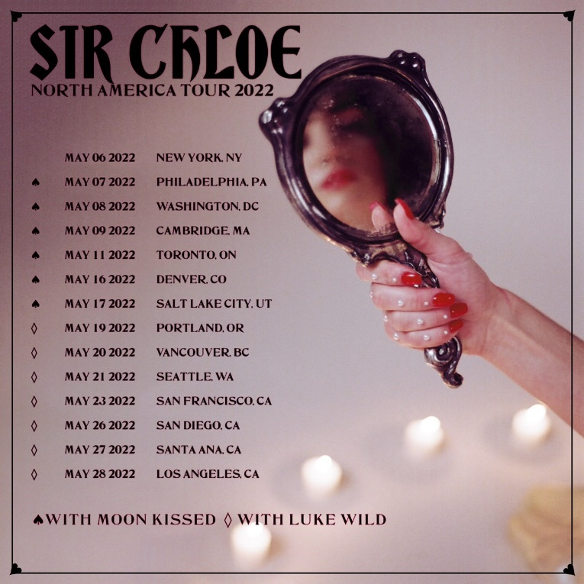

SIR CHLOE ON TOUR

MARCH 2022
1 – Nashville, TN – Nashville Municipal Auditorium *
2 – Atlanta, GA – State Farm Arena *
4 – Tampa, FL – Yuengling Center *
5 – Hollywood, FL – Seminole Hard Rock Hollywood *
6 – Orlando, FL – Orlando Amphitheater *
9 – Dallas, TX – The Factory in Deep Ellum *
10 – Dallas, TX – The Factory in Deep Ellum *
12 – Austin, TX – Germania Insurance Amphitheater *
13 – Houston, TX – White Oak Music Hall *
15 - St Louis, MO – Chaifetz Arena *
16 – Detroit, MI – Masonic Temple Detroit *
17 – Milwaukee, WI – UW-M Panther Arena *
19 – Chicago, IL – Credit Union 1 Arena *
20 – Minneapolis, MN – The Armory *
21 – Omaha, NE – Baxter Arena * (w/o Portugal. The Man)

MAY 2022
6 – New York, NY – The Bowery Ballroom
7 – Philadelphia, PA – Johnny Brenda's
8 – Washington, DC – Songbyrd Music House & Record Cafe
9 – Cambridge, MA – The Sinclair
11 – Toronto, Ontario – The Garrison
12 – Chicago, IL – Subterranean
14 – Saint Paul, MN – Turf Club
16 – Denver, CO – Meow Wolf
17 – Salt Lake City, UT – Kilby Court
19 – Portland, OR – Polaris Hall
20 – Vancouver, BC – Fox Cabaret
21 – Seattle, WA – Barboza
23 – San Francisco, CA – August Hall
26 – San Diego, CA – Quartyard
27 – Santa Ana, CA – Constellation Room
28 – Los Angeles, CA – The Regent Theater

* w/alt-J & Portugal. The Man

# # #

CONNECT WITH SIR CHLOE
OFFICIAL | FACEBOOK | INSTAGRAM | TWITTER | SPOTIFY | YOUTUBE

For press inquiries, please contact:
Jessica Nall / Jessica.Nall@atlanticrecords.com
Libby Kober / Libby.Kober@atlanticrecords.com

