SURF CURSE UNVEILS NEW SINGLE “SUGAR” + VIDEO

FIRST TASTE OF FORTHCOMING
NEW ALBUM
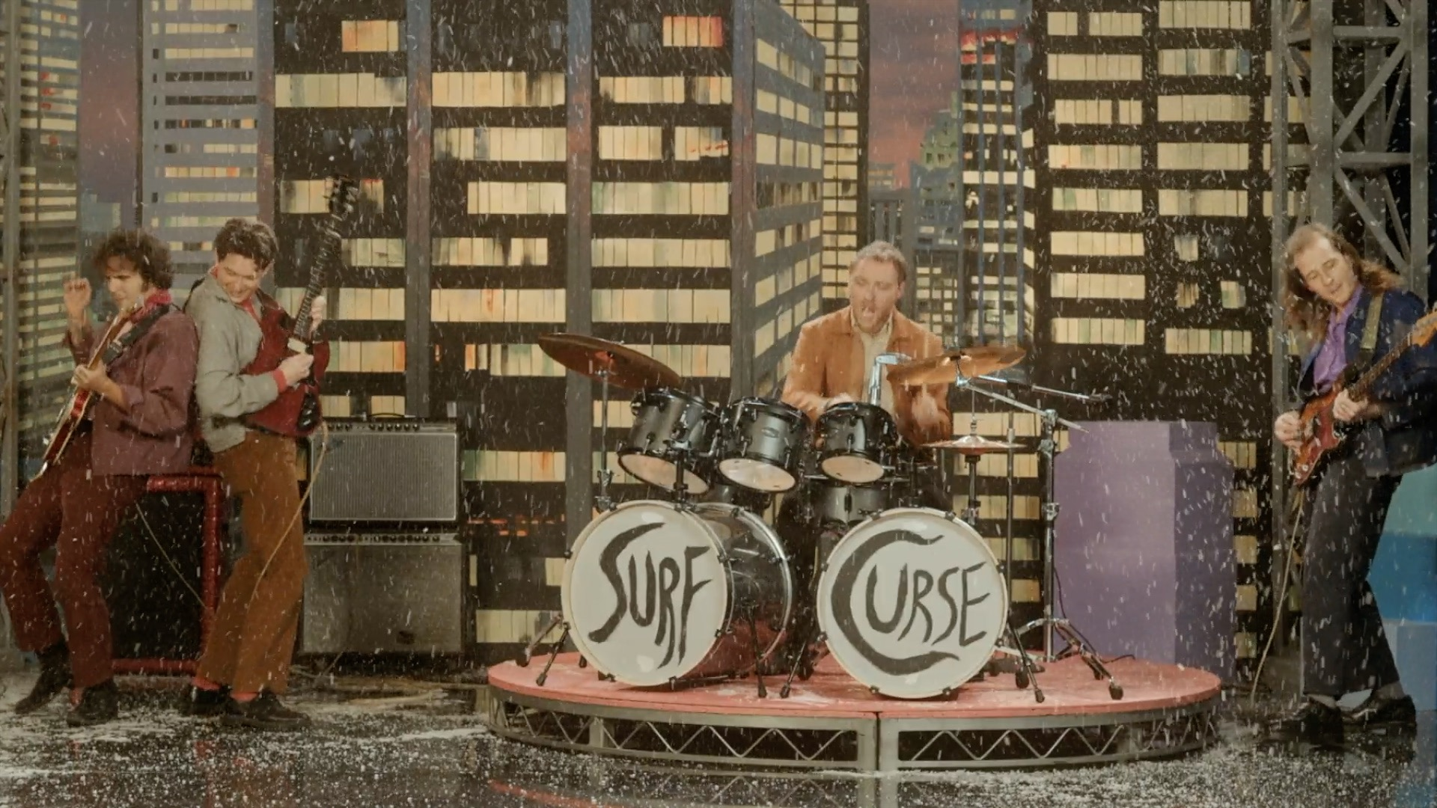
Music video still

March 30, 2022—L.A. DIY stars Surf Curse debut a new single, “Sugar,” today alongside a video directed by principal members Nick Rattigan and Jacob Rubeck—listen here and watch here. The track is the first taste of the band’s forthcoming fourth LP, set for release later this year.

“Sugar” was produced and mixed by Chris Coady (Yeah Yeah Yeahs, Beach House, Sasami) and recorded between New York’s iconic Electric Lady Studios and L.A.’s EastWest.

The new music follows a monumental 2021 for the band, which saw their track “Freaks”—originally independently released on their 2013 LP Buds and a rapturous fan favorite at sold out shows worldwide since—take the world by storm: exploding on TikTok, hitting the Top 15 at Alternative Radio, climbing charts at Spotify and racking up more than TK million streams worldwide.

Surf Curse will bring their wildly acclaimed live show back to the road this year with sets confirmed at Coachella and Governors Ball plus very special headline dates in London, Paris and Berlin this summer. More festivals and a full worldwide headline run are to be announced.

Surf Curse is Nick Rattigan (drums, vocals) and Jacob Rubeck (guitar, vocals), Henry Dillon (bass) and Noah Kohll (guitar). First meeting in their hometown of Las Vegas as middle schoolers, principal duo Rattigan and Rubeck called their collaboration a number of names (Buffalo 66, named for the Vincent Gallo film, was a highlight) before settling on Surf Curse after a move to Reno so Rattigan could attend college there. In between Rattigan’s classes and Rubeck’s shifts as a dishwasher at a senior center, the two made ten-hour drives to LA for gigs at iconic DIY venues like The Smell downtown. Eventually relocating to LA, they’ve since released three acclaimed albums—2013’s Buds, 2017’s Nothing Yet (both recorded in a single week at The Smell) and 2019’s Heaven Surrounds You, produced by Jarvis Taveniere of Woods. They’ve gone on to tour worldwide, with a rabid and dedicated international fanbase. Now signed to Atlantic Records, their fourth LP is imminent.

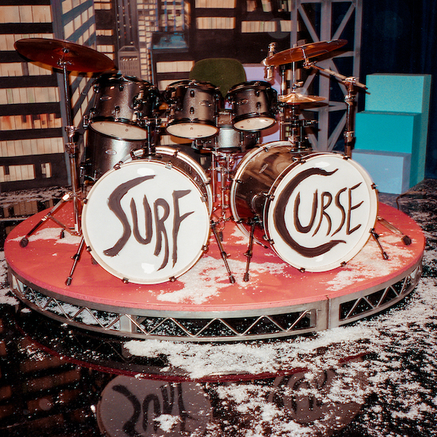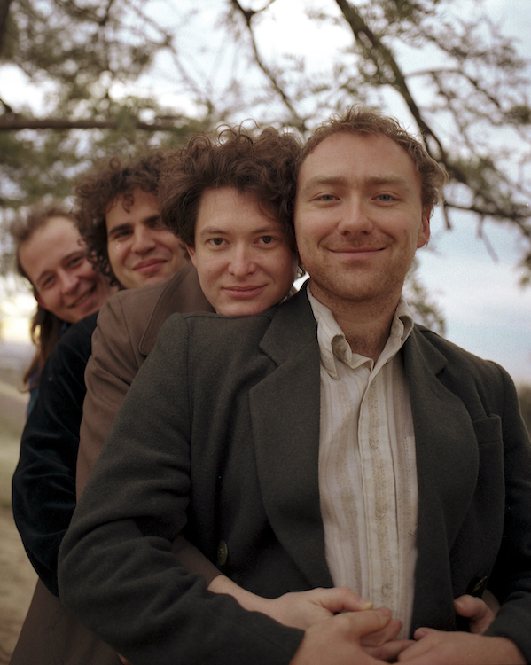
Single art, press photo (L-R: Henry Dillon, Noah Kohll, Jacob Rubeck, Nick Rattigan). Credit: Julien Sage

For press inquiries, please contact:
Jessica Nall // Jessica.Nall@atlanticrecords.com

