FOR IMMEDIATE RELEASE
AUGUST 5, 2021
SURF CURSE DEBUT “FREAKS” VIDEO
BREAKOUT TRACK CLIMBING AT ALTERNATIVE RADIO, MORE THAN
200 MILLION STREAMS TO DATE
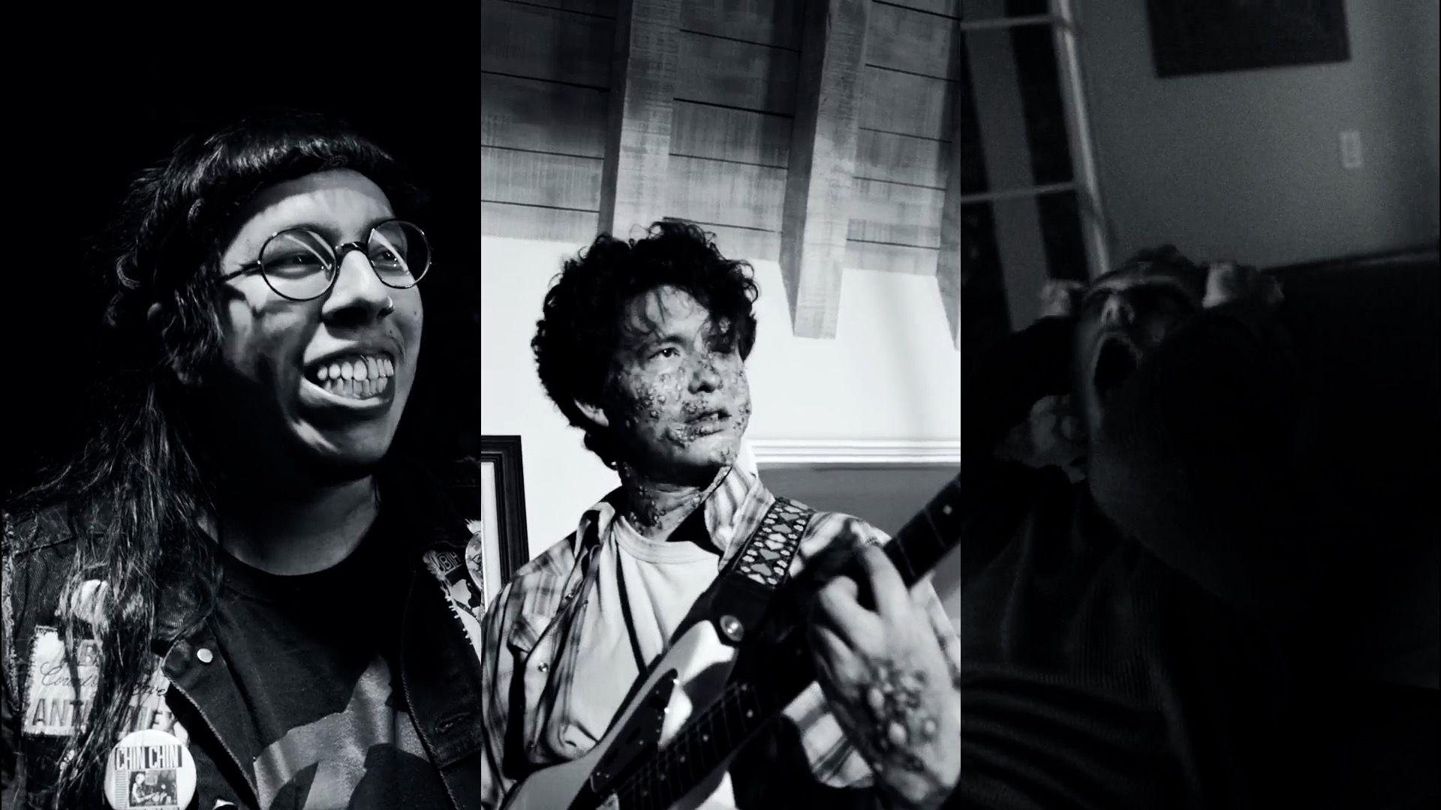
Photo credit: Julien Sage
August 5, 2021—Acclaimed L.A. duo Surf Curse debuts their self-directed video for “Freaks” today—watch it here. The track—originally independently released on their 2013 LP Buds and a rapturous fan favorite at sold out shows worldwide since— has had a second wind in recent months thanks to TikTok. It’s climbing the charts at Alternative radio and on digital platforms and has been streamed more than 200 million times to date worldwide.
"We never had any intention to make a music video for “Freaks,” but when the opportunity occurred we knew what it needed to be,” says the band. “We had to make a video set in Charles Burns’ Black Hole world, which originally inspired the song. We were lucky to cast our friends and put them in this mutant makeup. We were lucky to capture great moments on film and had an opportunity to make an ode to a graphic novel that heavily inspired us.”
The band will play two very special, intimate shows this fall: September 16 at the Masonic Lodge at Hollywood Forever in Los Angeles, which sold out in minutes, and September 30 at Warsaw in Brooklyn. Visit surfcurse.com for full details.
Surf Curse is the duo of Nick Rattigan (drums, vocals) and Jacob Rubeck (guitar, vocals). First meeting in middle school in their hometown of Las Vegas, Nevada, Rattigan and Rubeck called their collaboration a number of names (Buffalo 66, named for the Vincent Gallo film, was a highlight) before forming Surf Curse after a move to Reno so Rattigan could attend college there. In between Rattigan’s classes and Rubeck’s shifts as a dishwasher at a senior center, the two made ten-hour drives to LA for gigs at iconic DIY venues like The Smell downtown. Eventually relocating to LA, they’ve since released three acclaimed albums—2013’s Buds, 2017’s Nothing Yet (both recorded in a single week at The Smell) and 2019’s Heaven Surrounds You, produced by Jarvis Taveniere of Woods. They’ve gone on to tour worldwide, with a rabid and dedicated international fanbase. Now signed to Atlantic Records, new music from the band is forthcoming.
SURF CURSE LIVE
September 16 Masonic Lodge at Hollywood Forever Los Angeles, CA*
September 30 Warsaw Brooklyn, NY
*SOLD OUT
For more information, please contact:
Jessica Nall // Jessica.Nall@atlanticrecords.com

