**SYMBA TAPS 2 CHAINZ FOR “BIG HOMIE”**

**NEW COLLABORATION ARRIVES ALONGSIDE MECCA DON-DIRECTED COMPANION VISUAL**

**#DontRunFromRap**

[**WATCH “BIG HOMIE (FEAT. 2 CHAINZ)” HERE**](https://nam04.safelinks.protection.outlook.com/?url=https%3A%2F%2Ftherealsymba.lnk.to%2FBigHomieVideo&data=04%7C01%7CBrian.Sommer%40atlanticrecords.com%7Cdfe8854e04fa448aea8b08d877611c39%7C8367939002ec4ba1ad3d69da3fdd637e%7C0%7C0%7C637390606249483248%7CUnknown%7CTWFpbGZsb3d8eyJWIjoiMC4wLjAwMDAiLCJQIjoiV2luMzIiLCJBTiI6Ik1haWwiLCJXVCI6Mn0%3D%7C1000&sdata=yiu7PwjnJklyqkaMIUn0ncVQH3Y4qRqaCP616ahuHCs%3D&reserved=0)

[“Big Homie” produced by: Caston Grigsby]



*“A ‘Big Homie’ is someone who doesn’t let those who look up to him make the same mistakes he has. He doesn’t just give game, he provides another way. He provides access to a better situation for those who he takes under his wing. Shout out to the big bro Chainz, who I’ve always looked up to as an artist and as a figure in the culture but in the little time we’ve been in actual contact, he’s given me a lot of advice that only a Big Homie can give. It’s just an honor to have him on this record and on my upcoming mixtape.”*

**-SYMBA**

*“Dallas [Martin] first introduced me to Symba while we were working on my TRU’s compilation album ‘No Face No Case.’ I could see Symba’s ambition and drive, so when he sent ‘Big Homie’ it was a no brainer. Always wanna be an early supporter.”*

**-2 CHAINZ**

[**LISTEN TO “BIG HOMIE (FEAT. 2 CHAINZ)” HERE**](https://nam04.safelinks.protection.outlook.com/?url=https%3A%2F%2Ftherealsymba.lnk.to%2FBigHomie&data=04%7C01%7CBrian.Sommer%40atlanticrecords.com%7Cdfe8854e04fa448aea8b08d877611c39%7C8367939002ec4ba1ad3d69da3fdd637e%7C0%7C0%7C637390606249493248%7CUnknown%7CTWFpbGZsb3d8eyJWIjoiMC4wLjAwMDAiLCJQIjoiV2luMzIiLCJBTiI6Ik1haWwiLCJXVCI6Mn0%3D%7C1000&sdata=GHy%2FzcUj17V1SRxvq66JEuLw3kqoIovexGLuiu2g1bU%3D&reserved=0)

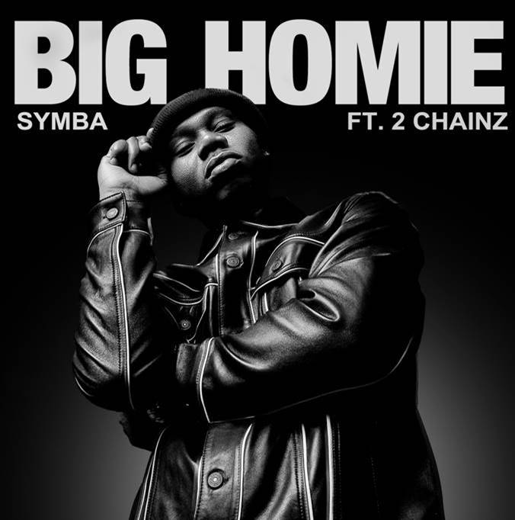

[**WATCH VIDEO FOR “I’M 4REAL”**](https://nam04.safelinks.protection.outlook.com/?url=https%3A%2F%2Fwww.youtube.com%2Fwatch%3Fv%3DFkiM_urrGEw&data=04%7C01%7CBrian.Sommer%40atlanticrecords.com%7Cdfe8854e04fa448aea8b08d877611c39%7C8367939002ec4ba1ad3d69da3fdd637e%7C0%7C0%7C637390606249493248%7CUnknown%7CTWFpbGZsb3d8eyJWIjoiMC4wLjAwMDAiLCJQIjoiV2luMzIiLCJBTiI6Ik1haWwiLCJXVCI6Mn0%3D%7C1000&sdata=28PGrUVfJtKAaY%2FVjQIwQINBMXF6a5kDlo8dC8a4AV0%3D&reserved=0)

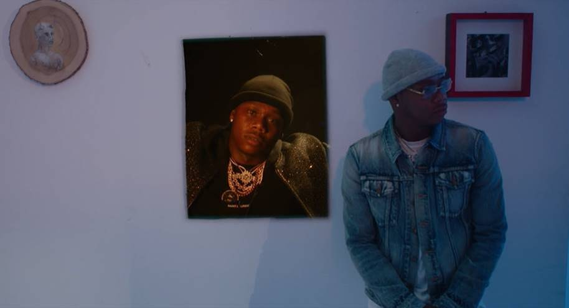

* * *

**+ WATCH SYMBA PROVE WHY HE’S UP NEXT WITH THESE RECENT FREESTYLES:**

[***“BROKE IN A MINUTE,”***](https://nam04.safelinks.protection.outlook.com/?url=https%3A%2F%2Ftherealsymba.lnk.to%2FBrokeInAMinuteFreestyle&data=04%7C01%7CBrian.Sommer%40atlanticrecords.com%7Cdfe8854e04fa448aea8b08d877611c39%7C8367939002ec4ba1ad3d69da3fdd637e%7C0%7C0%7C637390606249503235%7CUnknown%7CTWFpbGZsb3d8eyJWIjoiMC4wLjAwMDAiLCJQIjoiV2luMzIiLCJBTiI6Ik1haWwiLCJXVCI6Mn0%3D%7C1000&sdata=WE0GZR9ifjivRxAH9fAB7qW%2BE%2BFFOwoRPAY8h3myJcg%3D&reserved=0)[***“NOTHIN TO LOSE,”***](https://nam04.safelinks.protection.outlook.com/?url=https%3A%2F%2Fwww.youtube.com%2Fwatch%3Fv%3DWdHi158jmWU&data=04%7C01%7CBrian.Sommer%40atlanticrecords.com%7Cdfe8854e04fa448aea8b08d877611c39%7C8367939002ec4ba1ad3d69da3fdd637e%7C0%7C0%7C637390606249513229%7CUnknown%7CTWFpbGZsb3d8eyJWIjoiMC4wLjAwMDAiLCJQIjoiV2luMzIiLCJBTiI6Ik1haWwiLCJXVCI6Mn0%3D%7C1000&sdata=oU0HLrw%2Fye3qUuIlAUj6I%2B81R4%2F4D4FovpS1RklI1dA%3D&reserved=0)[***“COLD SUMMER”***](https://nam04.safelinks.protection.outlook.com/?url=https%3A%2F%2Fwww.instagram.com%2Ftv%2FB-nLgtLlOUI%2F%3Futm_source%3Dig_web_copy_link&data=04%7C01%7CBrian.Sommer%40atlanticrecords.com%7Cdfe8854e04fa448aea8b08d877611c39%7C8367939002ec4ba1ad3d69da3fdd637e%7C0%7C0%7C637390606249513229%7CUnknown%7CTWFpbGZsb3d8eyJWIjoiMC4wLjAwMDAiLCJQIjoiV2luMzIiLCJBTiI6Ik1haWwiLCJXVCI6Mn0%3D%7C1000&sdata=atOrNZAMoXwN1SXhAFSXK%2BXiJIzFVoUhJX3w6itMkLs%3D&reserved=0) ***&*** [***“WHAT’S CRACKIN”***](https://nam04.safelinks.protection.outlook.com/?url=https%3A%2F%2Ftherealsymba.lnk.to%2FWhatsCrackinVideo&data=04%7C01%7CBrian.Sommer%40atlanticrecords.com%7Cdfe8854e04fa448aea8b08d877611c39%7C8367939002ec4ba1ad3d69da3fdd637e%7C0%7C0%7C637390606249523220%7CUnknown%7CTWFpbGZsb3d8eyJWIjoiMC4wLjAwMDAiLCJQIjoiV2luMzIiLCJBTiI6Ik1haWwiLCJXVCI6Mn0%3D%7C1000&sdata=b8vVAEbs5RwYphp0J4DEq0W2%2Bk5XnUzQDAuJTZsErII%3D&reserved=0)

* * *

***ABOUT SYMBA:***

Inspired by everyone from JAY-Z to Steve Stoute and Steve Jobs, Bay Area-born and Los-Angeles based rapper Symba dove headfirst into the rap game following a rough upbringing. After a series of collaborations with Young Curt took off in the Bay, he headlined early Los Angeles shows on bills with the likes of YG, Tyga, and DJ Mustard as early as 2010. Symba struggled financially while recording, but eventually connected with friend and producer Nic Nac [Chris Brown, Kevin Gates] who encouraged him to move down to L.A. Upon arriving in the City of Angels, he turned heads with the *2 More Words* mixtape in 2015, boasting collaborations with the likes of Marc E. Bassy and IamSu!. In addition to praise from *XXL*, *Hypebeast* dubbed it, *“a fiery collection of songs balancing club-ready hooks with deft, incisive narratives*.*”* His grind paid off, and he inked a short-lived deal in 2017. A meeting with producer Cas inspired the next move.

Early demos caught the attention of Atlantic Records who signed him during 2019. Now, his most recent singles with Atlantic Records, “Serve,” “Birds In The Bando” and “I’m 4Real” chronicle some of the key experiences of his life, including his trapping lessons with his uncle. Returning now with his new track, “Big Homie,” Symba is making it known that he still lives for the hustle.

[**DOWNLOAD APPROVED PRESS IMAGE HERE**](https://nam04.safelinks.protection.outlook.com/?url=http%3A%2F%2Fpress.atlanticrecords.com%2Fsymba%2F&data=04%7C01%7CBrian.Sommer%40atlanticrecords.com%7Cdfe8854e04fa448aea8b08d877611c39%7C8367939002ec4ba1ad3d69da3fdd637e%7C0%7C0%7C637390606249523220%7CUnknown%7CTWFpbGZsb3d8eyJWIjoiMC4wLjAwMDAiLCJQIjoiV2luMzIiLCJBTiI6Ik1haWwiLCJXVCI6Mn0%3D%7C1000&sdata=%2BCu7B%2Bl7AY7X2kfEZiJHLoV%2BkRqjP4jHam%2FmkdwB4zo%3D&reserved=0)

[Photo Credit: Jimmy Fontaine]



**CONNECT WITH SYMBA:** [INSTAGRAM](https://nam04.safelinks.protection.outlook.com/?url=https%3A%2F%2Fwww.instagram.com%2Ftherealsymba%2F%3Fhl%3Den&data=04%7C01%7CBrian.Sommer%40atlanticrecords.com%7Cdfe8854e04fa448aea8b08d877611c39%7C8367939002ec4ba1ad3d69da3fdd637e%7C0%7C0%7C637390606249533212%7CUnknown%7CTWFpbGZsb3d8eyJWIjoiMC4wLjAwMDAiLCJQIjoiV2luMzIiLCJBTiI6Ik1haWwiLCJXVCI6Mn0%3D%7C1000&sdata=dNvjskyiFtJQSjw6XIGDkUjD5VRHssV5jbTHVNGzh3E%3D&reserved=0) | [TWITTER](https://nam04.safelinks.protection.outlook.com/?url=https%3A%2F%2Ftwitter.com%2Ftherealsymba%3Flang%3Den&data=04%7C01%7CBrian.Sommer%40atlanticrecords.com%7Cdfe8854e04fa448aea8b08d877611c39%7C8367939002ec4ba1ad3d69da3fdd637e%7C0%7C0%7C637390606249533212%7CUnknown%7CTWFpbGZsb3d8eyJWIjoiMC4wLjAwMDAiLCJQIjoiV2luMzIiLCJBTiI6Ik1haWwiLCJXVCI6Mn0%3D%7C1000&sdata=E8j0Y3haGdIZ13LJ6LNBPxDJG14Y5Z23jvgpL8xXbbc%3D&reserved=0) | [FACEBOOK](https://nam04.safelinks.protection.outlook.com/?url=https%3A%2F%2Fwww.facebook.com%2FTheRealSymba%2F&data=04%7C01%7CBrian.Sommer%40atlanticrecords.com%7Cdfe8854e04fa448aea8b08d877611c39%7C8367939002ec4ba1ad3d69da3fdd637e%7C0%7C0%7C637390606249543214%7CUnknown%7CTWFpbGZsb3d8eyJWIjoiMC4wLjAwMDAiLCJQIjoiV2luMzIiLCJBTiI6Ik1haWwiLCJXVCI6Mn0%3D%7C1000&sdata=pJylYAHF4KNDSTVr791sSF0i9ctZ%2BOdqSygpPyVNFGA%3D&reserved=0) | [YOUTUBE](https://nam04.safelinks.protection.outlook.com/?url=https%3A%2F%2Fwww.youtube.com%2Fuser%2FSymbaOnline&data=04%7C01%7CBrian.Sommer%40atlanticrecords.com%7Cdfe8854e04fa448aea8b08d877611c39%7C8367939002ec4ba1ad3d69da3fdd637e%7C0%7C0%7C637390606249553206%7CUnknown%7CTWFpbGZsb3d8eyJWIjoiMC4wLjAwMDAiLCJQIjoiV2luMzIiLCJBTiI6Ik1haWwiLCJXVCI6Mn0%3D%7C1000&sdata=i5unjbxd7BQOGiDrAArAmq2vnFmjdfxUrD7vVPmsfUk%3D&reserved=0) | [WEBSITE](https://nam04.safelinks.protection.outlook.com/?url=http%3A%2F%2Fofficialsymba.com%2F&data=04%7C01%7CBrian.Sommer%40atlanticrecords.com%7Cdfe8854e04fa448aea8b08d877611c39%7C8367939002ec4ba1ad3d69da3fdd637e%7C0%7C0%7C637390606249553206%7CUnknown%7CTWFpbGZsb3d8eyJWIjoiMC4wLjAwMDAiLCJQIjoiV2luMzIiLCJBTiI6Ik1haWwiLCJXVCI6Mn0%3D%7C1000&sdata=PiW0sUS7cybd4DVQfgZzaz2NvAVzM0%2FcUng1vOqXwgc%3D&reserved=0)

**PRESS CONTACT:** JASON DAVIS | [JASON.DAVIS@ATLANTICRECORDS.COM](mailto:JASON.DAVIS@ATLANTICRECORDS.COM)

# # #