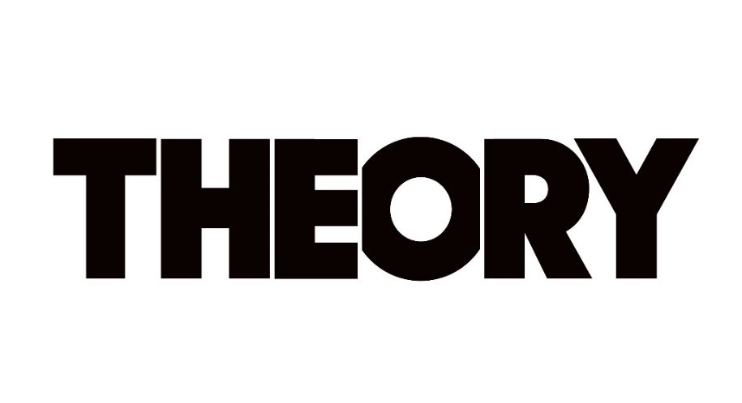
THEORY
New Studio Album Say Nothing
Out Now via Atlantic Records
PRESS HERE To Listen

Releases Official Music Video for “World Keeps Spinning”
PRESS HERE To Watch

Canadian Headlining Tour Kicks Off Tonight, January 31st
U.S. Dates Commence April 10th

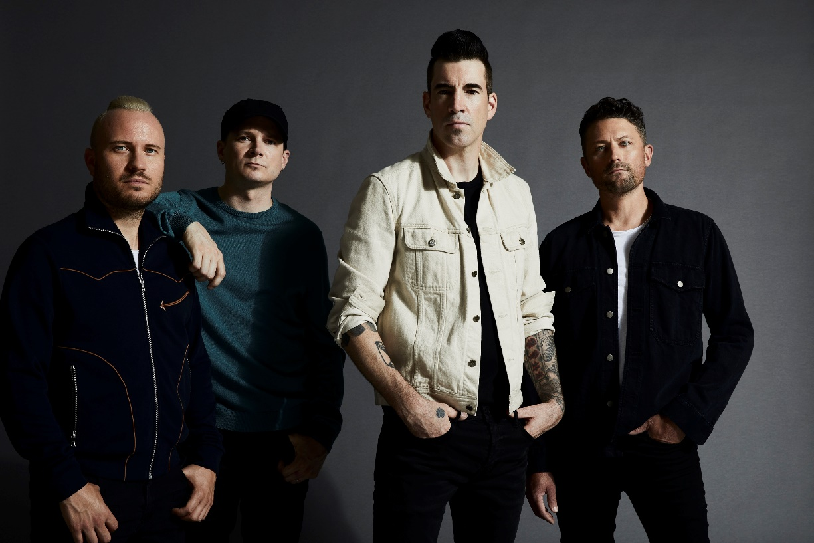
Photo Credit: Jimmy Fontaine

“[Say Nothing] The best album Theory has recorded to date.” – Glide Magazine

“A continuation of their sonic evolution, with Theory embracing the pillars of pop-rock…and intent on initiating a thoughtful conversation with their listeners.” – Alternative Press

“[‘Strangers’ is] a commanding anthem about the state of humanity…combining powerful lyrics with slick production and a rockin’ rhythm section.” – Parade

“…passionate and emotional…kudos to Theory Of A Deadman for tackling these issues and using their platform to do so…”
- CelebMix

“Not only has their sound evolved, their songwriting has put sometimes hard to talk about issues right at the forefront.”
– Sound Vapors

“[Theory] is back into making music with meaning.” – Alternative Addition

“There is a distinctly modern message to Theory’s material that meets the moment.” – Riff Magazine

“With the release of Say Nothing, Theory has proven they cannot be boxed into any one particular genre and have showcased incredible maturity and growth in both their musical and lyrical content.” – Music Mayhem Magazine

“The arrangements for each of the ten songs on Say Nothing are brilliant, matched with some of their most bold lyrics to date, and the irresistible vocals of Tyler Connolly…Say Nothing flows flawlessly.” – Cryptic Rock

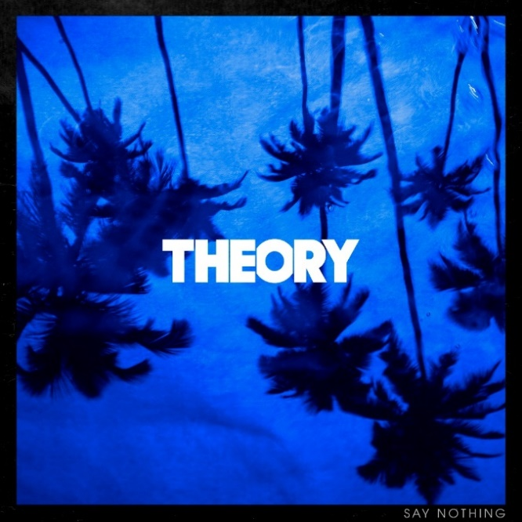
Los Angeles, CA – January 31, 2020 – Today, multi-platinum band THEORY (Theory Of A Deadman) has released their seventh studio album, Say Nothing. PRESS HERE to listen. The 10-track collection, available now via Atlantic Records, features the powerful lead single “History Of Violence,” which turns the tables on a story of domestic violence and is currently #3 at Active Rock Radio. PRESS HERE to watch the gripping video, illustrating a searing snapshot of a woman enduring an abusive husband as she plans to fight back, eventually ending up in jail but free of her abuser. Coinciding with the album’s release, THEORY – Tyler Connolly [lead vocals, guitar], Dave Brenner [guitar, backing vocals], Dean Back [bass], and Joey Dandeneau [drums, backing vocals] – has also dropped the official music video for “World Keeps Spinning,” a profoundly personal track written by Connolly about depression and anxiety. The new video was directed by Sam Sulam, who also helmed the video for “History Of Violence.” PRESS HERE to watch and check out the first story on the “World Keeps Spinning” video via Substream Magazine.

On Say Nothing, already being hailed their best album to date, THEORY is speaking up through timely lyrical commentary that finds the band’s finger on the pulse of the current climate and the issues that our society is grappling with today including domestic violence, racism, the divisiveness in American politics, and anxiety and depression, all threaded together with a message that’s both a cautionary warning and a hopeful wish for our collective future. With “History of Violence,” which has racked up more than 5 million collective streams, THEORY has been encouraging anyone affected by domestic abuse to call the National Domestic Violence Hotline (1-800-799-7233) for help. THEORY has also partnered with PLUS1 to donate $1 from every ticket sold for their upcoming U.S. tour to organizations dedicated to breaking the cycle of domestic violence and building a community free of abuse. Elsewhere on Say Nothing, the title track offers up a stark, emotional confessional about a communication breakdown in a relationship that ultimately leads to its demise and "Strangers" addresses the current tense state of American politics and the divisive nature of our culture, calling out how nasty it has become between those with differing political affiliations and our society’s increasing inability to openly listen and relate to one another.

With undeniable anthems, scorching songcraft, experimental vision, rock ‘n’ roll attitude, and clever pop ambition, THEORY peels back the layers of their depth and breadth like never before. Say Nothing, recorded in London with producer Martin Terefe [Jason Mraz, Yungblud], is a continuation of their musical and thematic evolution, displaying the band’s powerful storytelling in full force and introducing fresh sounds and sonics. See below for full tracklisting.

THEORY kicks off their “Say Nothing World Tour” tonight in their hometown of Vancouver with the first of two nights at The Commodore Ballroom. Their Canadian headlining outing will continue all month wrapping February 29th in Barrie, ON. Beginning April 9th, THEORY will launch their U.S. headlining cross-country spring tour, featuring special guest 10 Years, at the new Brooklyn Bowl Nashville. Tickets are on sale now; see below for the full list of upcoming tour dates and visit www.theoryofficial.com for all ticketing details.

Say Nothing is the follow-up to THEORY’s 2017 album Wake Up Call, which featured their platinum single “Rx (Medicate).” Addressing the opioid epidemic, “Rx” racked up more than 250 million streams, became their third #1 on the Billboard Hot Mainstream Rock Tracks chart, and received an iHeartRadio Music Award nomination for Rock Song of the Year. Over the course of nearly two decades, THEORY’s impressive catalogue has earned them several platinum and gold singles, a platinum album, two Top 10 album debuts on the Billboard Top 200, and eight Top Tens on the Billboard Hot Mainstream Rock Tracks Chart.

SAY NOTHING TRACKLISTING
- Black Hole In Your Heart
- History Of Violence
- Affluenza
- Say Nothing
- Strangers
- Ted Bundy
- World Keeps Spinning
- Quicksand
- White Boy
- It’s All Good

THEORY – UPCOMING TOUR DATES
Canada
Friday, January 31 Vancouver, BC @ The Commodore Ballroom
Saturday, February 1 Vancouver, BC @ The Commodore Ballroom
Monday, February 3 Kelowna, BC @ Kelowna Community Theatre
Tuesday, February 4 Cranbrook, BC @ Western Financial Place
Thursday, February 6 Grand Prairie, AB @ Bowes Event Center
Friday, February 7 Edmonton, AB @ Winspear Center
Saturday, February 8 Calgary, AB @ Grey Eagle Event Centre
Monday, February 10 Medicine Hat, AB @ Canalta Centre
Tuesday, February 11 Saskatoon, SK @ Coors Event Centre
Thursday, February 13 Regina, SK @ Casino Regina
Friday, February 14 Winnipeg, MB @ Club Regent
Sunday, February 16 Sault Saint Marie, ON @ Sault Community Theatre
Monday, February 17 Sarnia, ON @ Imperial Theatre
Tuesday, February 18 London, ON @ London Music Hall
Friday, February 21 Halifax, NS @ Casino Nova Scotia
Saturday, February 22 Moncton, NB @ Casino New Brunswick
Monday, February 24 Ottawa, ON @ Bronson Centre
Tuesday, February 25 Guelph, ON @ Guelph Concert Theatre
Thursday, February 27 Toronto, ON @ Rebel
Friday, February 28 Montreal, QC @ MTELUS
Saturday, February 29 Barrie, ON @ Mavericks
United States
Thursday, April 9 Nashville, TN @ Brooklyn Bowl Nashville
Friday, April 10 Columbus, OH @ Newport Music Hall
Saturday, April 11 Louisville, KY @ Old Forester’s Paristown Hall
Monday, April 13 Huntsville, AL @ Mars Music Hall
Tuesday, April 14 Mobile, AL @ Soul Kitchen
Wednesday, April 15 New Orleans, LA @ House of Blues
Friday, April 17 Tampa, FL @ WXTB 98 Rockfest at Amalie Arena+
Saturday, April 18 Orlando, FL @ WJRR Earthday Birthday at Central Florida Fairground+
Sunday, April 19 Charleston, SC @ Music Farm
Tuesday, April 21 Wilmington, NC @ Greenfield Lake Amphitheatre
Wednesday, April 22 Greenville, NC @ State Theatre
Friday, April 24 Newark, NJ @ WDHA’s Rock the Rock Fest at Prudential Center+
Saturday, April 25 Worcester, MA @ WAAF Big Gig at DCU Center+
Sunday, April 26 Niagara Falls, NY @ The Rapids Theatre
Tuesday, April 28 Cleveland, OH @ House of Blues
Wednesday, April 29 Angola, IN @ The Eclectic Room
Friday, May 1 Minneapolis, MN @ Skyway Theatre
Saturday, May 2 Milwaukee, WI @ Eagles Ballroom – Club Stage
Sunday, May 3 Green Bay, WI @ Green Bay Distillery
Tuesday, May 5 Des Moines, IA @ Val Air
Wednesday, May 6 Springfield, MO @ Gillioz Theatre
Friday, May 8 Kansas City, MO @ Arvest Bank Center at The Midland Theatre
Saturday, May 9 St. Louis, MO @ Pointfest at Hollywood Casino Amphitheatre+
Sunday, May 10 Tulsa, OK @ Brady Theater
Tuesday, May 12 Lincoln, NE @ Bourbon Theatre
Wednesday, May 13 Sioux Falls, SD @ The District
Friday, May 15 Deadwood, SD @ Deadwood Mountain Grand Event Center
Saturday, May 16 Colorado Springs, CO @ Sunshine Studios
Europe
Friday, June 12 Donnington Park, UK @ Download Festival+
June 18-20 Hradec Kralove, Czech Republic @ Rock For People+
United States
Thursday, July 16 Cadott, WI @ Rock Fest+

+denotes festival date

Follow THEORY:
Website / Facebook / Twitter / Instagram / YouTube / Spotify / Apple Music

For more information on THEORY, please contact:

Press Here:
Bari Lieberman / bari@pressherepublicity.com
Carla Senft / carla@pressherepublicity.com

Atlantic Records:
Ross Anderson / RossAnderson@elektra.com

