**TIËSTO DROPS “THE BUSINESS (220 KID REMIX)”**

**LISTEN** [**HERE!**](https://nam04.safelinks.protection.outlook.com/?url=https%3A%2F%2Ftiesto.lnk.to%2FTheBusiness220KidRemix&data=04%7C01%7CGabrielle.Reese%40atlanticrecords.com%7C1e39a123b608440ef77408d89d68a2be%7C8367939002ec4ba1ad3d69da3fdd637e%7C0%7C0%7C637432420023063900%7CUnknown%7CTWFpbGZsb3d8eyJWIjoiMC4wLjAwMDAiLCJQIjoiV2luMzIiLCJBTiI6Ik1haWwiLCJXVCI6Mn0%3D%7C1000&sdata=cn%2B8xrVYo%2BUTo863B8V9dfPhsfLSwItNEoq7ym7Lrhc%3D&reserved=0)

**WATCH “THE BUSINESS (220 KID REMIX)” OFFICIAL MUSIC VIDEO** [**HERE!**](https://nam04.safelinks.protection.outlook.com/?url=https%3A%2F%2Ftiesto.lnk.to%2FTheBusiness220KidRemix%2Fyoutube&data=04%7C01%7CGabrielle.Reese%40atlanticrecords.com%7C1e39a123b608440ef77408d89d68a2be%7C8367939002ec4ba1ad3d69da3fdd637e%7C0%7C0%7C637432420023073859%7CUnknown%7CTWFpbGZsb3d8eyJWIjoiMC4wLjAwMDAiLCJQIjoiV2luMzIiLCJBTiI6Ik1haWwiLCJXVCI6Mn0%3D%7C1000&sdata=Ko1uQLbbWUYF0D2tIyL1DtZTmLhgyNOzkMolVXFxfLc%3D&reserved=0)

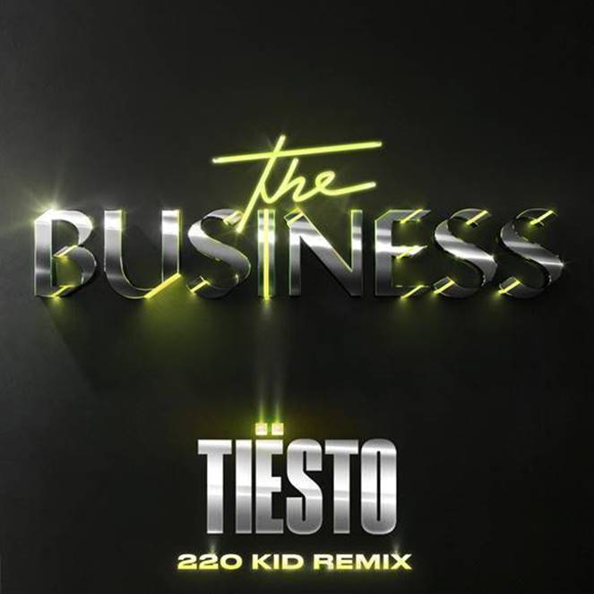

**December 11, 2020**—GRAMMY® Award-winning, platinum-certified, international icon **Tiësto** has dropped a new remix of his anthemic hit single with breakthrough artist **220 Kid!** **“The Business (220 Kid Remix)”** is out today **via Atlantic Records—**Listen to it [**here!**](https://nam04.safelinks.protection.outlook.com/?url=https%3A%2F%2Ftiesto.lnk.to%2FTheBusiness220KidRemix&data=04%7C01%7CGabrielle.Reese%40atlanticrecords.com%7C1e39a123b608440ef77408d89d68a2be%7C8367939002ec4ba1ad3d69da3fdd637e%7C0%7C0%7C637432420023083811%7CUnknown%7CTWFpbGZsb3d8eyJWIjoiMC4wLjAwMDAiLCJQIjoiV2luMzIiLCJBTiI6Ik1haWwiLCJXVCI6Mn0%3D%7C1000&sdata=gup093eEJ9VEXUPQJVfdFUgZryD3eQVAh9KNnVRhJLg%3D&reserved=0) Watch the new music video[**here!**](https://nam04.safelinks.protection.outlook.com/?url=https%3A%2F%2Ftiesto.lnk.to%2FTheBusiness220KidRemix%2Fyoutube&data=04%7C01%7CGabrielle.Reese%40atlanticrecords.com%7C1e39a123b608440ef77408d89d68a2be%7C8367939002ec4ba1ad3d69da3fdd637e%7C0%7C0%7C637432420023083811%7CUnknown%7CTWFpbGZsb3d8eyJWIjoiMC4wLjAwMDAiLCJQIjoiV2luMzIiLCJBTiI6Ik1haWwiLCJXVCI6Mn0%3D%7C1000&sdata=tDhuEXBZhDEFI4hwXqoG%2FkOovUJMmfIue9duDzoUfvk%3D&reserved=0)

Following the release of [**“The Business”**](https://nam04.safelinks.protection.outlook.com/?url=https%3A%2F%2Ftiesto.lnk.to%2FTheBusinessPR&data=04%7C01%7CGabrielle.Reese%40atlanticrecords.com%7C1e39a123b608440ef77408d89d68a2be%7C8367939002ec4ba1ad3d69da3fdd637e%7C0%7C0%7C637432420023083811%7CUnknown%7CTWFpbGZsb3d8eyJWIjoiMC4wLjAwMDAiLCJQIjoiV2luMzIiLCJBTiI6Ik1haWwiLCJXVCI6Mn0%3D%7C1000&sdata=s4f1tZmAFHKEc5yDGF2vzomUADN7Ypmf6VahmMayc1w%3D&reserved=0) in September, the track has garnered close to a staggering **100 Million Global Streams** to date. It has also held a steady position on Apple & Spotify’s “Today’s Top Hits” & “Today’s Hits” playlists. The track also hit **#1 at US Dance Radio**, is **certified Gold in the Netherlands** and holds a place on the **Top 50** official singles chart in the Netherlands, Poland, Ireland, Sweden, Norway, & Belgium, as well as **Top 50** on Spotify in 14 countries – the Netherlands, Slovakia, Lithuania, Estonia, Ireland, Latvia, Belgium, Hungary, Czech, Germany, Sweden, Norway, Poland and Denmark!

In addition, the [**official music video**](https://nam04.safelinks.protection.outlook.com/?url=https%3A%2F%2Fwww.youtube.com%2Fwatch%3Fv%3DnCg3ufihKyU%26feature%3Dyoutu.be%26src%3DLinkfire%26lId%3D2c768eae-f73f-4963-9e15-965f4ef27eb0%26cId%3D243a20ab-c558-413d-a755-b68ba13bc941&data=04%7C01%7CGabrielle.Reese%40atlanticrecords.com%7C1e39a123b608440ef77408d89d68a2be%7C8367939002ec4ba1ad3d69da3fdd637e%7C0%7C0%7C637432420023093773%7CUnknown%7CTWFpbGZsb3d8eyJWIjoiMC4wLjAwMDAiLCJQIjoiV2luMzIiLCJBTiI6Ik1haWwiLCJXVCI6Mn0%3D%7C1000&sdata=0m92YFhGT0S6awNSP4xLDSk%2BSYfb92OeqiGFkg%2BKWDI%3D&reserved=0)for “The Business” has clocked over **17 Million views** thus far!The video, directed by **Christian Breslauer**, stars viral comedian **Casey Frey** as he dances his way back to life. The video premiered directly after Tiësto delivered a special live performance from **Red Rocks Amphitheatre** one of the world's most unique concert venues, on September 24th. The virtual dance party featured an array of artists, with Tiësto’s headlining set as the finale.

An artist who needs no introduction, **Tiësto** has over 8 BILLION global streams across platforms, 36M+ Total Record Sales, 30M+ Social Audience & over 160M TikTok Video Views across users. The DJ and producer is the only artist to ever hold the titles of “The Greatest DJ of All Time” courtesy of Mixmag, “#1 DJ” according to Rolling Stone, and “The Godfather of EDM,” as proclaimed by Billboard. From his underground dance floor bangers to his high-profile Las Vegas residency and crossover success, Tiësto created the blueprint that defines what it means to be a success in today’s dance music world.

Amassing over 100 million streams across all platforms, alongside a top ten spot for his first release ‘Don’t Need Love’ featuring fellow newcomer GRACEY, **220 Kid’s** musical ascent has been somewhat stratospheric with his breakthrough single peaking at #1 in the US Dance Radio Chart as well as earning a platinum BRIT certification. One of the UK’s most exciting dance pop artists, 220 Kid writes instantly anthemic melodies and bold, infectious beats that he is fast becoming synonymous for. A producer, DJ and writer that centers powerful and emotive songwriting at the forefront of all of his music, alongside authentic and meaningful collaboration. His latest track ‘Too Many Nights’ was the #1 added dance song across Spotify globally. 'Too Many Nights’ follows a string of 220 Kid remixes that recently just dropped, reimagining both the hit Anne Marie single ‘To Be Young’ featuring Doja Cat as well the latest Little Mix track ‘Holiday.'

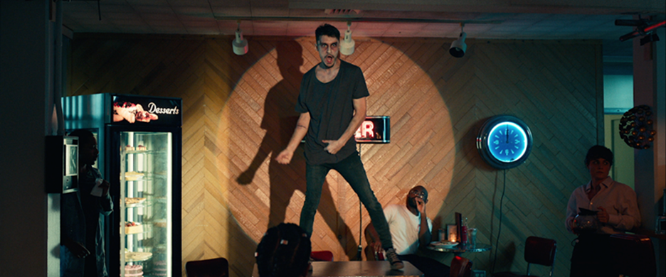

**Download Assets** [**HERE**](https://warnermusicgroup.app.box.com/s/trbh83pzbbmsf65d43f9b4xtw8y5n8yj)

**CONNECT WITH TIËSTO:**

[Instagram](https://nam04.safelinks.protection.outlook.com/?url=https%3A%2F%2Fwww.instagram.com%2Ftiesto%2F%3Fhl%3Den&data=04%7C01%7CGabrielle.Reese%40atlanticrecords.com%7C1e39a123b608440ef77408d89d68a2be%7C8367939002ec4ba1ad3d69da3fdd637e%7C0%7C0%7C637432420023093773%7CUnknown%7CTWFpbGZsb3d8eyJWIjoiMC4wLjAwMDAiLCJQIjoiV2luMzIiLCJBTiI6Ik1haWwiLCJXVCI6Mn0%3D%7C1000&sdata=c0Gyz5g5zzJ7wGwx93rXjHC4ovYVJuCCznudPswM%2Bf4%3D&reserved=0) | [Facebook](https://nam04.safelinks.protection.outlook.com/?url=https%3A%2F%2Fwww.facebook.com%2Ftiesto%2F&data=04%7C01%7CGabrielle.Reese%40atlanticrecords.com%7C1e39a123b608440ef77408d89d68a2be%7C8367939002ec4ba1ad3d69da3fdd637e%7C0%7C0%7C637432420023103728%7CUnknown%7CTWFpbGZsb3d8eyJWIjoiMC4wLjAwMDAiLCJQIjoiV2luMzIiLCJBTiI6Ik1haWwiLCJXVCI6Mn0%3D%7C1000&sdata=qp69BA4DVxGu1c0UP%2FGES1O1GibeYs2FpKEpH2szpDo%3D&reserved=0) | [Twitter](https://nam04.safelinks.protection.outlook.com/?url=https%3A%2F%2Ftwitter.com%2Ftiesto&data=04%7C01%7CGabrielle.Reese%40atlanticrecords.com%7C1e39a123b608440ef77408d89d68a2be%7C8367939002ec4ba1ad3d69da3fdd637e%7C0%7C0%7C637432420023103728%7CUnknown%7CTWFpbGZsb3d8eyJWIjoiMC4wLjAwMDAiLCJQIjoiV2luMzIiLCJBTiI6Ik1haWwiLCJXVCI6Mn0%3D%7C1000&sdata=fn51SeU2ohdWWfJpRmLifJqZPvYgLz5%2B%2BS1aJXyGhA4%3D&reserved=0) | [Spotify](https://nam04.safelinks.protection.outlook.com/?url=https%3A%2F%2Fopen.spotify.com%2Fartist%2F2o5jDhtHVPhrJdv3cEQ99Z%3Fsi%3DQgM-v7EFRaOX3xdGVXSm6g&data=04%7C01%7CGabrielle.Reese%40atlanticrecords.com%7C1e39a123b608440ef77408d89d68a2be%7C8367939002ec4ba1ad3d69da3fdd637e%7C0%7C0%7C637432420023113682%7CUnknown%7CTWFpbGZsb3d8eyJWIjoiMC4wLjAwMDAiLCJQIjoiV2luMzIiLCJBTiI6Ik1haWwiLCJXVCI6Mn0%3D%7C1000&sdata=GQJ0OSN5E9pRW0VuQkAefW0bAxxriZyAg8KRS2Dfb4A%3D&reserved=0)

**FOR MORE INFORMATION:**

Cara Hutchison

[Cara.Hutchison@ledecompany.com](mailto:Cara.Hutchison@ledecompany.com)

Paige Rosoff – Atlantic Records/Big Beat Records

[Paige.Rosoff@atlanticrecords.com](mailto:Paige.Rosoff@atlanticrecords.com)