**EVER-EVOLVING RAPPER TOKEN RELEASES “HIGH HEELS”**

**WITH INIMITABLE PUNK RAPPER RICO NASTY**

**ALSO ANNOUNCES OCTOBER ALBUM PINK IS BETTER**

**WATCH THE MUSIC VIDEO** [**HERE**](https://youtu.be/JGF0ozcn9gU)

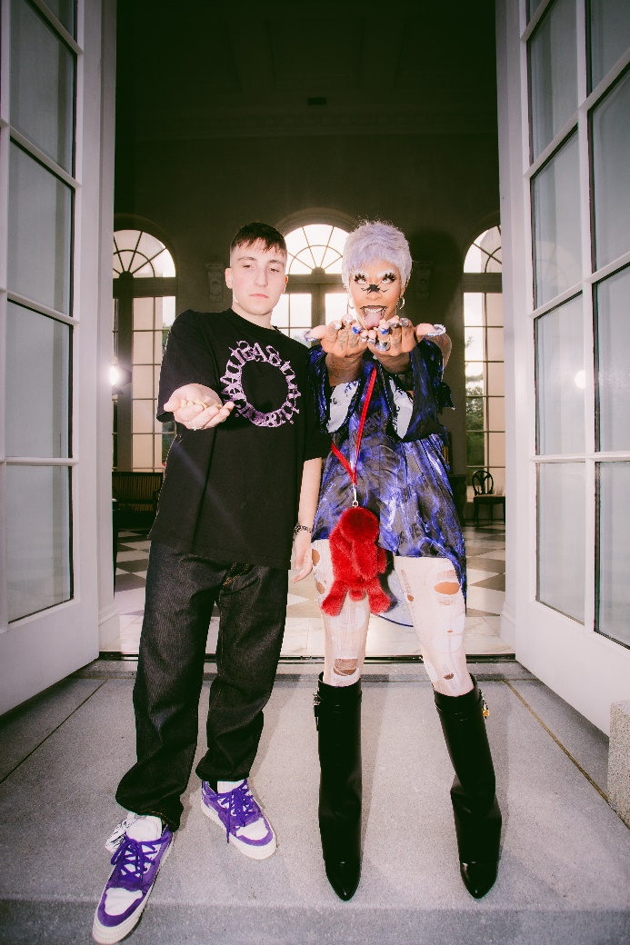

[DL press photos here](https://press.atlanticrecords.com/token/)

Rap wunderkind **Token** is back and better than ever, releasing “High Heels,” featuring the unparalleled **Rico Nasty** today. Watch the music video, directed by Token and Ben Proulx and featuring both artists, [HERE](https://youtu.be/JGF0ozcn9gU). Token also announced his third album, *Pink is Better*, which will be released Friday, October 8th on Token’s label [Never Too Different](https://www.nevertoodifferent.com/), in partnership with Atlantic Records.

On the collaboration Token says, "*Rico and I came together to embrace the fast life we find ourselves trapped inside of. This song represents the high energy, fun life I always dreamed about without acknowledging any of its downsides. It was an exciting time in my life, so I just sound like an excited ass kid. I was fresh off tour and single again. You can hear it in my voice. I was inspired by all of the new things coming my way and I was having fun. I’ve put out a lot of darker, sadder songs, but this one is me enjoying myself for the first time. Rico killed it too!”*

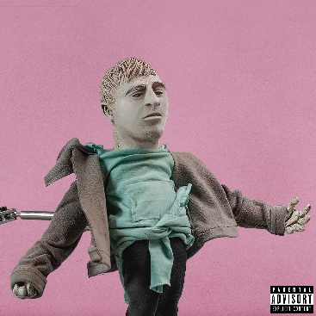

[DL album art here](https://press.atlanticrecords.com/token/)

Token was recently co-signed by NBA superstar Damian Lillard, who was impressed with Token’s freestyle paying tribute to J. Cole. ‘[Hi J. Cole…](https://youtu.be/6ySZSAgxoTo)’ is one of Token’s highest viewed on YouTube, reaching 310k views in its first 24 hours and 1.2M views within the first 7 days of release. Additionally, Token’s latest official single “[Chit Chat](https://www.youtube.com/watch?v=dwBhYBHKPi8&src=Linkfire&lId=8414c15b-2e8b-415a-9228-290ab5e994a8&cId=d3d58fd7-4c47-11e6-9fd0-066c3e7a8751&ab_channel=tokenhiphop),” produced by Ronny J (Juice WRLD, Eminem, Kanye West, Denzel Curry), has over 3M streams since its May release.

Confidence can’t be given. Instead, it’s earned. Through a prolific, albeit quiet grind, Token has morphed into an outlier in hip-hop. After amassing hundreds of millions of YouTube views and streams independently and receiving acclaim from *The Boston Globe*, *XXL*, *Complex*, and more, he leaps forward again on his 2021 project *Pink Is Better*—the first to be released under his own label Never Too Different and Atlantic Records.

Growing up outside of Boston, music anesthetized depression, anxiety, stress, and loneliness throughout his childhood. So, Token put his head down and honed his craft at just 10-years-old, putting in countless hours, recording tracks of his own, burning CDs, and distributing them around Massachusetts. During 2015, his “No Sucka MCs Contest Entry” went viral, eventually exceeding 5.7 million YouTube views. After Token wound up on Mark Wahlberg’s radar, he appeared on the hit television show Wahlburgers and landed a role in the blockbuster *Patriots Day*. Simultaneously, he lit up *Sway in the Morning* with a headline-making six-minute freestyle. *XXL* christened it *“one of the year’s best freestyles, if not one of the best performances ever on Sway’s legendary show*.*”*

On its heels, he dropped his first mixtape *Eraser Shavings* in 2016 followed by 2018’s *Between Somewhere*, which vaulted into the Top 5 on the iTunes Hip-Hop/Rap Albums Chart. Generating 100 million-plus streams, it also spawned anthems, including “YouTube Rapper” [feat. Tech N9ne], “Household Name,” and “Flamingo.” Not to mention, he sold out shows on multiple continents and contributed music to the *Fast & Furious Hobbs & Shaw* soundtrack and *Scoob! The Album*.

Throughout 2020, he carefully assembled what would become *Pink Is Better*, achieving a sense of personal and creative balance.

“The project is about the highest of highs and the lowest of lows,” he observes. “It’s me realizing, no matter what, it’s all going to be okay.”

# # #

CONNECT WITH TOKEN

[OFFICIAL](https://nam04.safelinks.protection.outlook.com/?url=https%3A%2F%2Furldefense.proofpoint.com%2Fv2%2Furl%3Fu%3Dhttps-3A__nam04.safelinks.protection.outlook.com_-3Furl-3Dhttps-253A-252F-252Fwww.tokenhiphop.com-252F-26data-3D02-257C01-257CCorey.Brewer-2540atlanticrecords.com-257Cf6dbca39bcd84c6d7ed108d837c027de-257C8367939002ec4ba1ad3d69da3fdd637e-257C0-257C0-257C637320645884163493-26sdata-3D460MQh5-252BV8mFg7VeUdsfk0Wwwy6b-252BQJOV1FJ9v-252FqRBg-253D-26reserved-3D0%26d%3DDwMGaQ%26c%3DeuGZstcaTDllvimEN8b7jXrwqOf-v5A_CdpgnVfiiMM%26r%3DFSTML3jvsT1nrXb7i-MgtoMF-nQTL90szF2A1QEeZW4%26m%3D6Pl3ZINBZvjRd0sOFnk1OANEo54se9XTkD4PnPO_bSE%26s%3D14Gvax5rRUZL8q8iuIYiVfZsCUcVklVDIyHKFLETUCA%26e%3D&data=02%7C01%7CGabrielle.Reese%40atlanticrecords.com%7Cfc83bae6964c48800d2a08d8389379f7%7C8367939002ec4ba1ad3d69da3fdd637e%7C0%7C0%7C637321553348257580&sdata=3g1iFPco47x%2BG2u%2F8Ol41ieGnYbKiHVG%2Bn0LDAHqADE%3D&reserved=0) | [FACEBOOK](https://nam04.safelinks.protection.outlook.com/?url=https%3A%2F%2Furldefense.proofpoint.com%2Fv2%2Furl%3Fu%3Dhttps-3A__nam04.safelinks.protection.outlook.com_-3Furl-3Dhttps-253A-252F-252Fwww.facebook.com-252Ftokenhiphop-26data-3D02-257C01-257CCorey.Brewer-2540atlanticrecords.com-257Cf6dbca39bcd84c6d7ed108d837c027de-257C8367939002ec4ba1ad3d69da3fdd637e-257C0-257C0-257C637320645884163493-26sdata-3DxlNUIRvibwCbF4ftnKeY2KVXtuL0-252BhFJmjW6qBgVS6I-253D-26reserved-3D0%26d%3DDwMGaQ%26c%3DeuGZstcaTDllvimEN8b7jXrwqOf-v5A_CdpgnVfiiMM%26r%3DFSTML3jvsT1nrXb7i-MgtoMF-nQTL90szF2A1QEeZW4%26m%3D6Pl3ZINBZvjRd0sOFnk1OANEo54se9XTkD4PnPO_bSE%26s%3D9xA297qt20Sl4b1iFKqGv6B-wjDJsjTW6CvwWp2wPZk%26e%3D&data=02%7C01%7CGabrielle.Reese%40atlanticrecords.com%7Cfc83bae6964c48800d2a08d8389379f7%7C8367939002ec4ba1ad3d69da3fdd637e%7C0%7C0%7C637321553348257580&sdata=xwHA5QzKCdc%2BfltU93ccHK154O7Li8dG41yeqR9PpEc%3D&reserved=0) | [TWITTER](https://nam04.safelinks.protection.outlook.com/?url=https%3A%2F%2Furldefense.proofpoint.com%2Fv2%2Furl%3Fu%3Dhttps-3A__nam04.safelinks.protection.outlook.com_-3Furl-3Dhttps-253A-252F-252Ftwitter.com-252Ftokenhiphop-26data-3D02-257C01-257CCorey.Brewer-2540atlanticrecords.com-257Cf6dbca39bcd84c6d7ed108d837c027de-257C8367939002ec4ba1ad3d69da3fdd637e-257C0-257C0-257C637320645884173453-26sdata-3DhN0RSZ-252FzcriClH4j8ke9rMwqVG1sVzeUc-252Ft07pSP5v8-253D-26reserved-3D0%26d%3DDwMGaQ%26c%3DeuGZstcaTDllvimEN8b7jXrwqOf-v5A_CdpgnVfiiMM%26r%3DFSTML3jvsT1nrXb7i-MgtoMF-nQTL90szF2A1QEeZW4%26m%3D6Pl3ZINBZvjRd0sOFnk1OANEo54se9XTkD4PnPO_bSE%26s%3DY4oH3ymktOt_Ov-zAvGVIyCeVNfKUrQg9tA_7fRnMmo%26e%3D&data=02%7C01%7CGabrielle.Reese%40atlanticrecords.com%7Cfc83bae6964c48800d2a08d8389379f7%7C8367939002ec4ba1ad3d69da3fdd637e%7C0%7C0%7C637321553348267572&sdata=WU9KqNfvxgNPyjfy3lwbfU3NHaYpOgVxPLBS1EwTwHc%3D&reserved=0) | [INSTAGRAM](https://nam04.safelinks.protection.outlook.com/?url=https%3A%2F%2Furldefense.proofpoint.com%2Fv2%2Furl%3Fu%3Dhttps-3A__nam04.safelinks.protection.outlook.com_-3Furl-3Dhttps-253A-252F-252Fwww.instagram.com-252Ftokenhiphop-252F-26data-3D02-257C01-257CCorey.Brewer-2540atlanticrecords.com-257Cf6dbca39bcd84c6d7ed108d837c027de-257C8367939002ec4ba1ad3d69da3fdd637e-257C0-257C0-257C637320645884173453-26sdata-3D9MzmnUdTDk7IqRc3CQ7I2UK-252BYNTu6ip594RNEE5jUZE-253D-26reserved-3D0%26d%3DDwMGaQ%26c%3DeuGZstcaTDllvimEN8b7jXrwqOf-v5A_CdpgnVfiiMM%26r%3DFSTML3jvsT1nrXb7i-MgtoMF-nQTL90szF2A1QEeZW4%26m%3D6Pl3ZINBZvjRd0sOFnk1OANEo54se9XTkD4PnPO_bSE%26s%3DIEPNWh8yqf3UP4PCb9LrL-X4jr1udlASspgWAyCmP2Q%26e%3D&data=02%7C01%7CGabrielle.Reese%40atlanticrecords.com%7Cfc83bae6964c48800d2a08d8389379f7%7C8367939002ec4ba1ad3d69da3fdd637e%7C0%7C0%7C637321553348277569&sdata=%2BGR05PcwUuD6lEtb3255vorwGLbSwNbu1qJNvQCs7hQ%3D&reserved=0) | [YOUTUBE](https://nam04.safelinks.protection.outlook.com/?url=https%3A%2F%2Furldefense.proofpoint.com%2Fv2%2Furl%3Fu%3Dhttps-3A__nam04.safelinks.protection.outlook.com_-3Furl-3Dhttps-253A-252F-252Fwww.youtube.com-252Fuser-252Ftokenhiphop-26data-3D02-257C01-257CCorey.Brewer-2540atlanticrecords.com-257Cf6dbca39bcd84c6d7ed108d837c027de-257C8367939002ec4ba1ad3d69da3fdd637e-257C0-257C0-257C637320645884183402-26sdata-3DK5DrmCo2WTP4Mg-252BasEi33D2MSsLoZbAmlQj6h8VjYj8-253D-26reserved-3D0%26d%3DDwMGaQ%26c%3DeuGZstcaTDllvimEN8b7jXrwqOf-v5A_CdpgnVfiiMM%26r%3DFSTML3jvsT1nrXb7i-MgtoMF-nQTL90szF2A1QEeZW4%26m%3D6Pl3ZINBZvjRd0sOFnk1OANEo54se9XTkD4PnPO_bSE%26s%3DK5cauwof1Su58q-3Itj_KCW9R1k-fe_hLal4TEXY3_k%26e%3D&data=02%7C01%7CGabrielle.Reese%40atlanticrecords.com%7Cfc83bae6964c48800d2a08d8389379f7%7C8367939002ec4ba1ad3d69da3fdd637e%7C0%7C0%7C637321553348277569&sdata=b%2BmYMpjc00siijfacX8gm7TJOpf6do4wqd32gTub5Cw%3D&reserved=0) | [PRESS SITE](https://press.atlanticrecords.com/token/)

Token Press contact: [Corey.brewer@atlanticrecords.com](mailto:Corey.brewer@atlanticrecords.com)

Rico Nasty press contact: [Ariana.white@atlanticrecords.com](mailto:Ariana.white@atlanticrecords.com)