FOR IMMEDIATE RELEASE
APRIL 7, 2022

VANCE JOY ANNOUNCES NEW ALBUM IN OUR OWN SWEET TIME OUT JUNE 10
+ FINDS HIS “CLARITY” ON NEW SINGLE

MULTI-PLATINUM SINGER-SONGWRITER ANNOUNCES UPCOMING THIRD STUDIO ALBUM
ALONGSIDE BRIGHTLY MOVING NEW SINGLE

IN OUR OWN SWEET TIME ARRIVES EVERYWHERE ON FRIDAY, JUNE 10
PRE-SAVE IT HERE

SELECT NORTH AMERICAN LIVE DATES BEGIN MAY 14 IN REDONDO BEACH, CA

GLOBAL POP SENSATION VANCE JOY BOASTS OVER 5 BILLION LIFETIME STREAMS

LISTEN TO “CLARITY” HERE | WATCH OFFICIAL MUSIC VIDEO HERE
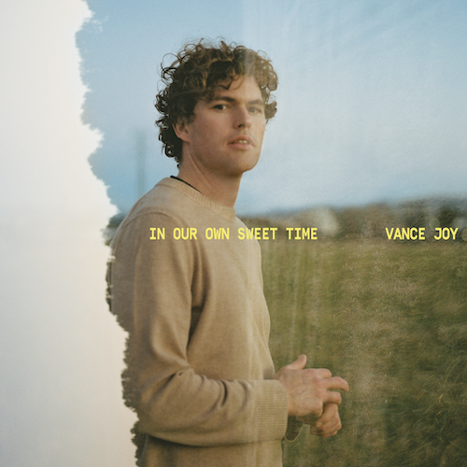
(DOWNLOAD HI-RES ARTWORK)

Multi-platinum singer-songwriter Vance Joy has announced his highly anticipated third studio album, In Our Own Sweet Time, arriving everywhere on Friday, June 10 - pre-order it now HERE. Created mostly in the pandemic, the album is Joy’s most personal project yet. Realizing what truly matters and growing in new ways personally and creatively, In Our Own Sweet Time is fueled by old friends, new memories and finding love in a not-so-hopeless place. The eagerly awaited new album includes collaborations with hitmakers such as Joel Little (Lorde, Taylor Swift), Dan Wilson (Adele, Leon Bridges), Take a Day Trip (Miley Cyrus, Lil Nas X) and more.

On the title of his new album, In Our Own Sweet Time, Joy shared, “I’m always drawn to the idea of timelessness or that shared moment that takes you out of the chaos outside. If the world is crazy, you can retreat somewhere. It’s always hard to think of the right title but I think that sums up the album perfectly.”

Along with the exciting announcement of the summer album, Joy has also released his bright new single “Clarity,” available now HERE. Produced/co-written with GRAMMY® Award-winning songwriter Joel Little over zoom, “Clarity” is joined by an official music video - streaming now HERE.

On “Clarity” Joy shared, “It’s very upbeat and poppy. Dan Wilson says if there is a song you might be a bit shy about because it feels poppy or makes you feel uncomfortable because it’s saying something really directly that’s probably the single. I got that feeling from ‘Clarity.’ When we finished the song Joel said he could imagine the feel of the production – when he sent it back to me, with the full production, it just exploded. I didn’t see that coming. The original voice memo was me doing mouth trumpet. He even sampled my weak mouth trumpet in the original demo, then that got replaced with the real thing.”

In Our Own Sweet Time will include “Clarity” as well as recent hits “Don’t Fade” and “Missing Piece.” “Don’t Fade” arrived earlier this year and quickly earned more than 10 million worldwide streams alongside critical applause from Rolling Stone, Entertainment Tonight, and more. “Missing Piece” proved a global sensation following last year’s world premiere on ABC’s Grey’s Anatomy, reaching #2 at Alternative radio outlets before earning more than 130 million global streams – bringing Joy’s catalogue up to over 5 billion streams worldwide – as well as a massive 3 billion TikTok views (with 2.6 million user-created videos). The irresistibly infectious track is now 2x Platinum in Australia and Gold Certified in the US.

Having toured the world with Taylor Swift and P!nk, and making festival appearances at Coachella, Firefly and Austin City Limits, Joy has now announced a highly-anticipated return to North America set for Spring 2022. The run of select live dates kicks off May 14 at Redondo Beach, CA’s Beachlife Festival and will include sold out headline performances at Nashville TN’s historic Ryman Auditorium (June 2) and New York City’s Pier 17 (June 4). For updates and ticket information, please visit www.vancejoy.com/tour.

DOWNLOAD PRESS PHOTOS HERE

VANCE JOY
NORTH AMERICA 2022

MAY
14 – Redondo Beach, CA – Beachlife Festival
27 – Vancouver, BC – Rogers Arena
29 – Napa, CA – Bottlerock Festival

JUNE
2 – Nashville, TN – Ryman Auditorium (SOLD OUT)
4 – New York, NY – The Rooftop At Pier 17 (SOLD OUT)
9 – Toronto, ON – Budweiser Stage

# # #

CONNECT WITH VANCE JOY:
WEBSITE | FACEBOOK | TWITTER | INSTAGRAM | YOUTUBE

For press inquiries, please contact:
Kelly McWilliam // Kelly.McWilliam@atlanticrecords.com
Libby Kober // Libby.Kober@atlanticrecords.com

