DAINE TEAMS UP WITH OLI SYKES FOR DESTRUCTIVE NEW TRACK ‘SALT’

Listen to the track HERE
Buy/Stream the track HERE

“Teen angst’s freshest voice” - V Magazine
“It feels healing and painful; like looking directly at a solar flare.” - The Guardian
“daine's tracks echo Midwestern emo greats like American Football, while simultaneously providing a dark-pop twist.” - PAPER
“A nihilistically detached voice” - The FADER
“daine’s creative spin on such a distinctive sound evokes an irresistible nostalgia” - Pigeons & Planes

In just over a year, daine has gone from releasing her debut single, to leading a new generation of DIY artists building uncompromising sonic worlds from their own bedrooms. The Melbourne based artist has, at the age of 18, become the new soundtrack for a disillusioned generation navigating life in an unforgiving world. After the hi-octane tribute to the hyperpop community of her last release boys wanna txt/dainecore, daine today delves deeper into the darker side of her alternative roots than ever before with ‘Salt’; a brand new single featuring rock icon Oli Sykes. An organic meeting of similarly experimental creative mindsets, the track was born from natural collaboration, with Sykes reaching out to daine after a longtime mutual appreciation of each other’s work.

A brooding cut of visceral electronic emo, ‘Salt’ marks daine’s heaviest work to date while also marking a return to the genesis of her original sound, with reverberating fingerpicked guitars weaving in and out of rap-inspired hi-hats - creating a foreboding backdrop for daine and Sykes to weave a vampiric tale of lost love. The track’s chorus is a sonic blast of unleashed emotion, with both daine and Sykes purging the pain through venomous screams, layered alongside soaring electronic production from Lonelyspeck to make way for the most anthemic hook of daine’s career so far. A true singalong moment, ‘Salt’ makes for cathartic listening; a sound for those weary with the weight of the world to get lost in, and for those that don’t, it’s an overwhelmingly powerful statement from one of 2021’s most exciting artists.

A complete sensory overload that redefines the sound of emo in 2021, ‘Salt’ combines the talents of one of contemporary alternative music’s biggest icons with one of its future stars. A staggering indication of where daine’s sound may go next, the track opens up the possibilities of not only her own output, but the capabilities of alternative music going into the future, with daine as one of its most promising burgeoning stars.

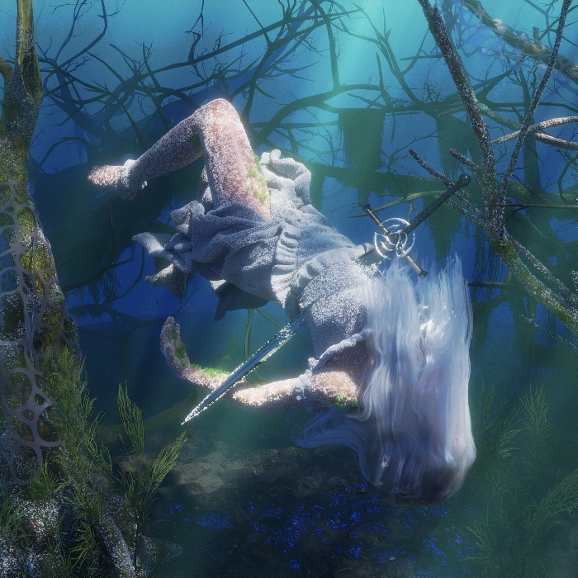

daine: Website | Twitter | Instagram

For more information on daine, contact mitch@revenant.earth

