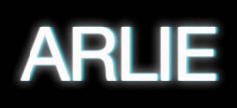

VISIONARY INDIE-POP ACT ARLIE RELEASE “landline” + ANNOUNCE U.S. HEADLINE TOUR DATES

HIGHLY ANTICIPATED ALBUM BREAK THE CURSE SET TO ARRIVE JUNE 3

NEW SINGLE DEBUTS WITH SIRIUS XM ALT NATION ADVANCED PLACEMENT PREMIERE

“landline” ARRIVES WITH OFFICIAL VIDEO STARRING THE BAND – WATCH HERE

HEADLINE TOUR KICKS OFF JUNE 17
TICKETS ON SALE THIS FRIDAY AT 10AM ET

“A true collage of everything from pop to alternative, pulled together with a squelching kaleidoscopic flare… beaming with lyrical savviness that exudes alternative infatuation.” – ONES TO WATCH

***

“landline” – BUY/STREAM | WATCH
BREAK THE CURSE – PRE-ORDER

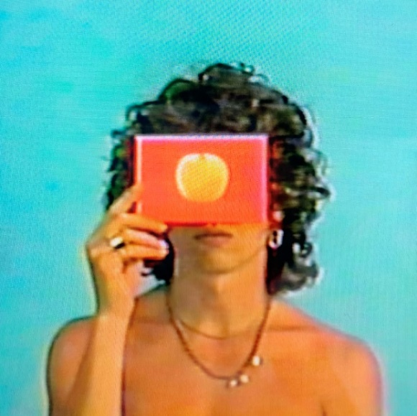
download artwork here

Visionary indie-pop act Arlie has released their new single “landline” (listen here). The high-energy track was cowritten and produced with Gabe Simon (Lana Del Rey, The Wombats) and had its official radio debut this evening via a SiriusXM Alt Nation advanced placement premiere and arrives paired with an official music video starring the band (watch here).

Lead singer, songwriter, multi-instrumentalist, and producer Nathaniel Banks shares of the song and video:

“Whether you interpret this one as an anthem sincerely celebrating freedom from being constantly reachable on a smartphone, or as an ironically celebratory social commentary that pokes fun at how one might unconsciously misapply ideas about freedom and self-care to justify avoidant behavior-either way, it’s an anthem and it’s fun.”

The single is lifted off the band’s forthcoming debut full-length BREAK THE CURSE – slated for release on June 3rd via Atlantic Records (pre-order here). The album was executive produced by Lars Stalfors (Still Woozy, Soccer Mommy, Samia) and features production from John Hill (Wallows, Sylvan Esso) and Andrew Sarlo (Big Thief, Bon Iver).

To celebrate the album, the band will embark on a US headline tour, set to kick off at Durham’s Motorco Music Hall on June 17th and include a show at New York’s Mercury Lounge on June 24, before culminating at Growlers in Memphis on July 28. Pre-sales for tickets begin tomorrow (5/12) at 12pm ET, with general on-sale beginning Friday (5/13) at 10am ET.

The Nashville-based outfit’s freshman LP is an unabashedly joyful, artfully minded indie-pop album conceived by Banks and co-produced by band members Ryan Savage and Adam Lochemes. Taking flight from where their 2018 debut EP ‘Wait’ left off, the full-length finds Arlie drawing on timeless pop influences to make music that is at once nostalgic and forward-thinking.

Laced with unforgettable hooks, deliberately naive sentiments, and winking self-awareness set against a genuine grappling with the weight of existential despair, the album is ultimately a journey centered around the theme of transcending societal, cultural, and generational traumas – ‘breaking the curse’ in order to blossom into one’s true authentic self and genuinely connect with others.

Today’s release of “landline” follows the album’s previous singles, “sickk,” “crashing down,” “poppin,” and debut single “karma.” The tracks each live in their own unique musical universe, yet all carry Arlie’s ambitious and unmistakable musical signature, exhibiting a meticulous obsession with saturation, contrast, and space.

Last month, Arlie launched their community number for fans to connect with Nathaniel and the band. Fans can text with them directly at (615) 813-6513 [HERE] to chat about the album, upcoming touring, and more.

With over 82M worldwide streams and counting, Arlie first began in the summer of 2015 as a solo bedroom project for Banks, eventually evolving to a full-band live act by 2017 and growing a fervent fan following in their hometown of Nashville and beyond.

Hailed for its striking synthesis of classic pop melodies with wildly creative modern production, Arlie’s 2018 Wait EP included such hit singles as “didya think” and “big fat mouth.” The project immediately drew acclaim for its invigorating songcraft, meticulous production, and playful, summertime energy. Upon release, FLAUNT praised the EP for “fusing a sound both futuristic and vintage…Arlie flirts with an aroma of nostalgic youth, like a mix between a 1984 Testarossa and The Jetsons’ hovercraft.” Ones to Watch similarly declared it: “A true collage of everything from pop to alternative, pulled together with a squelching kaleidoscopic flare…beaming with lyrical savviness that exudes alternative infatuation.”

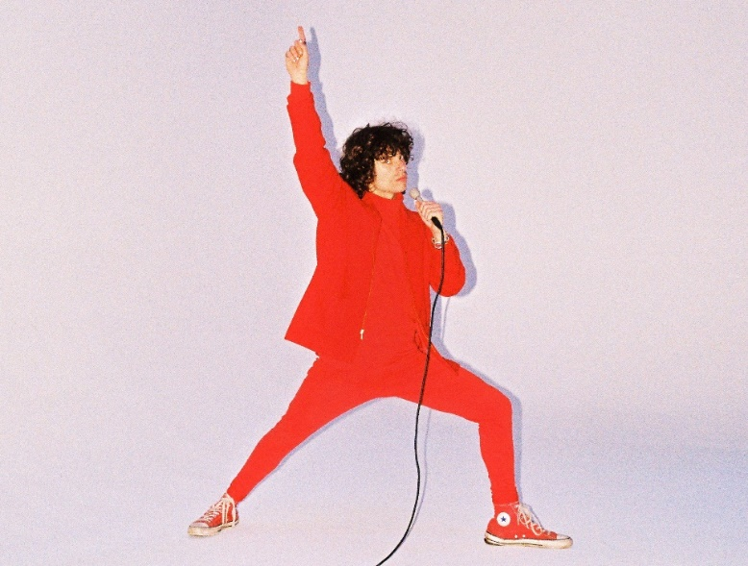
download press photo here; credit: Gabe Dreschler

*****

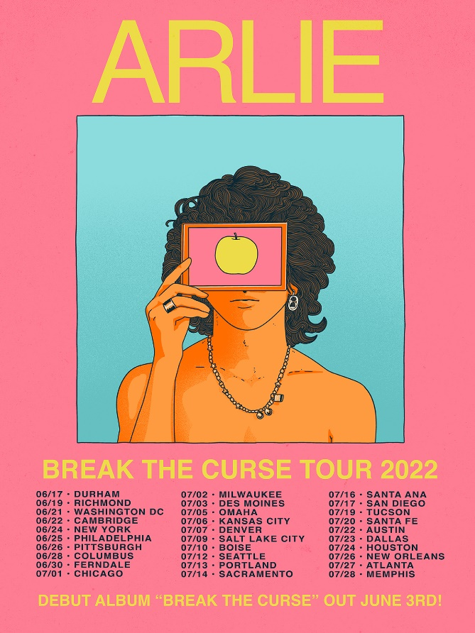

UPCOMING LIVE DATES:
JUNE 17, 2022 – DURHAM, NC – MOTORCO MUSIC HALL
JUNE 19, 2022 – RICHMOND, VA – RICHMOND MUSIC HALL
JUNE 21, 2022 – WASHINGTON, DC – DC9
JUNE 22, 2022 – CAMBRIDGE, MA – SONIA
JUNE 24, 2022 – NEW YORK, NY – MERCURY LOUNGE
JUNE 25, 2022 – PHILADELPHIA, PA – MILKBOY
JUNE 26, 2022 – PITTSBURGH, PA – THUNDERBIRD MUSIC HALL
JUNE 28, 2022 – COLUMBUS, OH – RUMBA CAFÉ
JUNE 30, 2022 – FERNDALE, MI – THE LOVING TOUCH
JULY 3, 2022 – DES MOINES, IA – XBK
JULY 5, 2022 – OMAHA, NE – SLOWDOWN
JULY 6, 2022 – KANSAS CITY, MO – ENCORE AT THE UPTOWN THEATER
JULY 7, 2022 – DENVER, CO – GLOBE HALL
JULY 9, 2022 – SALT LAKE CITY, UT – SOUNDWELL
JULY 10, 2022 – BOISE, ID – THE SHREDDER
JULY 12, 2022 – SEATTLE, WA – MADAME LOU’S
JULY 13, 2022 – PORTLAND, OR – MISSION THEATER
JULY 14, 2022 – SACRAMENTO, CA – GOLDFIELD TRADING POST
JULY 16, 2022 – SANTA ANA, CA – THE CONSTELLATION ROOM
JULY 17, 2022 – SAN DIEGO, CA – VOODOO ROOM AT HOUSE OF BLUES
JULY 19, 2022 – TUCSON, AZ – CLUB CONGRESS
JULY 20, 2022 – SANTA FE, NM – MEOW WOLF
JULY 22, 2022 – AUSTIN, TX – MOHAWK
JULY 23, 2022 – HOUSTON, TX – WAREHOUSE LIVE
JULY 26, 2022 – NEW ORLEANS, LA – GASA GASA
JULY 27, 2022 – ATLANTA, GA – ROOFTOP AT THE EASTERN
JULY 28, 2022 – MEMPHIS, ITN – GROWLERS

# # #

CONNECT WITH ARLIE:
OFFICIAL | INSTAGRAM | FACEBOOK | YOUTUBE | TWITTER

FOR ALL PRESS INQUIRIES, PLEASE CONTACT:
Libby Kober | Libby.Kober@AtlanticRecords.com
Trish Mollo | Trish.Mollo@AtlanticRecords.com

