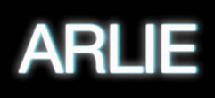

VISIONARY INDIE-POP ACT ARLIE RELEASES “sickk” + ANNOUNCES FORTHCOMING ALBUM BREAK THE CURSE

OFFICIAL DEBUT FULL-LENGTH SLATED TO ARRIVE JUNE 3

“sickk” ARRIVES WITH OFFICIAL VISUAL – WATCH HERE

ARLIE LAUNCHES COMMUNITY NUMBER FOR FANS TO TEXT DIRECTLY

CO-HEADLINE TOUR WITH BETCHA UNDERWAY NOW – TICKETS HERE

“A true collage of everything from pop to alternative, pulled together with a squelching kaleidoscopic flare… beaming with lyrical savviness that exudes alternative infatuation.” – ONES TO WATCH

***

“sickk” – BUY/STREAM | WATCH
BREAK THE CURSE – PRE-ORDER

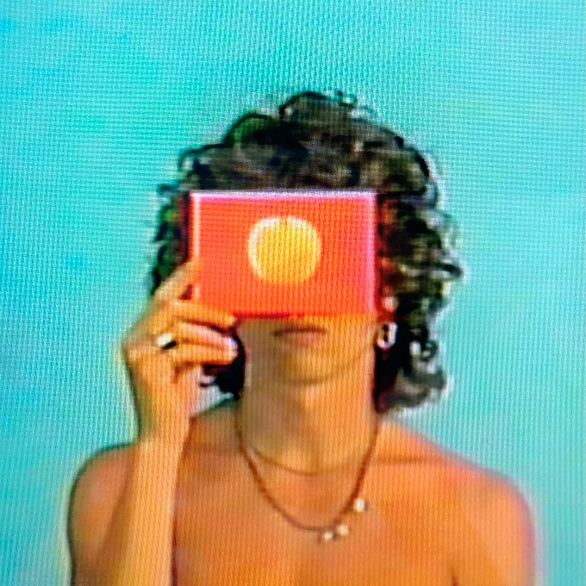
download artwork here

Visionary indie-pop act Arlie has today released their driving, synth-laden new single “sickk” and announced plans for their forthcoming debut full-length album – BREAK THE CURSE – set for release on June 3rd via Atlantic Records. The single itself arrives joined by an official visual starring lead singer, songwriter, multi-instrumentalist, and producer Nathaniel Banks (watch here).

In a note to fans, Banks shares of the song and video:
“In the video Gabe and I made for this track, I’m in a hospital gown. This was a symbolic decision, but for me it’s also more than just a symbol.

Five months after writing “sickk,” I reached a breaking point, and as a result was hospitalized for over a week. I have done a lot of growth in the past three years, and the next phase of my healing path is pointing me towards self-expression— telling my story and expressing who I am with an open heart.

Simply dismantling the idea that it’s not okay to be not okay is still an important mission.

I am glad I reached this breaking point sooner rather than later in my life. I’m happy to be alive, feeling stable, and surrounded by support now. And I’m especially happy to be playing shows, putting out music, and following my dreams again.”

The Nashville-based outfit’s freshman LP BREAK THE CURSE is an unabashedly joyful, artfully-minded indie-alternative pop album conceived by Banks and co-produced by band members Ryan Savage and Adam Lochemes. Taking flight from where their 2018 debut EP ‘Wait’ left off, the full-length finds Arlie drawing on timeless pop influences to make music that is at once nostalgic and forward-thinking.

Laced with unforgettable hooks, deliberately naive sentiments, and winking self-awareness set against a genuine grappling with the weight of existential despair, the album is ultimately a journey centered around the theme of transcending societal, cultural, and generational traumas – ‘breaking the curse’ in order to blossom into one’s true authentic self and genuinely connect with others.

Fans can pre-order BREAK THE CURSE, as well as gain access to exclusive merch here.

Also unveiled today is Arlie’s community number for fans to connect with Nathaniel and the band. Fans can text with them directly at (615) 813-6513 [HERE] to chat about the album, upcoming touring, and more.

Yesterday, Arlie kicked off a co-headline tour of the Midwest and West Coast with fellow Nashville band Betcha. The dates kicked off in Dallas and will include a show at Los Angeles’ Moroccan Lounge before wrapping at Saturn in Birmingham, AL. Tickets available here.

Today’s release of “sickk” follows the album’s previous singles “karma”, “crashing down”, and “poppin” released last year. Driven by kinetic, punk-rock energy and informed by decades of pop music, debut single “karma” boasted an understated air of nuance and sophistication, without pretense. The other tracks live in an entirely different musical universe, and yet still carry Arlie’s ambitious and unmistakable musical signature, exhibiting a meticulous obsession with saturation, contrast, and space.

With over 77M worldwide streams and counting, Arlie first began in the summer of 2015 as a solo bedroom project for Banks, eventually evolving to a full-band live act by 2017 and growing a fervent fan following in their hometown of Nashville and beyond.

Hailed for its striking synthesis of classic pop melodies with wildly creative modern production, Arlie’s 2018 Wait EP included such hit singles as “didya think” and “big fat mouth,” both joined by official music videos.

The project immediately drew acclaim for its invigorating songcraft, meticulous production, and playful, summertime energy. Upon release, FLAUNT praised the EP for “fusing a sound both futuristic and vintage…Arlie flirts with an aroma of nostalgic youth, like a mix between a 1984 Testarossa and The Jetsons’ hovercraft.” Ones to Watch similarly declared it: “A true collage of everything from pop to alternative, pulled together with a squelching kaleidoscopic flare…beaming with lyrical savviness that exudes alternative infatuation.”
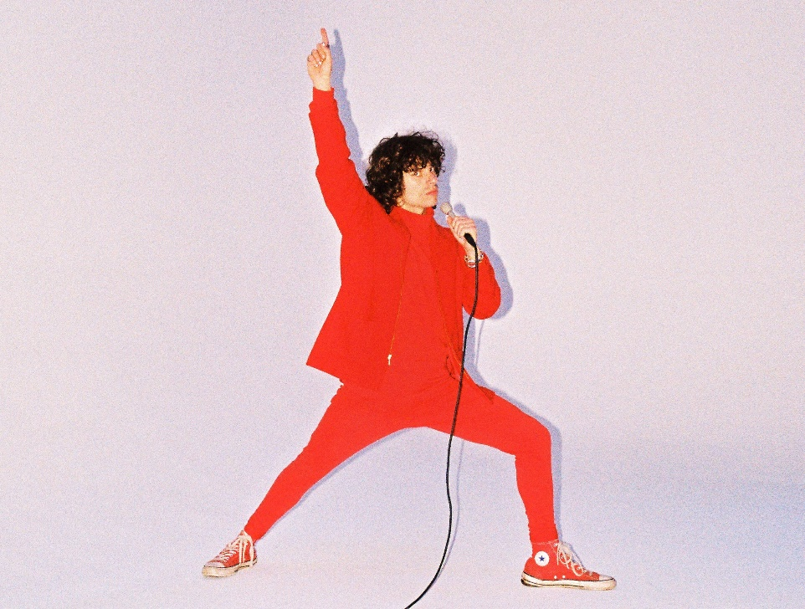
download press photo here
PHOTO CREDIT: GABE DRESCHLER

------------------

UPCOMING LIVE DATES (WITH BETCHA)
APRIL 2, 2022 – NEW ORLEANS, LA – GASA GASA
APRIL 22, 2022 – ST. LOUIS, MO – BLUEBERRY HILL
APRIL 23, 2022 – AMES, IA – THE MAINTENANCE SHOW
APRIL 26, 2022 – SALT LAKE CITY, UT – KILBY COURT
APRIL 28, 2022 – SAN FRANCISCO, CA – BRICK & MORTER MUSIC HALL
MAY 2, 2022 – MESA, AZ – NILE THEATER
MAY 4, 2022 – AUSTIN, TX – EMPIRE CONTROL ROOM & GARAGE
MAY 6, 2022 – LITTLE ROCK, AZ – STICKYZ ROCK-N-ROLL CHICKEN SHACK
MAY 7, 2022 – BIRMINGHAM, AL – SATURN

# # #

CONNECT WITH ARLIE:
OFFICIAL | INSTAGRAM | FACEBOOK | YOUTUBE | TWITTER

FOR ALL PRESS INQUIRIES, PLEASE CONTACT:
Libby Kober | Libby.Kober@AtlanticRecords.com
Trish Mollo | Trish.Mollo@AtlanticRecords.com

