FOR IMMEDIATE RELEASE

May 27, 2022

BANKROL HAYDEN PARTIES LIKE A ROCKSTAR WITH
NEW SINGLE + VIDEO “VAN HAYDEN”
WATCH HERE | STREAM HERE

FORTHCOMING PROJECT SET TO DROP THIS SUMMER

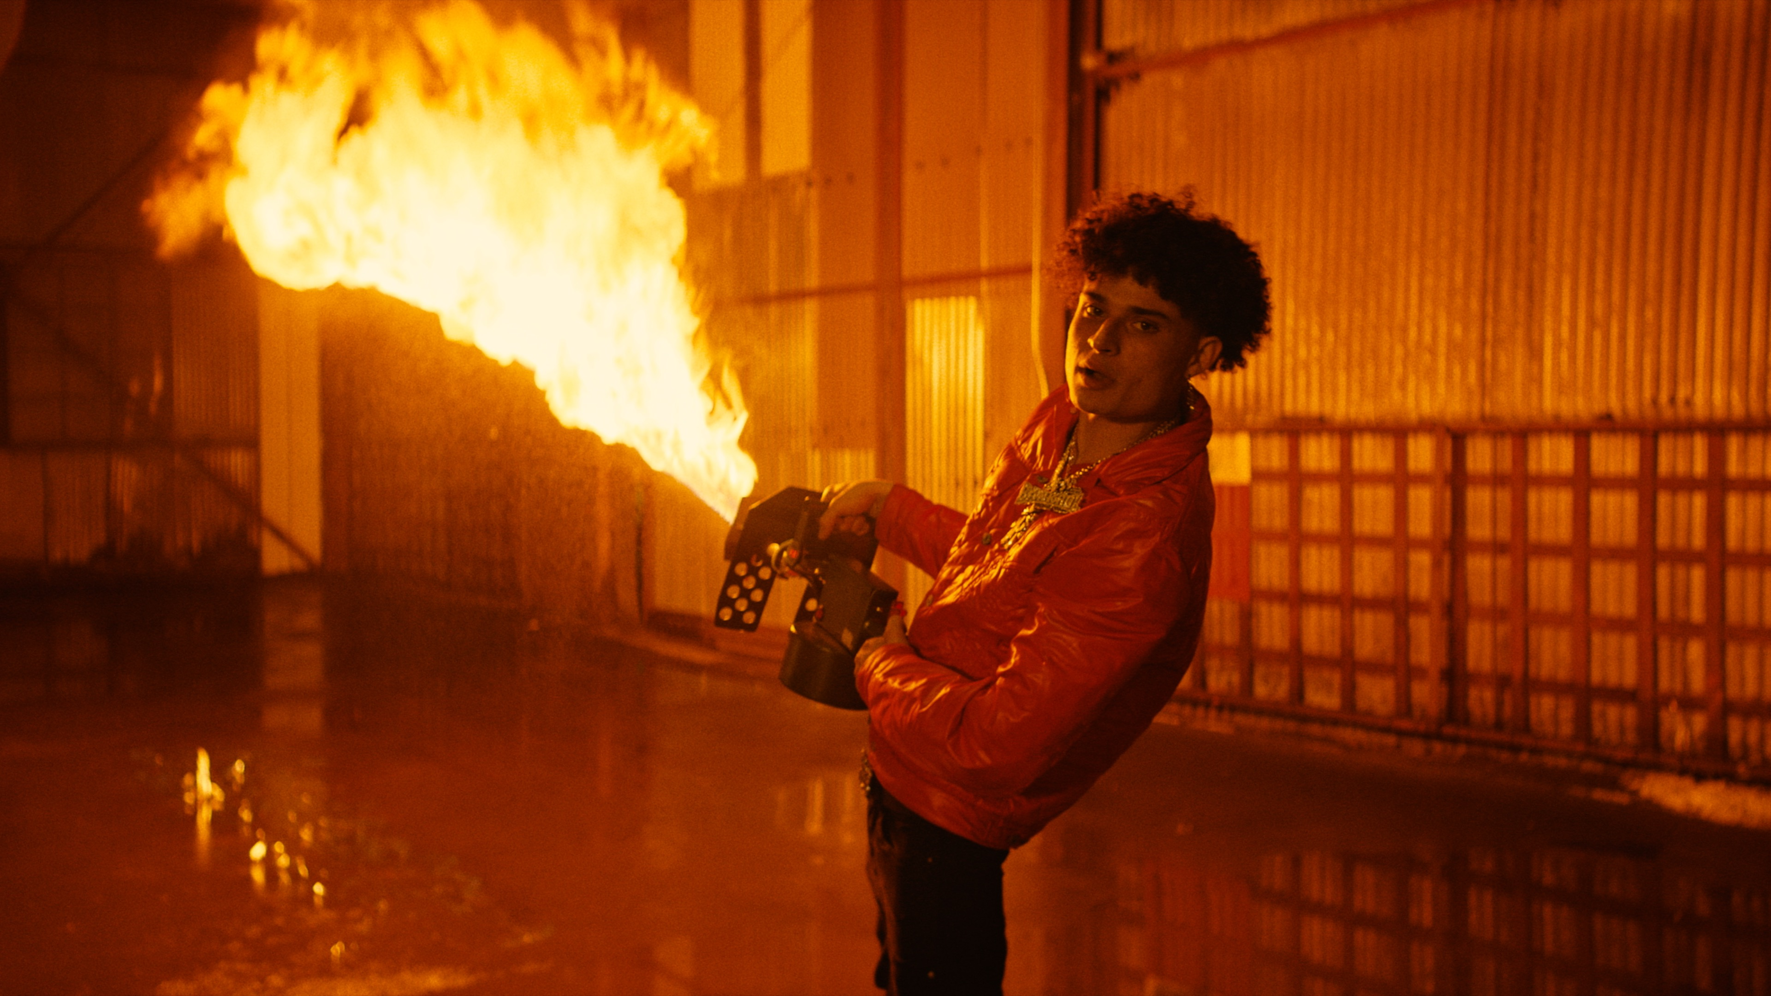s

Bankrol Hayden goes full-blown rockstar mode in new single + video, “Van Hayden”. The guitar-smashing, party-raving song was produced by GRAMMY® Award-nominee Roy Lenzo (Lil Nas X, Jack Harlow, Roddy Ricch) and Adriano (Gunna, Lil Skies, Ali Gatie); while the fun, braggadocious visual directed by JakeTheShooter, has Hayden feeling legendary like he’s on some G.O.A.T. status literally. Watch HERE.

“Van Hayden” is one of several tracks Bankrol Hayden is releasing prior to his eagerly awaited project, coming this Summer. The track follows a series of previously-released tracks, which include “F*ck Love” his RIAA gold-certified “Costa Rica,” “Cabo,” “No Drama“ and the smash hit, “Come Through (Ft. Lil Tecca),” the latter of which boasts over 85M worldwide streams thus far, after making top playlists such as Spotify’s “Rap Caviar” and “Most Necessary,” Apple Music’s “#OnRepeat” and “The Plug,” Amazon’s “Fresh Hip-Hop,” and more.

Recently, Hayden set fire to the Gulf Shores, AL’s Hangout Music Festival on May 21st and is set to hit multiple stages this year including, Grand Prairie, TX’s So What?! Music Festival (Friday, May ss27), and Dover, DE’s Firefly Music Festival (Sunday, September 25). Additional dates will be announced. Previously featured among YouTube’s “Artist on the Rise: Trending” series, Bankrol Hayden has proven to be an electrifying live performer, sharing stages around the world.

Currently holding over 120M YouTube views to date, Bankrol Hayden is a true phenomenon, earning fans around the globe with his positive brand of soulful, pop-forward hip-hop. The talented young artist first broke out in 2017 with a series of popular YouTube videos and SoundCloud favorites. Viral smashes as “B.A.N.K.R.O.L.,” “29,” and the RIAA gold certified “Brothers (Feat. Luh Kel)“ followed, the latter of which scored 30M Spotify streams and 6.5M YouTube plays in under six months.

Bankrol Hayden made his Atlantic Records debut in 2020 with the RIAA gold certified “Costa Rica,” quickly following up with his powerful debut album, Pain Is Temporary, highlighted by such emotionally charged tracks as “Whatchu On Today (Ft. Polo G),,” “Drop A Tear (Ft. Lil Baby),” and “Rich Bitch,” all joined by official music videos streaming now at YouTube.

“Tupac used to write as either an observer, participant, or themselves,” Bankrol Hayden says. “That inspires me. I stay true to myself and put my life into this, but you’ll get different perspectives.”

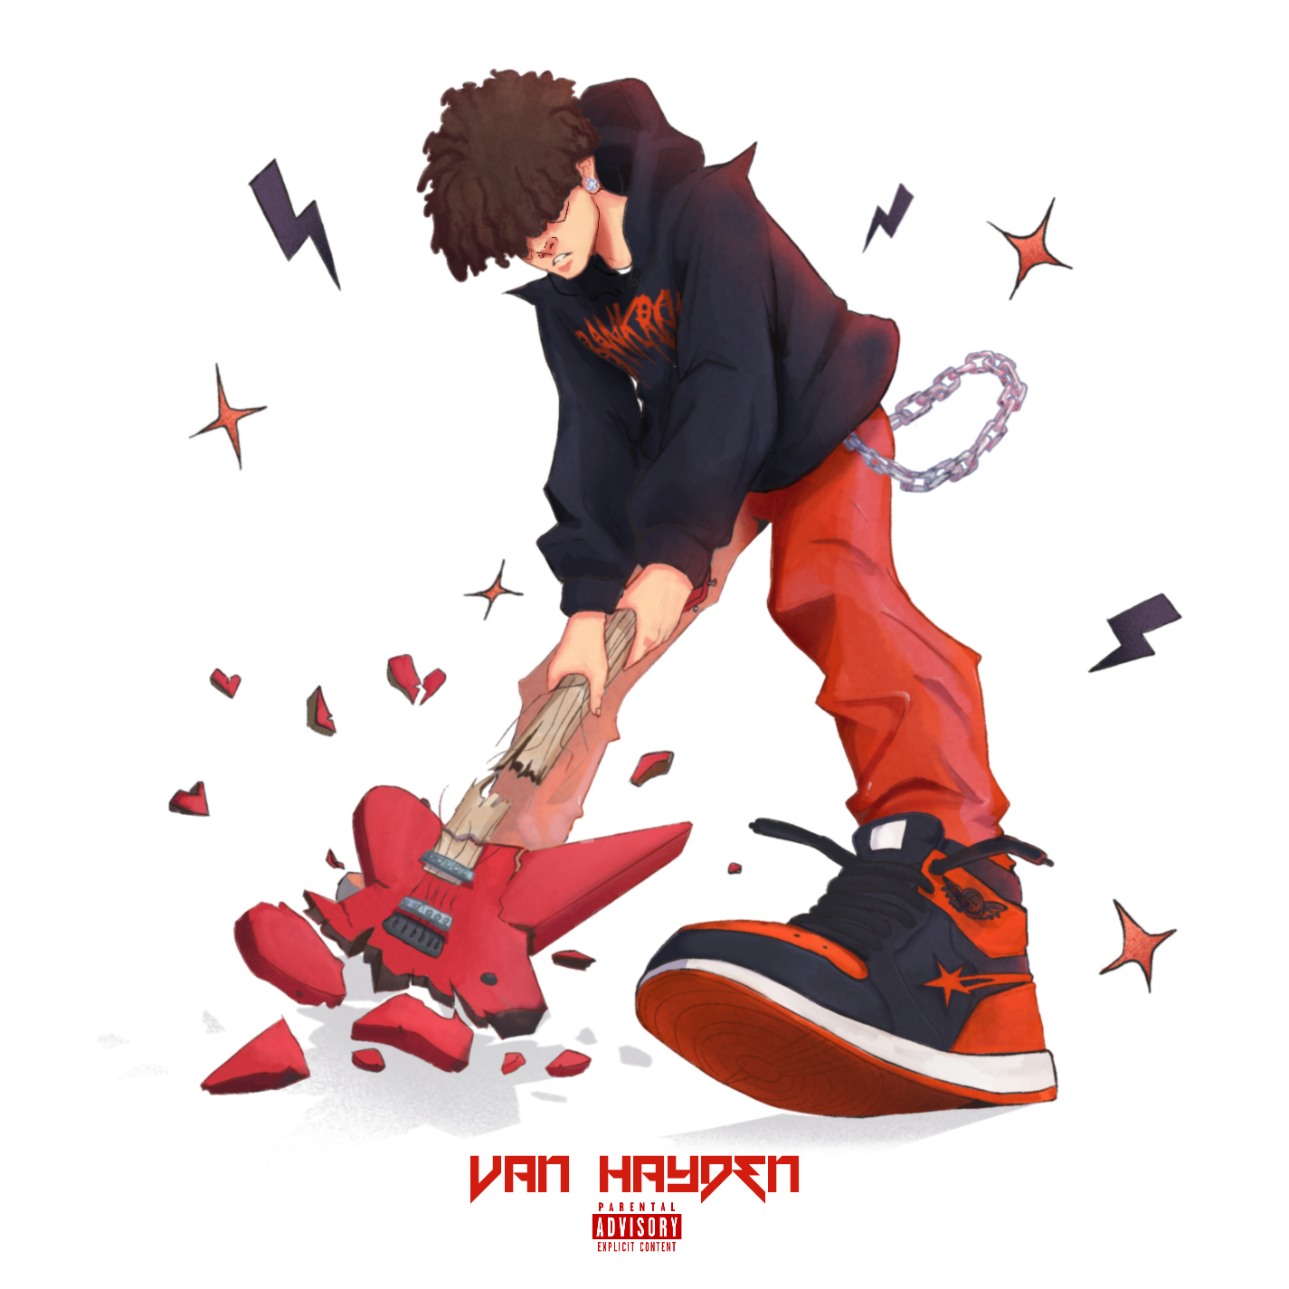
(DOWNLOAD HI-RES ARTWORK)

CONNECT WITH BANKROL HAYDEN
INSTAGRAM | TIKTOK | TWITTER | YOUTUBE

PRESS CONTACT
FAIRLEY MCCASKILL | FAIRLEY.MCCASKILL@ATLANTICRECORDS.COM

# # #

