CAPRISONGS
THE NEW MIXTAPE FROM FKA TWIGS
OUT JANUARY 14

FEATURING COLLABORATIONS WITH THE WEEKND, PA SALIEU,
DANIEL CAESAR, REMA, JORJA SMITH, UNKOWN T, DYSTOPIA AND SHYGIRL

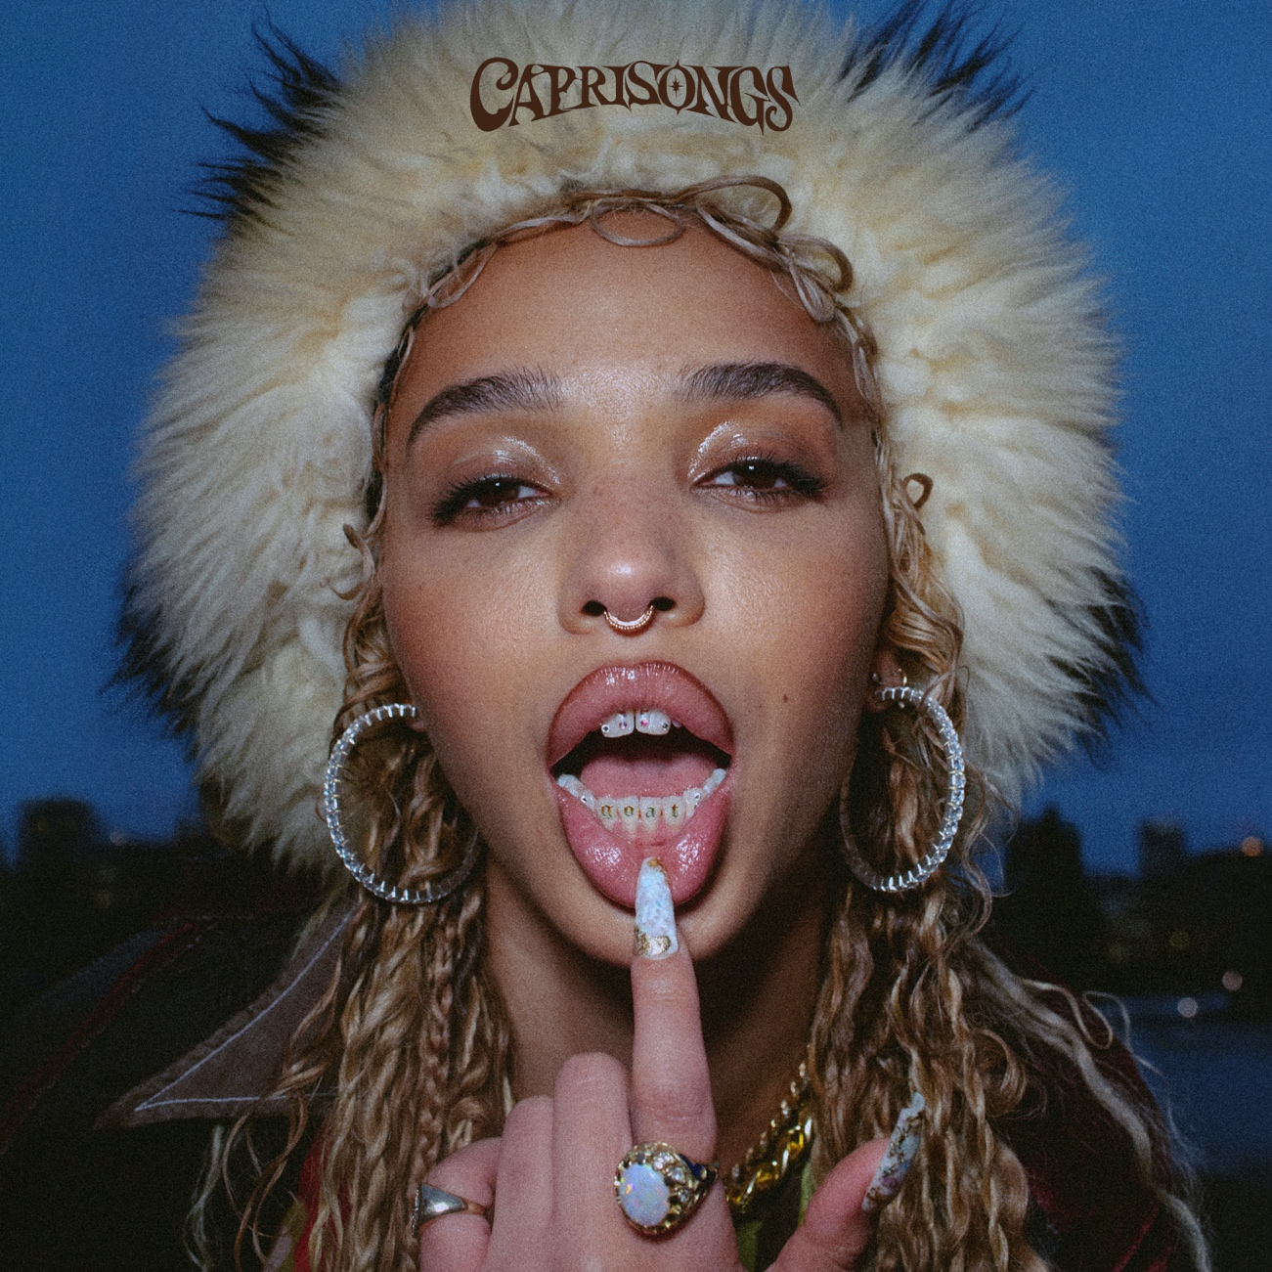
[Cover Artwork – high res HERE]

FKA twigs will release her highly anticipated new mixtape CAPRISONGS on January 14. The mixtape documents twigs’ “journey back to myself through my amazing collaborators and friends.” and showcases an evolution and expansion for this prolific artist who continues to thoughtfully push at the edges of her art.

“CAPRISONGS… it’s bronzer in the sink, alco pop on the side, a cherry lolly, apple juice when you’re thirsty, friends in the park, your favourite person, that one sentence somebody said to you that changed everything, a club pre-game, your bestie who is always late but brings the most to the party, meeting a friend at the airport, just togetherness. And my world: London, Hackney, Los Angeles, New York City and Jamaica.

It’s my stubborn Caprisun ass telling me to work thru my pain by delivering at work, don’t think just go studio and create. My Sagi moon being the enigmatic temptress craving the club, to dance and to be social and my Pisces/Venus hot mess disastrous heart falling in love all over again. But this time with music and with myself.” – FKA twigs

CAPRISONGS features collaborations with Pa Salieu (on “honda,”), Daniel Caesar (“careless”), Rema (“jealousy”), Jorja Smith and Unknown T (“darjeeling”), DYSTOPIA (“which way”) and Shygirl (“papi bones”) in addition to the previously released single “tears in the club”, which saw twigs teaming up with The Weeknd for her biggest track to date.

The mixtape is executive produced by FKA twigs and El Guincho and features production from FKA twigs, El Guincho, Koreless, P2J, Mike Dean, Marius de Vries, Jasper Harris, Teo Halm, Arca, FRED, Psymun, Cirkut, BKay, Reaper, Sega Bodega, Fake Guido, Pau, Felix Joseph, AoD, Jeff Kleinman, Warren Ellis, Jonathan Coffer and BAK.

CAPRISONGS TRACKLIST

1. ride the dragon
2. honda (feat pa salieu)
3. meta angel
4. tears in the club (feat the weeknd)
5. oh my love
6. pamplemousse
7. caprisongs interlude
8. lightbeamers
9. papi bones (feat shygirl)
10. which way (feat dystopia)
11. jealousy (feat rema)
12. careless (feat daniel caesar)
13. minds of men
14. minds of men (outro)
15. darjeeling (feat jorja smith & unknown t)
16. christi interlude
17. thank you song

