COLDPLAY’S MUSIC OF THE SPHERES WORLD
TOUR APP AVAILABLE TO DOWNLOAD NOW
FREE TOUR COMPANION APP ALLOWS BAND TO MEASURE AND DRAWDOWN CARBON EMISSIONS FROM FANS’ TRAVEL. ALSO OFFERS EXCLUSIVE LIVESTREAM AND BEHIND-THE-SCENES TOUR CONTENT.

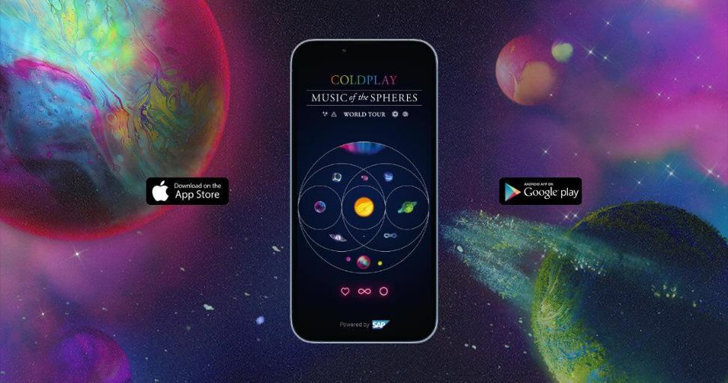
Download: coldplay.com/app

Coldplay’s new Music Of The Spheres World Tour App is available to download now for iOS and Android devices via coldplay.com/app ahead of the hotly-anticipated US leg of the band’s global stadium tour, which begins in Dallas on May 6. The free app - made in partnership with SAP - can be downloaded via coldplay.com/app.

The app forms a key part of the band’s pledge to make their upcoming Music Of The Spheres World Tour as sustainable and low-carbon as possible since - according to studies¹ - fan travel accounts for the largest part of tour-related emissions. The app allows fans to plan low-carbon travel to and from shows, with those who choose green journeys rewarded with a merch discount code.

The app will also measure total fan-travel carbon emissions so that the band can drawdown these impacts via high quality nature-based solutions such as reforestation and soil regeneration.

The app was first made available to fans before the band’s record-breaking Latin American shows in March / April. Tens of thousands of journey plans have already been submitted, with the average fan carbon footprint down around 50% from 2016/17’s A Head Full Of Dreams Tour.

Alongside the fan-travel calculator, the app also offers Coldplay-themed games and AR experiences, exclusive behind-the-scenes content, photos and videos from every show, plus Coldplay news updates and tour info.
The band will also be streaming the full concert audio of an upcoming European date exclusively via the app in a presentation powered by SAP (full details to be announced soon).
"We’re really proud of the Music Of The Spheres World Tour app,” said Coldplay. “For the past few years, we’ve been figuring out how to put sustainability at the heart of our tour. The app is a big part of that. You can use the app to figure out the cleanest and greenest ways to get to and from the concert. It also allows us to see how people have travelled to and from the shows so that we can drawdown all those emissions. You can also get right to the heart of the tour with exclusive photos, performances and behind-the-scenes access.”

“With our technology and solutions, we empower organisations worldwide to drive sustainable change,” said Christian Klein, CEO and member of the Executive Board of SAP SE. “Coldplay and SAP share a common and profound commitment to sustainability, and we are thrilled to join forces to make their tour as environmentally friendly as possible.”

For more information on the band’s touring initiatives, check out coldplay.com/sustainability and to download the app, go to coldplay.com/app.

The Music Of The Spheres World Tour dates are available at coldplay.com/tour.

¹ Source: Super-Low Carbon Live Music Report, The Tyndall Centre, June 2021

—----

About SAP
SAP's strategy is to help every business run as an intelligent enterprise. As a market leader in enterprise application software, we help companies of all sizes and in all industries run at their best: SAP customers generate 87% of total global commerce. Our machine learning, Internet of Things (IoT), and advanced analytics technologies help turn customers' businesses into intelligent enterprises. SAP helps give people and organisations deep business insight and fosters collaboration that helps them stay ahead of their competition. We simplify technology for companies so they can consume our software the way they want - without disruption. Our end-to-end suite of applications and services enables business and public customers across 25 industries globally to operate profitably, adapt continuously, and make a difference. With a global network of customers, partners, employees, and thought leaders, SAP helps the world run better and improve people's lives. For more information, click here.

For more information please visit Coldplay.com or contact:
Sheila Richman | sheila.richman@atlanticrecords.com
Ted Sullivan | ted.sullivan@atlanticrecords.com
Gabrielle Reese (Tour) | gabrielle.reese@atlanticrecords.com

