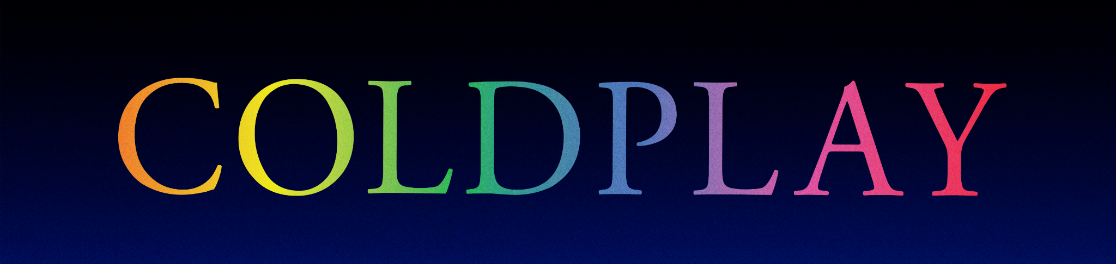

COLDPLAY ANNOUNCE NEW SHOWS
FOR PERU, CHILE AND BRAZIL
BAND CONFIRM SIX NEW DATES IN SEPTEMBER AND OCTOBER, WITH TICKETS ON SALE APRIL 11-13TH

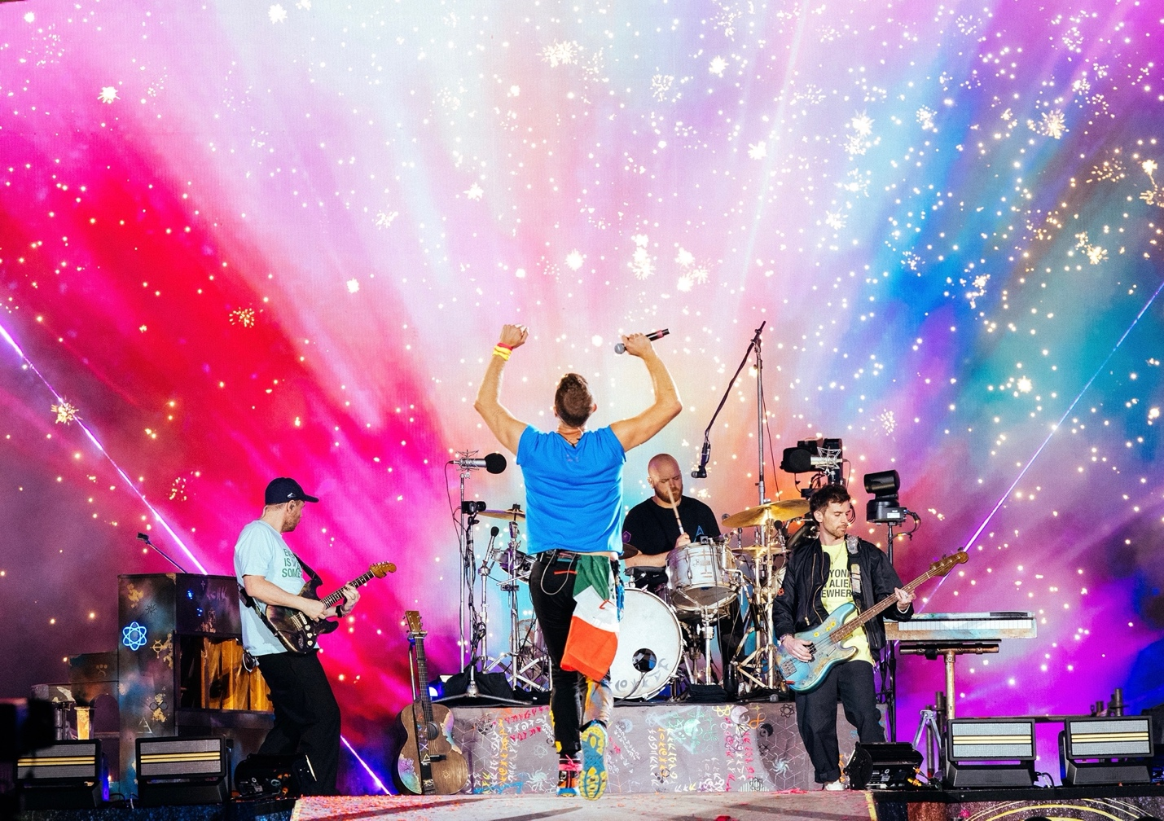
Credit: James Marcus Haney / @marcushaney

Due to overwhelming demand, Coldplay have today announced six new shows for their Music Of The Spheres World Tour, with September dates in Lima, Peru and Santiago, Chile plus October shows in Rio de Janeiro and São Paulo, Brazil.

More than 2.6 million tickets have already been sold for the tour, which kicked off on March 18th with the band’s triumphant first show in Costa Rica, and has continued with rapturously-received stops in the Dominican Republic and Mexico. The tour has continued to set records around the globe. This will be the first time any artist has performed three nights at Estadio Nacional in Santiago, Chile and also marks the first time any international artist has sold out four nights at Foro Sol in Mexico City and two nights at Estadio Akron in Guadalajara. The tour continues with US dates in May and June, before the band head to Europe for shows in Germany, Poland, France, Belgium and the UK. More dates and cities will continue to be added.

The tour is accompanied by a comprehensive set of sustainability initiatives which can be seen at coldplay.com/sustainability.

Support varies by date and includes Camila Cabello, H.E.R. and London Grammar. Additional supports for the US leg have also been announced (see below).

Due to logistical issues, the Lima date originally scheduled for September 20th has now been rescheduled for September 13th, with a new, second show added for September 14th. The two Los Angeles dates that were originally scheduled for 2022 will now be moved to 2023, with new show dates to be announced as soon as possible.

Tickets for the newly-added Lima show go on sale Monday, April 11th at 9am local time, with the Santiago show on sale Wednesday, April 13th at 11am local time and the Rio De Janeiro and São Paulo shows on sale Tuesday, April 12th at 10am local time.

The full list of shows is below and at coldplay.com/tour.

MUSIC OF THE SPHERES WORLD TOUR 2022:

MAY
6: Dallas, TX - Cotton Bowl Stadium (Support: H.E.R. and Leila Pari)
8: Houston, TX - NRG Stadium (Support: H.E.R. and Alaina Castillo)
12: Phoenix, AZ - State Farm Stadium (Support: H.E.R. and Kacy Hill)
15: Santa Clara, CA – Levi’s Stadium (Support: H.E.R. and Bobby Gonz)
28: Chicago, IL - Soldier Field (Support: H.E.R. and DRAMA)
29: Chicago, IL - Soldier Field (Support: H.E.R. and DRAMA)

JUNE
1: Washington, DC - FedExField (Support: H.E.R. and SHAED)
4: East Rutherford, NJ - Metlife Stadium (Support: H.E.R. and Bea Miller)
5: East Rutherford, NJ - Metlife Stadium (Support: H.E.R. and Bea Miller)
8: Philadelphia, PA - Lincoln Financial Field (Support: H.E.R. and Lizzy McAlpine)
11: Atlanta, GA - Mercedes-Benz Stadium (Support: H.E.R. and Mariah the Scientist)
14: Tampa, FL - Raymond James Stadium (Support: H.E.R. and gigi)

JULY
2: Frankfurt, DE - Deutsche Bank Park (Support: H.E.R.)
3: Frankfurt, DE - Deutsche Bank Park (Support: H.E.R.)
5: Frankfurt, DE - Deutsche Bank Park (Support: London Grammar)
8: Warsaw, PL - PGE Narodowy (Support: H.E.R.)
10: Berlin, DE - Olympiastadion Berlin (Support: London Grammar)
12: Berlin, DE - Olympiastadion Berlin (Support: H.E.R.)
13: Berlin, DE - Olympiastadion Berlin (Support: H.E.R.)
16: Paris, FR - Stade de France (Support: H.E.R.)
17: Paris, FR - Stade de France (Support: H.E.R.)
19: Paris, FR - Stade de France (Support: London Grammar)
20: Paris, FR - Stade de France (Support: London Grammar)

AUGUST
5: Brussels, BE - King Baudouin Stadium (Support: H.E.R.)
6: Brussels, BE - King Baudouin Stadium (Support: H.E.R.)
8: Brussels, BE - King Baudouin Stadium (Support: London Grammar)
9: Brussels, BE - King Baudouin Stadium (Support: London Grammar)
12: London, UK - Wembley Stadium (Support: H.E.R.)
13: London, UK - Wembley Stadium (Support: H.E.R.)
16: London, UK - Wembley Stadium (Support: London Grammar)
17: London, UK - Wembley Stadium (Support: H.E.R.)
19: London, UK - Wembley Stadium (Support: London Grammar)
20: London, UK - Wembley Stadium (Support: London Grammar)
23: Glasgow, UK - Hampden Park Stadium (Support: H.E.R.)
24: Glasgow, UK - Hampden Park Stadium (Support: London Grammar)

SEPTEMBER
10: Rio De Janeiro, BR - Rock in Rio Festival
13: Lima, PE - Estadio Nacional (Support: Camila Cabello) - DATE CHANGE
14: Lima, PE - Estadio Nacional (Support: Camila Cabello) - NEW
17: Bogotá, CO - Estadio El Campín (Support: Camila Cabello)
21: Santiago, CL - Estadio Nacional (Support: Camila Cabello) - NEW
23: Santiago, CL - Estadio Nacional (Support: Camila Cabello)
24: Santiago, CL - Estadio Nacional (Support: Camila Cabello)

OCTOBER
11: Rio De Janeiro, BR - Estadio Nilton Santos - NEW
15: São Paulo, BR - Allianz Parque (Support: H.E.R.) - NEW
16: São Paulo, BR - Allianz Parque (Support: H.E.R.) - NEW
25: Buenos Aires, AR - Estadio River Plate (Support: H.E.R.)
26: Buenos Aires, AR - Estadio River Plate (Support: H.E.R.)
28: Buenos Aires, AR - Estadio River Plate (Support: H.E.R.)
29: Buenos Aires, AR - Estadio River Plate (Support: H.E.R.)

DATES TBA
Los Angeles, CA - SoFi Stadium (Support: H.E.R.)
Los Angeles, CA - SoFi Stadium (Support: H.E.R.)

