U.S. LEG OF COLDPLAY’S MUSIC OF THE SPHERES WORLD TOUR KICKS OFF IN DALLAS

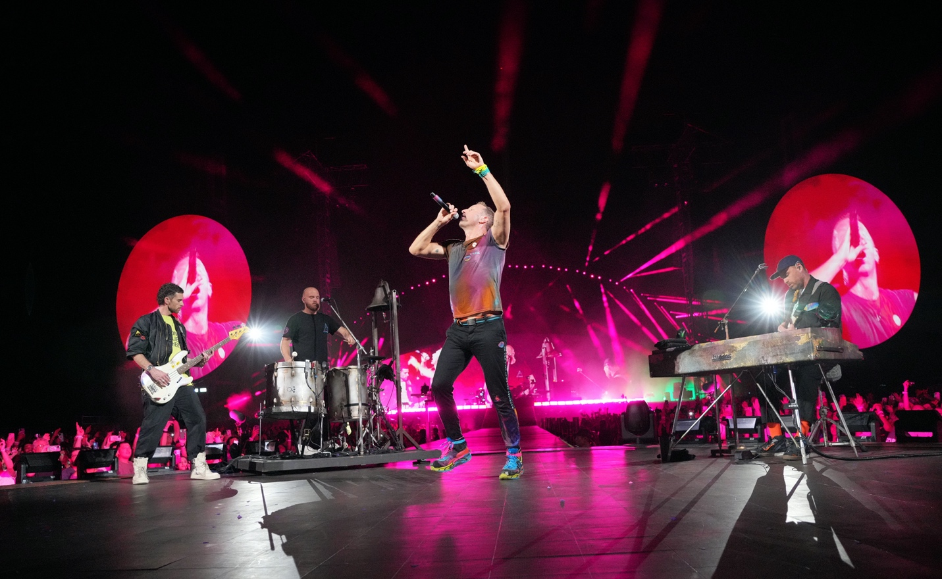
Photo credit: Kevin Mazur/ Getty Images
Social media @kevinmazur @gettyentertainment

Last night, Coldplay played the first show of the highly-anticipated U.S. leg of the band’s record-breaking Music Of The Spheres World Tour to 55,000 ecstatic fans at Dallas’s Cotton Bowl Stadium.

Click free-to-use image from the spectacular performance

Celebrating the release of their current album Music Of The Spheres, the show featured the band’s recent hits My Universe, Higher Power and Let Somebody Go alongside classics including Yellow, Clocks, Fix You, Viva La Vida and Adventure Of A Lifetime.

The sold out date was the latest of a global tour which is taking the band to stadiums across Latin America, North America and Europe, with more than 3.2 million tickets already sold for the shows announced so far, including an incredible six sold out nights at London’s iconic Wembley Stadium.

The full list of Music Of The Spheres World Tour shows is available at coldplay.com/tour, alongside details of support performances from acts including H.E.R, Camila Cabello, Carla Morrison and London Grammar.

The tour is accompanied by a comprehensive set of sustainability initiatives which includes the following commitments:

- A show powered by renewable energy
- Power bikes and kinetic dancefloors allowing fans to help power the show
- Solar panels at every show
- Pledge to cut tour emissions by 50%
- One tree planted for every ticket sold
- Incentives to encourage fans to travel to shows by green transport

The Dallas show also saw the band trial a new initiative offering a limited number of fans free rides on public transport to and from the show, in partnership with Dallas Area Rapid Transit (DART). The hope is to roll this out at other US venues.

Full details of the band’s sustainability initiatives can be seen at coldplay.com/sustainability.

For more information please visit Coldplay.com or contact:
Sheila Richman | sheila.richman@atlanticrecords.com
Ted Sullivan | ted.sullivan@atlanticrecords.com
Gabrielle Reese (Tour) | gabrielle.reese@atlanticrecords.com

