FKA TWIGS RELEASES A SERIES OF CAPRIVIDS
TO ACCOMPANY CAPRISONGS MIXTAPE

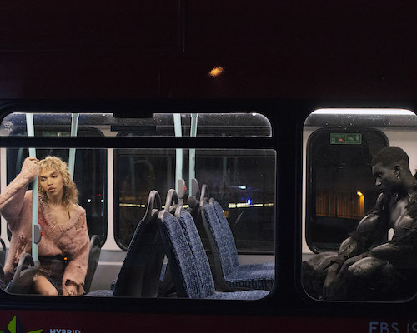
Photo Credit: Orograph

"We hear a new side to twigs in a series of voice-notes, countless collaborations and the brightest, poppiest music of her career”
NME MAGAZINE

“The most buoyant music of her career”
ROLLING STONE

“There’s a joyous freedom which permeates many of the songs in 'CAPRISONGS', where FKA twigs’ reclamation of sexuality leads to some utterly infectious tracks”
CLASH MAGAZINE

“One of her most buoyant, unfussy, and—perhaps most notably–playful projects yet"
NYLON MAGAZINE

Today FKA twigs releases the final CAPRIVID in a series of visuals created to accompany tracks from her CAPRISONGS mixtape. The final visual for the project comes in the form of ‘thank you song’. The mixtape was born out of FKA twigs’ desire to be back with friends dancing and having fun; the CAPRIVIDS embody that. The vocalist, songwriter, lyricist, and producer defines CAPRIVIDS as “a short and punchy music video using a segment of a song. Mini music videos made with limited time and resource.” FKA twigs collaborated with Aidan Zamiri to create the visuals (for all excluding ‘tears in the club’ which was directed by Amber Grace Johnson). The videos were all unveiled within a couple of weeks.

CAPRISONGS consists of a group of rhythmic and celebratory songs that mark a new era for twigs and the mixtape is perhaps the most explicit example of FKA twigs’ ample supply of influences, only further testifying to her status as one of the decade’s most innovative pop musicians.

Below, FKA twigs explains her inspirations for each of the visuals.

ride the dragon – https://www.youtube.com/watch?v=yDhVqgeRPJ8
“The ‘ride the dragon’ CAPRIVID is a video that’s very close to my heart because it is filmed in my local area, on the steps of my local town hall which is where the community go to vote and it’s also next to the theatre that I’ve gone to see lots of local productions in over the years. It’s really the epitome of my experience growing up in London, choreographing things with my friends and going and shooting around Stratford or in Maryland and just doing choreo and filming it on the street. Run and gun, let’s just get it done and look cute. I was lucky enough to work with Kash Powell, again a long-term collaborator, we actually started dancing together when we were teenagers so we’ve really grown together. I really wanted to dance with Pearlywhirll (Pearl Leary) and Samuel (Samuel Mena Garcia) and all of the incredible dancers who really come out of Kash’s crew and Kash’s world and again that’s a world that I’ve been privy to because I grew up dancing – going to do Kash’s class and just wanting to be one of the girls that was picked to do the routine at the end. So, I’m living my best life being front and centre with all these incredible, talented dancers around me and we just had a little kiki and got it done despite the local council trying to shut us down.”

honda (feat pa salieu) – https://www.youtube.com/watch?v=kxokAmGVzOs
"honda for me is like a perfect definition of a CAPRIVID because it’s super short and cheeky and it at leaves you wanting more. For me, making these shorts or CAPRIVIDS it’s like a hole punch of your favorite scenes from a music video, nothing more nothing less. It’s like sorbet, you know like when you just keep on wanting more and more. I love the fact that people are like upset with how short they are because that’s the whole point. A little flash shot into my world, into my London and into who I am. Honda was so much fun to shoot, it felt really dangerous because I was actually tied front first onto a pole zooming down the motorway. YOLO, like with me it’s just anything to get the shot. Working with Aidan Zamiri has been incredible, he’s a genius.”

meta angel – https://www.youtube.com/watch?v=MbZ797lufBk
“meta angel is a very personal visual to me on the project. It’s almost like a rebirth where my Sagittarius self is shooting my Capricorn self in the heart. For me, it’s about rebirth and it’s about allowing different sides of oneself to take over and use the skills when needed to be in charge of your life and create your own destiny. It’s an idea that Aidan and I started talking about a year and a half ago, so it was really incredible last year to shoot it again in my local area, super grounded. For me, CAPRIVIDS just shows that you almost like don’t need a fat budget to create something really special and intimate. I think we shot another two videos on that day as well, each caprivid I shot 2 or 3 videos in each day, so that was like run to the park, get it done. We shot it the same day we shot ‘ride the dragon’.”

tears in the club (feat the weeknd) – https://www.youtube.com/watch?v=cZTKjzAJLCk
“On ‘tears in the club’, I was lucky enough to work with Amber (Amber Grace Johnson) as a director. We put that video together with Object and Animal in seven days so all of that magic, from start to finish, was in seven days. I hadn’t even spoken to Amber until literally one week before we shot that video and the tears in the club dance scene was pretty much done in 48 hours. I’m really proud of it – working with Amber and bringing both of our ideas to life was really inspiring and I’m obviously a big fan of The Weeknd so just super happy that we got to make this project together.”

oh my love – https://www.youtube.com/watch?v=3jH7dFvMmKk&t=7s
“oh my love’ is really one of the songs that’s at the heart of the CAPRISONGS mixtape. It features my real-life friends giving me real life advice on how to navigate and respect myself. It’s really showing how friends can support you and be there for you. It’s really fun. It also is like the closest to a Spice Girls song that I’m ever going to get which I’m really proud of.”

papi bones (feat shygirl) – https://www.youtube.com/watch?v=7vJ9F9YAaxc
“Black culture dominates pop culture in so many ways, and a lot of that, in my opinion, is American Black culture. But in the UK, there’s this whole other vibe. I grew up listening to Afrobeats on pirate radio stations, or when I was a teenager, at Notting Hill Carnival. So, I really wanted to show that side of myself, and connect with who I was when I was around 16 or 17 and started seeking out music and clubs and people that represented my heritage. I guess that’s where the inspiration for the video came from.”

which way (feat dystopia) – https://youtu.be/u151e242Lgo
“’which way’ was originally started by Mike Dean in LA, I then took it to London and asked a local Hackney girl band called ‘Dystopia’ to jump on it and do some extra vocals. I’ve been following them for a while, and I really love their attitude and just the way they were doing their own thing musically – I really love the way it’s turned out. The video is really special to me because we’re running around London & Central London together and it’s a lot of places that I feel when I first moved to London I’d go, and hangout and I’d dream about being an artist. We’re also wearing Clarks Wallabees which is really cool because it’s a big part of West Indian culture but also reminds me of being a schoolgirl and the type of shoes that I had and that I wanted growing up. It just relates back to a sort of Jamaican style and way of dressing that I really like.”

jealousy (feat rema) – https://www.youtube.com/watch?v=BFrp8gPLObQ
“The ‘jealousy’ video was inspired by the Soul II Soul video ‘Jazzie’s Groove’. A lot of the cuts and the edits are inspired by the feel of the Jazzie’s Groove video. I’m lucky enough to know Jazzie and his family personally and he let me take a lot of clothes from his Soul ll Soul archive. It really felt like a big inspiration from my youth was coming now, at such an exciting point in my career, and giving me a little tap on the back and saying, ‘you go girl’, which is so important to me because it’s a lonely journey doing this! So just any support and love you can get, I appreciate it so much. I love the ‘jealousy’ slide, it’s a really cute dance routine that you can learn, so if you haven’t gone to see it…go and learn the ‘jealousy’ dance slide video and tag me in it. I just want to see everyone dancing and having fun.”

darjeeling (feat jorja smith & unknown t) – https://www.youtube.com/watch?v=HlilMZ1FwVA
“For the ‘darjeeling’ CAPRIVID, Maji Claire and I made a super cute little vogue hand performance. It was very technical and there were a lot of moves, but I just trusted in the process and trusted Maji to guide me through to the end. It’s just for me representing the culture in which I grew up in, in Gloucestershire – going to pubs when I was young and hanging out. It’s like the world I’m in now, clashing with the world from which I was spawn. The two in one way completely do not go together, but in another way it’s the perfect harmony and that is me. That British country pub culture…I understand it. It was really amazing to crash that and collide that with the ballroom scene and all the magic that falls in-between the two cultures.”

thank you song – https://www.youtube.com/watch?v=hYBEeJzxS5Q
“The CAPRIVID for ‘thank you song’ is incredibly intimate. To me, it’s about embracing ones demons and finding things that are individual about one’s self, to make your life better. The song to me is very personal – it’s really about thanking the person or even the aspect of yourself that’s got all of us through a really challenging couple of years…socially, financially, culturally. I guess in a nutshell, ‘thank you song’ is about riding with one’s inner demons and embracing them. Those demons can become your angel if you let it.”

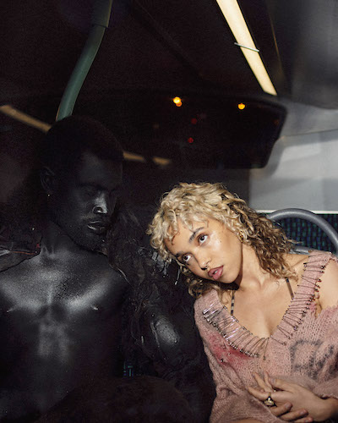
Photo Credit: Orograph
(Download high-res images here)

FKA twigs Official Site / Instagram / Facebook / Twitter / YouTube

For more information on FKA twigs, please contact:

Benny Tarantini / BT PR
Benny@BTPR.biz

Moya Crowley / BT PR
Moya@BTPR.biz

Ariana White / Atlantic Records
Ariana.White@atlanticrecords.com

