FOR IMMEDIATE RELEASE

MAY 20, 2022

**FOREST BLAKK RETURNS WITH NEW SINGLE “GIVE YOU LOVE”**

**ACCLAIMED SINGER/SONGWRITER ON TOUR SUPPORTING DEAN LEWIS**

[DOWNLOAD HIGH-RES ARTWORK HERE](http://press.atlanticrecords.com/forest-blakk/)

**STREAM “GIVE YOU LOVE”:** [LINK](https://forestblakk.lnk.to/giveyoulove)

Acclaimed singer/songwriter **Forest Blakk** has returned with new single “**Give You Love**” – available now via **Atlantic** **Records**. Currently on the road in North America supporting **Dean Lewis**, Blakk celebrates the release tonight with a show at New York City’s Webster Hall and continues with performances though July. For full routing, please visit [forestblakk.com/tour](https://www.forestblakk.com/tour/).

*“When you fall for someone you choose the good days along with the bad days. You invite all their crazy and amazing parts alike. With that, you give all the love you got in return. That’s what ‘Give You Love’ is all about. It’s accepting the people you love for all they are and loving them for it!”* – **FOREST BLAKK**

“**Give You Love**” pairs Blakk’s earnest songwriting with unconditional adoration, following in the footsteps of his smash 2021 single “**If You Love Her**.” Having amassed over 250 million total global streams to date and certified Gold in the United States (along with Platinum in his native Canada), “**If You Love Her**” earned Blakk his official US chart debut on **Billboard**’s **Emerging Artists** chart, his national US TV debut on **ABC**’s **Live with Kelly & Ryan,** top 30 placement on the Hot AC radio chart & saw the singer/songwriter collaborate with **Meghan** **Trainor** on a stunning duet version. Meanwhile his follow-up single “**Fall Into Me**,” co-written alongside **Matchbox Twenty** front man **Rob Thomas** and **Gregg** **Wattenberg** (**John** **Legend**, **O.A.R.**), has been streamed over 55 million times since release last fall and also reached top 30 on the Hot AC radio chart.

Highlighted as one of **PEOPLE Magazine**’s *“talented emerging artists making their mark on the musical landscape”* and deemed an *“artist on the rise”* by **Billboard**, Blakk made his debut with his 2018 EP ***Minutes*** and follow-up 2020 sophomore EP ***Sideways*** – the latter of which saw Blakk collaborate with the likes of **Will** **IDAP** (**Train**, **Florida** **Georgia** **Line**), **Nick Long** (**King Princess**), **Carl Ryden** (**Ricky Martin**, **David Guetta**), **Ollie** **Green** (**Freya** **Ridings**, **Gavin** **James**) & more to tell a love story through an incredibly realistic and candid lens. The 6-track collection featured singles “**I Wish I Knew**” (deemed an *“introspective look at love and love lost”* by **American Songwriter**) and uplifting anthem of resilience “**Put Your Hands Up**,” which debuted on an episode of **ABC**’s ***Grey’s Anatomy***. A compelling live performer, Blakk has toured extensively supporting **NEEDTOBREATHE**, **Gavin James** & more.

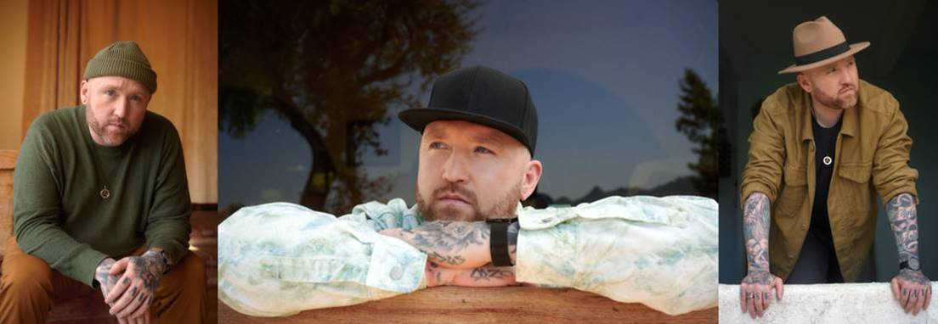

CREDIT: BENJAMIN ASKINAS – [DOWNLOAD HIGH-RES HERE](http://press.atlanticrecords.com/forest-blakk/)

**FOREST BLAKK LIVE:**

*all dates supporting Dean Lewis*

5/20 - New York, NY @ Webster Hall

5/21 - Boston, MA @ Roadrunner

5/23 - Montreal, QC @ MTELUS

5/24 - Toronto, ON @ Rebel

5/26 - Detroit, MI @ St. Andrews Hall

5/27 - Chicago, IL @ Park West

5/28 - Minneapolis, MN @ The Fillmore

5/30 - Denver, CO @ Ogden Theatre

5/31 - Salt Lake City, UT @ The Depot

6/2 - Vancouver, BC @ Malkin Bowl

6/4 - Seattle, WA @ The Showbox

6/5 - Portland, OR @ Roseland Theater

6/7 - San Francisco, CA @ Regency Ballroom

6/8 - Los Angeles, CA @ Fonda Theatre

6/11 - San Diego, CA @ The Observatory North Park

6/12 - Tempe, AZ @ Marquee Theatre

6/15 - Dallas, TX @ Granada Theater

6/16 - Austin, TX @ Emos

6/17 - Houston, TX @ Warehouse Live

6/20 - Asheville, NC @ The Orange Peel

6/21 - Richmond, VA @ The National

6/22 - Asbury Park, NJ @ Asbury Lanes

6/24 - Pittsburgh, PA @ Mr. Smalls Theatre

6/25 - Indianapolis, IN @ Deluxe at Old National Centre

6/28 - St. Louis, MO @ Delmar Hall

6/29 - Kansas City, MO @ The Truman

**CONNECT WITH FOREST BLAKK:**

[TIKTOK](https://www.tiktok.com/@forestblakk?lang=en) | [TWITTER](https://twitter.com/forestblakk) | [FACEBOOK](https://www.facebook.com/forestblakk) | [INSTAGRAM](https://www.instagram.com/forestblakk) | [YOUTUBE](https://www.youtube.com/channel/UC9vKX9Hz5dGVrhD5v3-UnAQ) | [FORESTBLAKK.COM](http://forestblakk.com/)

**CONTACT:**

[ted.sullivan@atlanticrecords.com](mailto:ted.sullivan@atlanticrecords.com)