FOR IMMEDIATE RELEASE
MAY 13, 2022

GALANTIS DROPS KNOCKOUT NEW SINGLE “1X1”

SUMMER-READY TRACK OUT NOW VIA BIG BEAT RECORDS

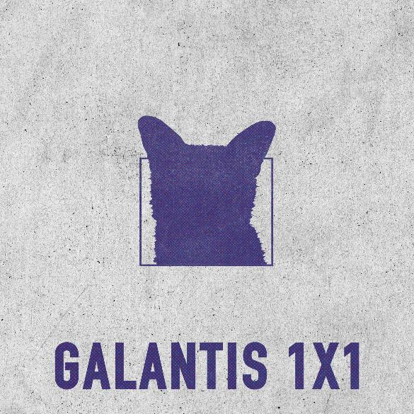
DOWNLOAD HIGH-RES IMAGES/ARTWORK

WATCH/STREAM “1X1”: LINK

Internationally-acclaimed collaborative project Galantis has dropped knockout new single “1x1” –available now alongside a mesmerizing and trippy lyric video via Big Beat Records. Tailor-made for summer, the track provides the drum, the bass, and the energy to bring the ceiling down in any venue and become a pool party staple – encompassing what Galantis does best, merging authentic electronic dance music with addictive lyrics and pop sensibility for every dance floor and festival. “1x1” arrives ahead of newly announced New York City shows at The Brooklyn Mirage – including a sold-out show celebrating Midsommar Eve on June 24th. For ticket information, please visit wearegalantis.com.

"’1x1’ is a club banger for the summer! Went in a bit of a different direction for this one, pulling some inspiration from early house music influences . Was a total goosebump moment to preview this tune at the sold out Red Rocks show last month, and now suuuuper excited for you all to hear it.”
- GALANTIS

The past few months have seen a series of massive releases from Galantis, most recently including a re-work of the Roxette classic “Fading Like A Flower,” and genre-bending collaborations such as “What It Feels Like” with Navos & YOU, “Good Luck” with Mabel & Jax Jones, “Run” with Becky Hill (sitting at #3 at US Dance Radio this week), “Sweet Talker” with Years & Years and a remix of Coldplay & BTS’ #1 single “My Universe.” Galantis also reunited with Little Mix for a remix of their single “No,” marking their second collaboration with the superstar group after their 2021 global smash hit “Heartbreak Anthem” alongside David Guetta.

***

ABOUT GALANTIS:
Setting a new standard for songwriting in dance music, Galantis is a collaborative project led by Christian Karlsson (aka Bloodshy, one-third of Miike Snow). Galantis' debut album Pharmacy reached No. 1 on the Billboard Dance album chart on the strength of RIAA gold certified single “Peanut Butter Jelly” and 2x platinum certified smash “Runaway (U & I)” – the latter of which earned GRAMMY nominations for “Best Dance Recording” and “Best Remixed Recording” – while 2017’s sophomore album The Aviary (featuring platinum certified single “No Money”) saw a top 10 debut in 23 countries. The third Galantis album, 2020’s Church, featured the chart-topping single “Faith” with country music icon Dolly Parton featuring Mr. Probz, which saw a #1 debut on Billboard’s Dance/Electronic Chart before quickly reaching #1 on the Dance/Mix Show Airplay Chart where it remained for 5 weeks. Meanwhile, 2021’s collaborative single “Heartbreak Anthem” with David Guetta & Little Mix proved a global sensation, spending 10 weeks on the Billboard Global 200 chart and reaching #1 on the overall UK Radio chart. Galantis has received over 7 billion cumulative worldwide streams, and over 1.8 billion video views to date.

The story of Galantis started back in 2009. Working as Bloodshy, Karlsson’s songwriting collaborations have included Madonna, Kylie Minogue, Katy Perry and Britney Spears (whose “Toxic” earned a GRAMMY for “Best Dance Recording”). This collaborative nature led to the birth of the Galantis project which had its live debut at 2014’s Coachella Valley Music and Arts Festival and has continued on years later as one of dance music's most dynamic and in-demand live performers.

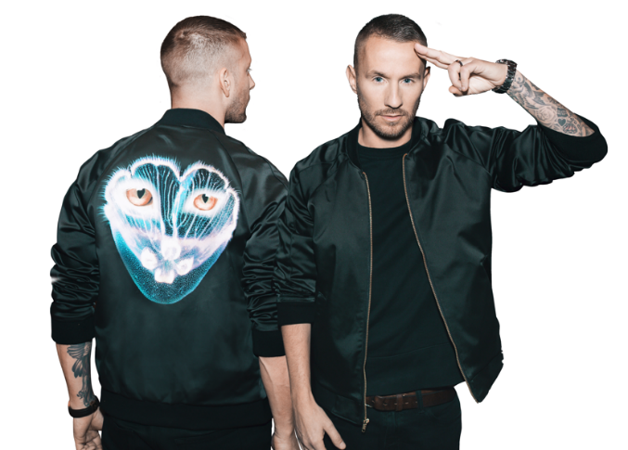
DOWNLOAD HIGH-RES IMAGES/ARTWORK

GALANTIS LIVE:
May 14 - Mexico City, MX - Tecate Emblema
May 15 - Las Vegas, NV - AYU
May 29- Indianapolis, IN - Snake Pit at Indy 500
June 4 - Guatemala City, Guatemala - Empire Festival
June 17 - Hangö, Finland Hanko Sommarfest
June 24 - Brooklyn , NY - Midsommar Eve at The Brooklyn Mirage
June 25 - Brooklyn, NY - Planet Pride at The Brooklyn Mirage
July 3 - Stockholm, Sweden - Lollapalooza Stockholm
July 13 - Kaldnes, Norway - Slottsjfell Festival
July 16- 17 - Chicago, IL - Heatwave Festival
July 29- 31 - Toronto, ON - VELD Festival
Aug 12, 2022 - Turku, Finland - Aura Fest
Aug 13, 2022 - Seinäjoki, Finland - Solar Sound Festival

CONNECT WITH GALANTIS:
WeAreGalantis.com | Twitter | Facebook | YouTube | Instagram | Press Assets

CONTACT:
Ted Sullivan (Atlantic Records) | Ted.Sullivan@atlanticrecords.com

