FOR IMMEDIATE RELEASE
JANUARY 8, 2021

Galantis & JVKE TEAM UP ON “DANDELION”

MESMERIZING NEW single out now VIA BIG BEAT RECORDS

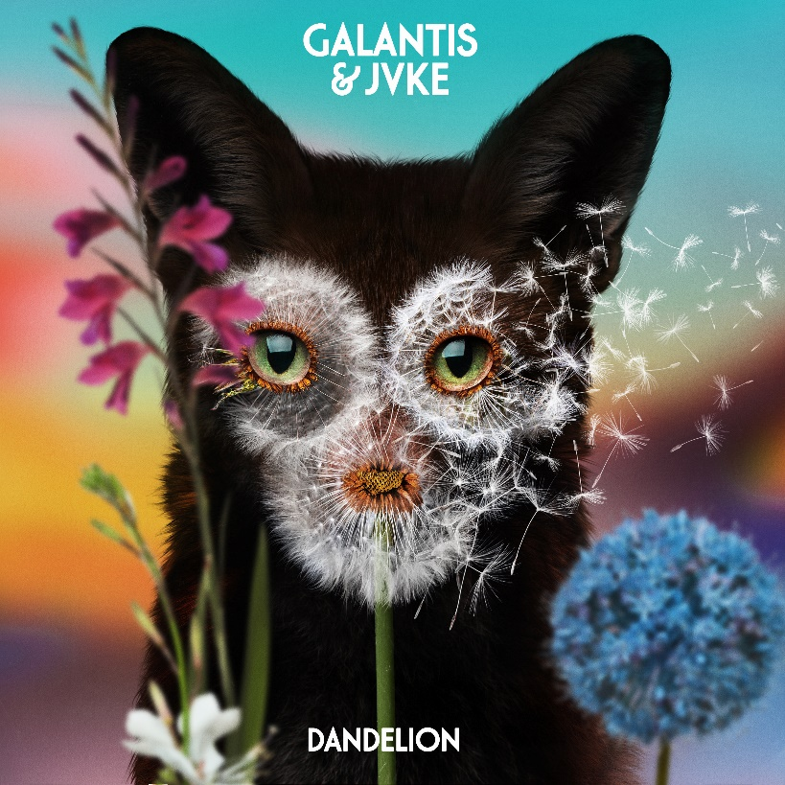
DOWNLOAD HIGH-RES IMAGES/ARTWORK

“DANDELION” LYRIC VIDEO: https://youtu.be/L0Y7GiSl1z8

Internationally-acclaimed collaborative project Galantis has teamed up with viral sensation JVKE for new single “Dandelion” – available now via Big Beat Records. The mesmerizing track tells a story of fleeting love with a signature sprightly beat and infectiously distorted vocals.

“’Dandelion’ came about after JVKE requested to hop on a Galantis Instagram Live. I recognized him from TikTok and I asked him what he was up to. He said he was working on an idea for a song and started to sing it for me. I really loved the vibe and he asked if I was down to work on it together. We ended up sending it back and forth and it became this natural organic collaboration with no real plan or goal. The past year has really changed how we make music and work with other artists, with negative circumstances actually opening doors to unlikely opportunities – GALANTIS

“Dandelion” marks the latest in a series of several genre-bending Galantis collaborations – most recently including “Tu Tu Tu (That’s Why We)” with NGHTMRE & Liam O’Donnell and “Pretty Please” with Jackson Wang – in addition to remixes for the likes of Pele (“Acredita No Véio” feat. Rodrigo Y Gabriela), Brando (“Don’t Call Me”) and Falling In Reverse (“Popular Monster” with NGHTMRE). Meanwhile, JVKE’s debut single “Upside Down” quickly became one of the biggest TikTok songs of 2020, generating over 15 million videos and over 7 billion plays on the app, in addition to a remix featuring Charlie Puth.

***

ABOUT GALANTIS:
Setting a new standard for songwriting in dance music, Galantis is a collaborative project led by Christian Karlsson (aka Bloodshy, one-third of Miike Snow). Galantis' debut album Pharmacy reached No. 1 on the Billboard Dance album chart on the strength of RIAA gold certified single “Peanut Butter Jelly” and 2x platinum certified smash “Runaway (U & I)” – the latter of which earned GRAMMY nominations for “Best Dance Recording” and “Best Remixed Recording” – while the 2017 sophomore album The Aviary (featuring platinum certified single “No Money”) saw a top 10 debut in 23 countries. Most recently, the third Galantis album Church featured the chart-topping single “Faith” with country music icon Dolly Parton featuring Dutch singer-songwriter Mr. Probz, which saw a #1 debut on Billboard’s Dance/Electronic Chart before quickly reaching #1 on the Dance/Mix Show Airplay Chart where it remained for 5 weeks. Galantis has received over 3 billion cumulative worldwide streams, and over 1 billion video views to date.

The story of Galantis started back in 2009. Working as Bloodshy, Karlsson’s songwriting collaborations have included Madonna, Kylie Minogue, Katy Perry and Britney Spears (whose “Toxic” earned a GRAMMY for “Best Dance Recording”). This collaborative nature led to the birth of the Galantis project which had its live debut at 2014’s Coachella Valley Music and Arts Festival and has continued on years later as one of dance music's most dynamic and in-demand live performers.

ABOUT JVKE:
JVKE is the artist behind the viral hit “Upside Down.” Since it’s release, the frothy, upbeat bop has risen to the top 3 most used sounds on TikTok (with over 15 million videos created and over 7 billion plays), climbed to #4 on Spotify’s US Viral and Global Viral charts (JVKE is the cover image for Spotify’s Pop Sauce x Teen Beats playlist), and is currently featured as the soundtrack for TikTok’s global TV commercial. This is JVKE’s debut single as a solo artist and features pulsing synthesizers and emo-pop melodies that sing about memories of a fresh love lost. He has previously landed cuts with global superstar Jason Derulo, South Korean-Chinese boy band EXO and K-pop group Super Junior.

JVKE joined TikTok in June 2020 and today counts over 3.5 million followers, he regularly shares videos creating mashups with his mom – his sounds have been used by TikTok stars like Charli D'Amelio, Bella Poarch and Loren Gray (among numerous others). He grew up surrounded by music and began playing piano, drums and guitar by age 3; by age 7 he was leading weekly performances at his church; by age 14 he was producing his own music; and at age 18 he dropped out of college and signed his first publishing deal.

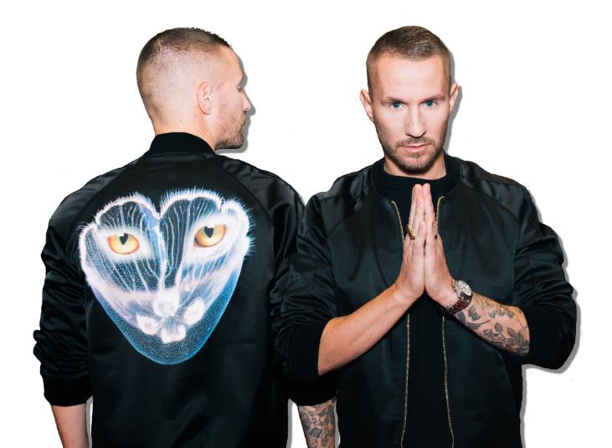
DOWNLOAD HIGH-RES IMAGES/ARTWORK

CONNECT:
WeAreGalantis.com | Twitter | Facebook | YouTube | Instagram | Press Assets

CONTACT:
Ted Sullivan | Ted.Sullivan@atlanticrecords.com

