FOR IMMEDIATE RELEASE

MAY 20, 2021 (12P EST)

**Galantis, David Guetta & Little Mix release “Heartbreak Anthem”**

**Explosive collaborative single & music video out now via Big Beat Records**

[DOWNLOAD HIGH-RES IMAGES/ARTWORK](http://press.wearebigbeat.com/artists/galantis/)

**WATCH “HEARTBREAK ANTHEM” VIDEO:** [https://Atlantic.lnk.to/HeartbreakAnthem/youtube](https://nam04.safelinks.protection.outlook.com/?url=https%3A%2F%2Fatlantic.lnk.to%2FHeartbreakAnthem%2Fyoutube&data=04%7C01%7CTed.Sullivan%40atlanticrecords.com%7C86424b6154e742dcd77808d91b07643f%7C8367939002ec4ba1ad3d69da3fdd637e%7C0%7C0%7C637570540849162518%7CUnknown%7CTWFpbGZsb3d8eyJWIjoiMC4wLjAwMDAiLCJQIjoiV2luMzIiLCJBTiI6Ik1haWwiLCJXVCI6Mn0%3D%7C1000&sdata=0T453hD1yowEE3e7DleCEAhU0ryQVUL9zvo3VxjcS6I%3D&reserved=0)

**STREAM “HEARTBREAK ANTHEM”:** <https://Atlantic.lnk.to/HeartbreakAnthemPR>

Internationally-acclaimed collaborative project **Galantis**, superstar DJ/producer **David Guetta** & global pop superstars **Little Mix** have joined forces for new single “**Heartbreak** **Anthem**” – available now via **Big Beat Records**. The explosive collaboration arrives alongside a striking music video directed by **Samuel Douek**, who most recently teamed up with **Little Mix** for their buzzworthy “**Confetti**” visual last month. Contrary to its title, “**Heartbreak** **Anthem**” proves a declaration of resilience – fusing the jaunty productions of the powerhouse producers with the impeccable harmonies of the world’s biggest girl band.

*"We’ve been working on ‘****Heartbreak******Anthem’*** *for over a year now! It started with just the chord progression at a studio in London right before the pandemic. As many collaborations have gone in these times, it was a remote work in progress for months, with stems sent back and forth from London to Los Angeles to Stockholm to Paris. We’d been talking with David about working together for a long time, and having* ***Little*** *Mix and their unique, strong vocals has made this one really special. Feels great to finally get this out into the world!"* – **Christian Karlsson** (**Galantis**).

***

**ABOUT GALANTIS:**

Setting a new standard for songwriting in dance music, **Galantis** is a collaborative project led by **Christian** **Karlsson** (aka **Bloodshy**, one-third of **Miike** **Snow**). **Galantis'** debut album ***Pharmacy*** reached No. 1 on the Billboard Dance album chart on the strength of RIAA gold certified single “**Peanut** **Butter** **Jelly**” and 2x platinum certified smash “**Runaway (U & I)**” – the latter of which earned GRAMMY nominations for “Best Dance Recording” and “Best Remixed Recording” – while 2017’s sophomore album ***The******Aviary*** (featuring platinum certified single “**No** **Money**”) saw a top 10 debut in 23 countries. Most recently, the third **Galantis** album ***Church*** featured the chart-topping single “**Faith**” with country music icon **Dolly** **Parton** featuring **Mr.** **Probz**, which saw a #1 debut on Billboard’s Dance/Electronic Chart before quickly reaching #1 on the Dance/Mix Show Airplay Chart where it remained for 5 weeks. **Galantis** has received over 4 billion cumulative worldwide streams, and over 1.5 billion video views to date.

The story of **Galantis** started back in 2009. Working as **Bloodshy**, Karlsson’s songwriting collaborations have included **Madonna**, **Kylie** **Minogue**, **Katy** **Perry** and **Britney** **Spears** (whose “**Toxic**” earned a GRAMMY for “Best Dance Recording”). This collaborative nature led to the birth of the **Galantis** project which had its live debut at 2014’s **Coachella Valley Music and Arts Festival** and has continued on years later as one of dance music's most dynamic and in-demand live performers.

**ABOUT DAVID GUETTA:**

There are artists and entertainers who achieve stardom and popularity, but few have the influence and endurance to redraw borders between genres and reshape the industry's dynamics. In 2009, "**When Love Takes Over**," the first single from his breakthrough album ***One Love*** hit #1 in the UK and the Guetta-produced **Black Eyed Peas** song "**I Gotta Feeling**" became a worldwide hit, topping the charts in 17 countries. Over the decade since, Guetta's success has been off the charts. Globally, he's racked up over 50 million record sales, where as his total number of streams is over 10 billion. He has received numerous Platinum and Gold certifications, was named *EDM Power Player* by **Billboard** and won two GRAMMY Awards out of six nominations. Besides his hard-won DJ skills, he is prolific in the studio, working with superstar artists like **Madonna**, **Rihanna**, **Lady** **Gaga**, **Snoop** **Dogg**, **Martin** **Garrix**, **Usher**, **Sia**, **John** **Legend**, **Nicki Minaj**, **Sean** **Paul**, **Kelly** **Rowland**, **Avicii**, **Ne-Yo**, **Akon** and more.  His seventh studio album titled ***7***, included huge electronic pop tracks like "**2U**" with **Justin** **Bieber**, "**Flames**" with **Sia**, "**Don't Leave Me Alone**" with **Anne-Marie**, "**Goodbye**" with **Jason** **Derulo**, **Nicki** **Minaj** and **Willy** **William** and "**Say My Name**" with **J Balvin** and **Bebe** **Rexha** plus a second disc of underground dance tracks, recorded under Guetta's **Jack Back** alias. With his wide-reaching and game-changing approach, he is more than just a DJ and producer: he's made dance music reach the mainstream, fused urban, electronic and pop music into new popular genres, and managed to stay on top of the game for decades.

**ABOUT LITTLE MIX:**

With over 60 million records sold, 10 billion global streams, over 5 billion YouTube views, 5 platinum albums, 5 UK number 1 singles, and over 2 million tickets sold **Little Mix** are officially the worlds biggest girl band. Since forming 10 years ago **Little Mix** have been an unstoppable force in British pop music. The recent album ***Confetti*** gave them their 6th top 5 album and included the number 1 single “**Sweet Melody**” which has just reached over 200 million streams worldwide. VEVO crowned them the *Most Watched UK Act Of 2020* and the UK charts recently classed them as the *Best Selling Girl Group In UK History* based on track sales. 2021 saw **Little Mix** make BRIT Award history as the first girl band ever to win Best British Group in its 43 year history.

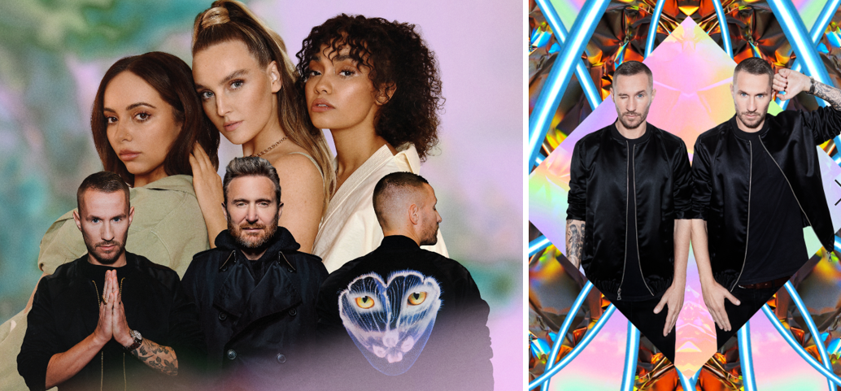

[DOWNLOAD HIGH-RES IMAGES/ARTWORK](http://press.wearebigbeat.com/artists/galantis/)

**CONNECT WITH GALANTIS:**

[WeAreGalantis.com](http://www.wearegalantis.com/) | [Twitter](http://www.twitter.com/wearegalantis) | [Facebook](http://www.facebook.com/wearegalantis) | [YouTube](http://www.youtube.com/user/galantistv) | [Instagram](http://www.instagram.com/wearegalantis) | [Assets](http://press.wearebigbeat.com/artists/galantis/)

**CONNECT WITH DAVID GUETTA:**

[DavidGuetta.com](https://davidguetta.com/) | [Twitter](https://twitter.com/davidguetta) | [Facebook](https://www.facebook.com/DavidGuetta) | [YouTube](https://www.youtube.com/channel/UC1l7wYrva1qCH-wgqcHaaRg) | [Instagram](https://www.instagram.com/davidguetta/)

**CONNECT WITH LITTLE MIX:**

[Little-Mix.com](https://www.little-mix.com/) | [Twitter](https://twitter.com/LittleMix) | [Facebook](https://www.facebook.com/LittleMix) | [YouTube](https://www.youtube.com/channel/UCIvqWqjC4aLvp7zI8hzARrA) | [Instagram](https://www.instagram.com/littlemix/)

**CONTACT:**

Ted Sullivan (Atlantic Records) | [Ted.Sullivan@atlanticrecords.com](mailto:Ted.Sullivan@atlanticrecords.com)