FOR IMMEDIATE RELEASE
NOVEMBER 22, 2021
2021 BREAKOUT STAR, POOH SHIESTY, EARNS FIRST GRAMMY NOMINATION AT THE 64TH? GRAMMY AWARDS
CATEGORIES INCLUDE XXX
NOMINATIONS ARRIVE WEEKS AFTER “BACK IN BLOOD” EARNS 3X PLATINUM CERTIFICATION

ART

Pooh Shiesty’s “Back In Blood” ft Lil Durk has officially earned him his first GRAMMY nomination for the 64th Annual GRAMMY Awards® CATEGORIES. After storming his way onto the scene with the now 3x platinum earworm, Shiesty quickly earned the crown as one of 2021’s biggest breakout stars. The 64th Annual GRAMMY Awards® will be held Monday, January 31, 2022.
The certified blockbuster rose to #13 on Billboard’s “Hot 100” earlier this year while spending multiple weeks atop Rolling Stone’s “Top 100” and both Apple Music’s overall and “Hip-Hop/Rap” charts. The track’s official companion visual now celebrates over 209M views on YouTube after earning 2.4M of those views within its first 24 hours and instantly trending.

“Back In Blood” helped usher in Shiesty’s debut mixtape, SHIESTY SEASON, which exploded onto Billboard’s “Top Rap Albums” at #1 upon its February release while also peaking at #3 on the Billboard 200. The acclaimed mixtape topped Rolling Stone’s “Top 200” (#3), Spotify’s “Top US Albums” (#1) and both Apple Music’s overall and “Hip-Hop/Rap” charts (#1). Upon release, all 17 tracks on SHIESTY SEASON hit the top 50 on Apple Music’s overall “Top Songs” chart.

Earlier this year, Shiesty made his TV debut on The Tonight Show Starring Jimmy Fallon with a performance of “Back In Blood” and earned his first award show nomination for Best New Artist at the 2021 BET Awards, later followed by multiple nominations at the 2021 BET Hip-Hop Awards (Best New Hip-Hop Artist, Song of the Year, Best Collaboration). He was also seen on the cover of XXL’s 2021 Freshman Class Issue and crowned as “Rookie Of The Year” by RapCaviar. As of June 2021, he became 1 of only 2 Black artists to release and certify a debut project this year while SHIESTY SEASON became recognized as one of the highest selling hip-hop projects this year.

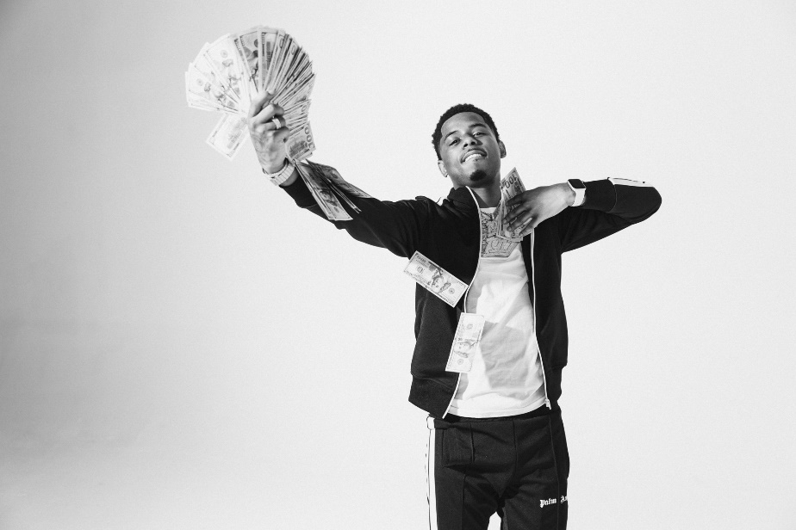
DOWNLOAD HI-RES PRESS IMAGES HERE
VIEW FULL BIO HERE

CONNECT:
WEBSITE | INSTAGRAM | TWITTER | FACEBOOK | SOUNDCLOUD | AUDIOMACK

POOH SHIESTY CONTACT:
SELAM.BELAY@ATLANTICRECORDS.COM

