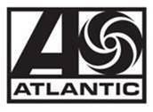

JACK HARLOW REVEALS TRACKLIST FOR NEW ALBUM
‘COME HOME THE KIDS MISS YOU’

HIGHLY ANTICIPATED SOPHOMORE ALBUM FEATURES:
DRAKE, LIL WAYNE, JUSTIN TIMBERLAKE & PHARRELL

‘COME HOME THE KIDS MISS YOU’ ARRIVES THIS FRIDAY, MAY 6

“FIRST CLASS” CONTINUES REIGN AS ONE OF THE BIGGEST SONGS IN THE WORLD

RAP SUPERSTAR STUNNED IN GIVENCHY AT LAST NIGHT’S MET GALA

Download/Stream “First Class” here
Pre-order COME HOME THE KIDS MISS YOU here

WATCH ‘CHTKMY’ ALBUM TRAILER
Starring Danielle Fishel (Topanga Lawrence on Boy Meets World)
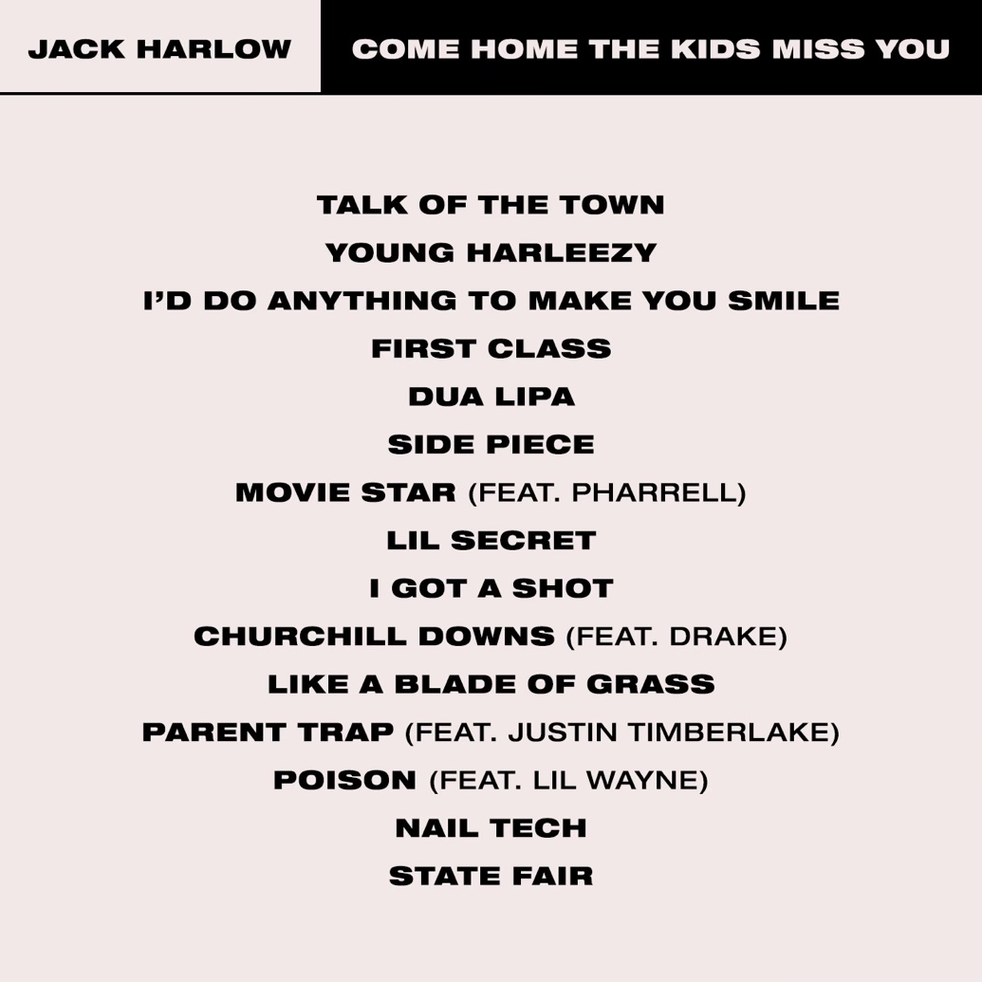

(Photo Credit: Urban Wyatt)

TRACKLIST:
1. Talk Of The Town
2. Young Harleezy
3. I’d Do Anything To Make You Smile
4. First Class
5. Dua Lipa
6. Side Piece
7. Movie Star (feat. Pharrell)
8. Lil Secret
9. I Got A Shot
10. Churchill Downs (feat. Drake)
11. Like A Blade Of Grass
12. Parent Trap (feat. Justin Timberlake)
13. Poison (feat. Lil Wayne)
14. Nail Tech
15. State Fair

* * *

Read Jack’s full Rolling Stone cover story here. On newsstands now!

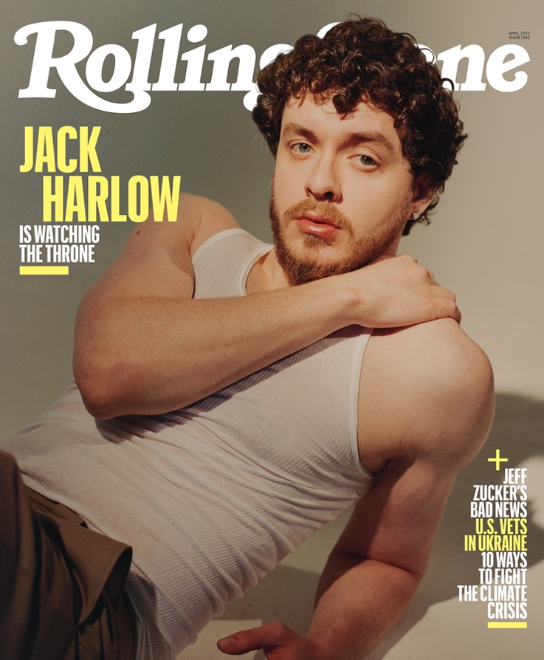

* * *

ABOUT JACK HARLOW:
Hailed as the “hitmaker of tomorrow” by Variety, Jack Harlow is one of music’s greatest new stars. The Louisville, KY native boasts three GRAMMY Award nominations, two #1 singles, 12 RIAA platinum certifications, and over 5 billion career streams to date. Harlow released his critically acclaimed, RIAA platinum certified debut album, THATS WHAT THEY ALL SAY in December 2020, which featured the 7x Platinum worldwide hit, “WHATS POPPIN,” which peaked at #2 on the Billboard Hot 100 chart and earned the 24-year-old his first GRAMMY nomination for “Best Rap Performance,” along with a wide array of other award nominations.

The Generation Now/Atlantic Records star has graced the covers of Rolling Stone, Forbes, Variety, Complex, SPIN, Footwear News and XXL’s coveted Freshman Class Issue, and brought his captivating live show to TV with performances on Saturday Night Live, The Tonight Show Starring Jimmy Fallon, Jimmy Kimmel Live!, the 2021 MTV Video Music Awards, and the 2022 Kids Choice Awards, to name a few.

Harlow is now poised to reach even greater heights with his hugely anticipated second album, COME HOME THE KIDS MISS YOU, highlighted by the bombastic lead single “Nail Tech” and the infectious follow-up, “First Class,” which made a spectacular debut at atop the Billboard “Hot 100,” marking his first solo #1 single, while earning the biggest streaming week of 2022, thus far.

For all Jack Harlow press inquiries, please contact:
Jason Davis jason.davis@atlanticrecords.com

# # #

