JASIAH AND JXDN UNLEASH “EARTHQUAKE” VISUAL
NEW VISUAL PRODUCED BY DAMIEN WAYNE, SINGLE PRODUCED BY JOHN FELDMANN & TRAVIS BARKER
GENRE-BENDING RECORDING ARTIST ANNOUNCED TO PERFORM AT LOLLAPALOOZA
JASIAH TO JOIN JXDN ON TELL ME ABOUT TOMORROW TOUR THIS SPRING
LISTEN HERE
WATCH HERE
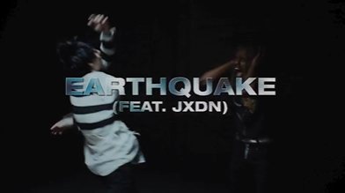
CONNECT WITH JASIAH:
WEBSITE | FACEBOOK | TWITTER | INSTAGRAM | YOUTUBE

CONTACT:
JASON DAVIS | JASON.DAVIS@ATLANTICRECORDS.COM

# # #

