NEW ALBUM ‘LAST NIGHT IN THE BITTERSWEET’
TO BE RELEASED ON JULY 1ST - PRE-ORDER HERE

FEATURING THE NEW SINGLES ‘LOSE IT’ AND ‘THROUGH THE ECHOES’
LISTEN HERE

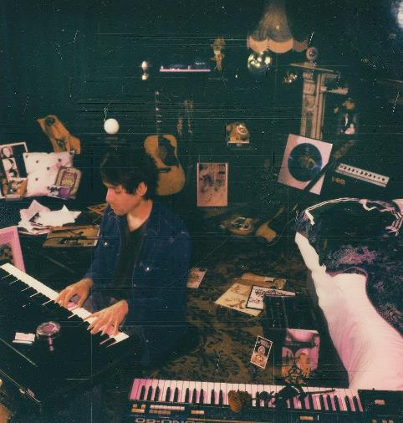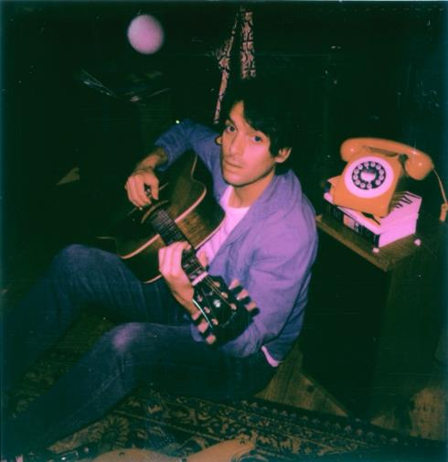

Download the album artwork HERE / Photo Credit: Shamil Tanna

Paolo Nutini is set to release his new album and fourth studio set ‘Last Night In The Bittersweet’ on July 1st via Atlantic Records. He launches the album by sharing two new singles, ‘Lose It’ and ‘Through The Echoes’. Listen HERE. Earlier this week Paolo announced seven intimate UK shows which sold-out immediately, kicking off in Sheffield this weekend and include 4 shows at London’s 100 Club next week.

A recap of everything Paolo has achieved to date reiterates his status as one of British music’s biggest success stories. Two of his three albums to date, ‘Sunny Side Up’ and ‘Caustic Love’, have hit #1 on the UK album charts as he amassed 8 million global album sales, 8 million UK single sales, and 1.5 billion global streams. The Ivor Novello winner and multiple BRIT Award nominee has also collected a remarkable 18 Platinum certifications in the UK alone. Paolo has previously headlined festivals including Glastonbury’s Other Stage and Benicàssim, as well as huge arena shows at London’s O2 and Glasgow’s OVO Hydro.

‘Last Night In The Bittersweet’ will only extend that phenomenal success. It’s a 70-minute epic that spans the distance from classic rock to post-punk to hypnotic Krautrock, in the process proving its value as his deepest, most varied, most accomplished, and ultimately most rewarding set so far. The insistent Motorik rhythms of new single ‘Lose It’ brings shades of early ‘70s German bands like Can and Neu!, and are a product of Paolo writing increasingly on bass guitar. At the other end of the spectrum, ‘Through The Echoes’ is a timeless classic in the lineage of Ben E. King and Otis Redding, with Nutini’s vocal delivery reminding us why he got snapped up by Atlantic in the first place.

‘Last Night In The Bittersweet’ was produced by Paolo Nutini alongside Dani Castelar and Gavin Fitzjohn. It was written by Paolo, with some select co-write contributions from members of his band.

‘Last Night In The Bittersweet’ is now available to pre-order HERE. Notable physical formats include a clear green double-vinyl which is available exclusively from Paolo’s official store, while key Scottish indie stores are offering an exclusive white marble double-vinyl.

Paolo Nutini will be touring this summer when he hits the road headlining TRNSMT and Victorious Festivals and two large outdoor shows in Bristol and Belfast, plus very special guest billing at Liam Gallagher’s huge Knebworth Park show. Meanwhile, European dates include a tour of Italy in July as well as the Montreux Jazz Festival and Lollapalooza Berlin. Please see HERE for a full list of dates.

‘Last Night In The Bittersweet’ tracklist:

- ‘Afterneath’
- ‘Radio’
- ‘Through The Echoes’
- ‘Acid Eyes’
- ‘Stranded Words’ (Interlude)
- ‘Lose It’
- ‘Petrified In Love’
- ‘Everywhere’
- ‘Abigail’
- ‘Children of the Stars’
- ‘Heart Filled Up’
- ‘Shine A Light’
- ‘Desperation’
- ‘Julianne’
- ‘Take Me Take Mine’
- ‘Writer’

Full list of live shows:

MAY
14th - Sheffield, The Leadmill (SOLD OUT)
16th - London, 100 Club (SOLD OUT)
17th - London, 100 Club (SOLD OUT)
19th - London, 100 Club (SOLD OUT)
20th - London, 100 Club (SOLD OUT)
27th - Oban, Corran Halls (SOLD OUT)
28th - Oban, Corran Halls (SOLD OUT)

JUNE
3rd - Knebworth Park (very special guest to Liam Gallagher, SOLD OUT)
23rd - Bristol, Sounds at Canons Marsh Amphitheatre (SOLD OUT)

JULY
5th - Montreux, Montreux Jazz Festival
8th - Glasgow, TRNSMT
15th - Brescia, Anfiteatro Vittoriale (SOLD OUT)
16th - Pistoia, Pistoia Blues
19th - Rome, Cavea (SOLD OUT)
20th - Bologna, Sequoie Music Park (SOLD OUT)
22nd - Servigliano, NoSound Festival
23rd - Trani, Locus Festival
25th - Caserta, Belvedere Di San Leucio (SOLD OUT)
27th - Taormina, Teatro Antico

AUGUST
25th - Belfast, Custom House Square (SOLD OUT)
27th - Portsmouth, Victorious Festival

SEPTEMBER
9th - Malaga, Andalucia Big Festival
24th - Berlin, Lollapalooza Berlin

Follow Paolo Nutini:
Spotify | Apple Music | YouTube | Facebook | Twitter | Instagram | Website

For more information please contact christina.kotsamanidis@atlanticrecords.com

