FOR IMMEDIATE RELEASE
APRIL 22, 2022

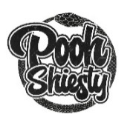

POOH SHIESTY CELEBRATES RIAA PLATINUM SUCCESS OF SHIESTY SEASON
WITH DELUXE EXPANDED EDITION AND SMILESSS X SHIESTY SEASON NFT COLLECTION

NFT COLLECTION AVAILABLE WEDNESDAY, APRIL 27 VIA WWW.SHIESTY.SMILESSS.COM WITH 1 OF 1 AUCTION ONLY ON OPENSEA

SHIESTY SEASON: CERTIFIED ARRIVES VIA GUCCI MANE’S THE NEW 1017/ATLANTIC
ON FRIDAY, APRIL 29

DOWNLOAD HI-RES ART HERE

Multi-platinum Memphis rapper Pooh Shiesty is celebrating the RIAA platinum certified success of his blockbuster debut mixtape, SHIESTY SEASON, with a newly expanded deluxe edition SHIESTY SEASON: CERTIFIED that will be available in spatial audio on April 29th. Shiesty is also teaming up with the prominent digital artist behind the Shiesty Season art – Smilesss co-founder Waheed Zai – for an exclusive NFT collection dropping on Wednesday, April 27th.

SHIESTY SEASON: CERTIFIED arrives via Gucci Mane’s The New 1017 and Atlantic Records on Friday, April 29; pre-orders are available now. This release will include a handful of new tracks from Shiesty with appearances from Gucci Mane, Lil Uzi Vert, BIG30, 42 Dugg, EST Gee and more. SHIESTY SEASON: CERTIFIED arrives after the recently released SHIESTY SEASON – SPRING DELUXE which introduced 4 new tracks with appearances from Lil Baby and G Herbo.

For the Smilesss x Shiesty Season NFT collection, 250/each of the four Shiesty Season alternate covers (winter, summer, spring, and fall) will be available to mint (1,000 pieces in total) along with a 24-hour 1-of-1 auction of the official SHIESTY SEASON mixtape cover exclusively on OpenSea, all designed by Waheed Zai, the co-creator of the web 3 streetwear brand Smilesss, and artist behind the original SHIESTY SEASON cover art . In partnership with Infinite Objects , the first 20 collectors of all 4 Seasons will receive a video print displaying their newly minted NFTs.

“As I look back, what at the time felt like a good commission opportunity, now is a significant moment in my artistic career. I took a leap of faith to build something I hadn’t built before, and Pooh Shiesty and his team took a gamble on having me deliver on that promise,” Waheed tells COMPLEX. “Months later, that risk allowed me to create my own world through Smilesssvrs. With Pooh’s album going Platinum and me building my own name and world via my NFT project, it felt inevitable to come together to help highlight and celebrate our growth as artists over the past year, which birthed Smilesss x Shiesty Season.”
Buyers of the NFT will receive an exclusive t-shirt and ski mask designed by Waheed, a holder-only metaverse wearable, plus an exclusive first listen to SHIESTY SEASON: CERTIFIED, exclusively in Smilesss discord. In addition, the winner of the OpenSea 1-of-1 auction will also receive a personalized SHIESTY SEASON platinum plaque. The Smilesss x Shiesty Season NFT collection drops Wednesday, April 27 at 1:20 pm (PST)/4:20 pm (EST) at www.shiesty.smilesss.com, with the 1-of-1 action following at 4:20 pm (PST)/ 7:20 pm (EST), exclusively on OpenSea.

ABOUT POOH SHIESTY:
Memphis rapper Pooh Shiesty snakes through airy beats with a venomous bite and slick melodies. On his certified platinum debut mixtape, the chart-topping SHIESTY SEASON, Pooh captivated with his undeniably catchy, southern flows. The highly anticipated project topped Apple Music’s pre-add chart for 2 weeks straight and later debuted at #1 on Billboard’s Top Rap Albums while peaking at #3 on the Billboard 200. He also simultaneously held 3 spots on the Hot 100 with the 2x platinum earworm “Back In Blood” leading the way and peaking at #13. The official visual topped YouTube’s “Top Music Videos” earning over 245M views.

As he continued to top several charts including Billboard’s “Emerging Artists” and “Artist 100” charts and the #1 spot on Rolling Stone’s “Breakthrough 25,” Pooh went on to make his TV debut on The Tonight Show Starring Jimmy Fallon with a performance of “Back In Blood” and earn his first award show nomination for Best New Artist at the 2021 BET Awards, later followed by multiple nominations at the 2021 BET Hip-Hop Awards (Best New Hip-Hop Artist, Song of the Year, Best Collaboration) and the 2022 Billboard Music Awards (Top New Artist). He was also seen on the cover of XXL’s 2021 Freshman Class Issue and crowned as “Rookie Of The Year” by RapCaviar.

ABOUT SMILESSS:
Smilesss was born out of the cultural crossroads of hip-hop, fashion and technology. Aiming to redefine luxury streetwear, we’re pushing and flexing the boundaries of fashion across the physical and digital realms. The Smilesss NFT collection consists of 8,888 full-body characters designed by artist Waheed Zai. The collection contains over 200 traits representing different aspects of culture from everyday life to music to sports. For more information, please visit www.smilesss.com or @smilesss on Twitter.

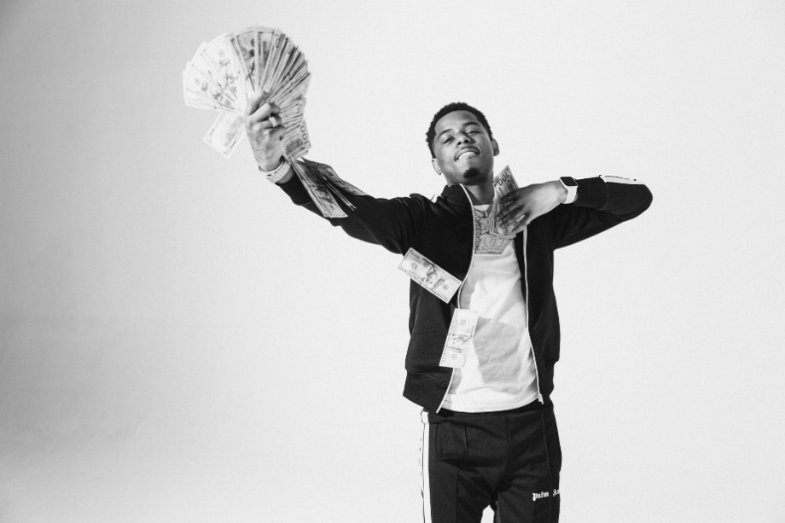
DOWNLOAD HI-RES PRESS IMAGES HERE

CONNECT:
WEBSITE | INSTAGRAM | TWITTER | FACEBOOK | SOUNDCLOUD | AUDIOMACK

POOH SHIESTY PRESS CONTACT:
SELAM.BELAY@ATLANTICRECORDS.COM

