FOR IMMEDIATE RELEASE
MAY 21, 2021
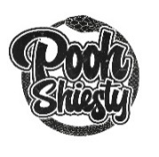

POOH SHIESTY UNVEILS SHIESTY SEASON – SPRING DELUXE

SPRING DELUXE SEES 4 ADDITIONAL TRACKS WITH APPEARANCES FROM G HERBO & LIL BABY

SHIESTY SEASON SPRING DELUXE AVAILABLE NOW

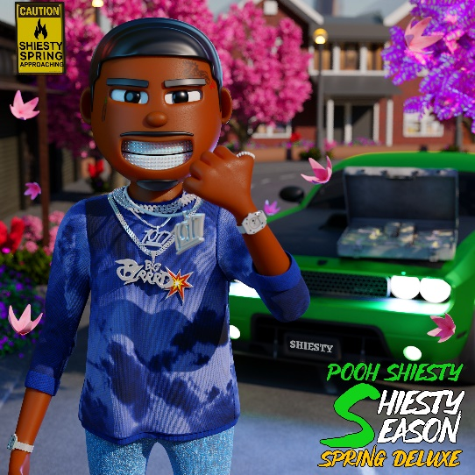
DOWNLOAD HI-RES GRAPHIC HERE

Platinum certified Memphis, TN rapper POOH SHIESTY has announced the arrival of the expanded version of his breakthrough mixtape, SHIESTY SEASON – SPRING DELUXE via Gucci Mane’s The New 1017/Atlantic Records. The deluxe sees appearances from G Herbo for “Switch It Up” and Lil Baby for “Welcome To The Riches.”

After topping Apple Music’s pre-add chart for 2 weeks straight SHIESTY SEASON exploded onto Billboard’s “Top Rap Albums” at #1 upon its February release, while also debuting at #4 on the “Billboard 200” before peaking at #3. In addition, the acclaimed mixtape topped Rolling Stone’s “Top 200” (#3), Spotify’s “Top US Albums” (#1) and both Apple Music’s overall and “Hip-Hop/Rap” charts (#1). Upon release, all 17 tracks on SHIESTY SEASON hit the top 50 on Apple Music’s overall “Top Songs” chart.

SHIESTY SEASON’s overwhelming popular success was led by the RIAA platinum certified blockbuster, “Back In Blood (Feat. Lil Durk),” which rose to #13 on Billboard’s “Hot 100” earlier this year while spending multiple weeks atop Rolling Stone’s “Top 100” and both Apple Music’s overall and “Hip-Hop/Rap” charts. The track’s official companion visual now celebrates over 142M views on YouTube after earning 2.4M of those views within its first 24 hours. The mixtape also included “Neighbors (Feat. BIG30)“ and “Box of Churches (Feat. 21 Savage),” both of which made an appearance on Billboard’s “Hot 100” earlier this year. Other notable tracks include “Guard Up” (15.4M views) “See Red” (16.9M views) and “Ugly” feat Gucci Mane (10.7M views). Shortly after the success of SHIESTY SEASON, he was also seen on the JUDAS AND THE BLACK MESSIAH original motion picture soundtrack with “No Profanity.”

Recently named as Billboard’s first-ever “Hip-Hop/R&B Rookie of The Month“ as well as one of their “15 Hip-Hop & R&B Artists to Watch in 2021,” Pooh Shiesty has quickly proven a critically acclaimed, breakout new star. This year has seen the Memphis rapper debut on multiple charts including Billboard’s “Emerging Artists” and “Artist 100” charts and the #1 spot on Rolling Stone’s “Breakthrough 25.” Furthermore, Pooh was ranked among Complex’s “Rappers to Watch in 2021“ and Rap Caviar’s “10 Artists to Watch in 2021.” Pooh also recently made his network television debut with a performance of “Back In Blood” on NBC’s The Tonight Show Starring Jimmy Fallon and was spotlighted as Audiomack’s February UpNow artist, February’s Noisey Next artist and BET’s Amplified Artist of the Month for April.

# # #

SHIESTY SEASON – SPRING DELUXE
POOH SHIESTY
THE NEW 1017/ATLANTIC RECORDS

- Switch It Up feat. G Herbo & No More Heroes
- Welcome To The Riches feat. Lil Baby
- See Me Comin
- Murder Skool
- Shiesty Season Intro
- Back In Blood feat. Lil Durk
- Guard Up
- Ugly feat. Gucci Mane
- Neighbors feat. BIG30
- 50 Shots
- No Chorus
- Box of Churches feat. 21 Savage
- Making A Mess feat. BIG30 & Veeze
- Choppa Way
- Take A Life feat. Foogiano
- Gone MIA
- Big 13 Gang feat. Lil Hank & Choppa Wop
- Drop Some Shit
- See Red
- Master P (feat. Tay Keith)
- Twerksum
# # #

“…we’re all witnessing something special right before our eyes.”
– REVOLT

“Pooh Shiesty is already a star.”
- STEREOGUM

“For Memphis native Pooh Shiesty, the release of his debut Shiesty Season feels more like a highly anticipated follow-up rather than his first trip around the block.”
– HIPHOPDX

“…one of the hardest new rappers out…his potential is through the roof…”
- COMPLEX
# # #

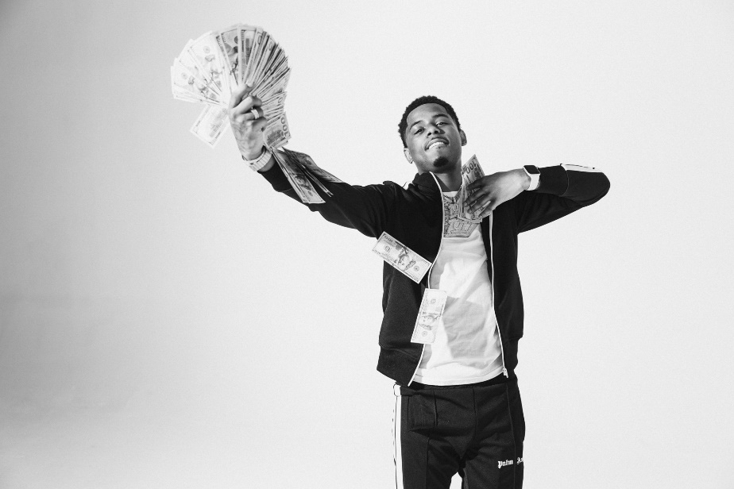
DOWNLOAD HI-RES PRESS IMAGES HERE
VIEW FULL BIO HERE

CONNECT:
WEBSITE | INSTAGRAM | TWITTER | FACEBOOK | SOUNDCLOUD | AUDIOMACK

POOH SHIESTY CONTACT:
SELAM.BELAY@ATLANTICRECORDS.COM

THE NEW 1017 LABEL CONTACT:
ASHLEY.KALMANOWITZ@ATLANTICRECORDS.COM

