FOR IMMEDIATE RELEASE
MAY 20, 2022

HAYLEY KIYOKO DEBUTS NEW SINGLE “FOR THE GIRLS”
FROM UPCOMING SOPHOMORE ALBUM PANORAMA

GROUNDBREAKING POP STAR DREAMS UP ROMANTIC QUEER PARODY OF
AMERICA’S FAVORITE DATING SHOW IN SELF-DIRECTED MUSIC VIDEO

HIGHLY ANTICIPATED NEW ALBUM PANORAMA ARRIVES JULY 29

SUMMER TOUR WITH LAUV KICKS OFF AUGUST 11

LISTEN TO “FOR THE GIRLS” | WATCH OFFICIAL MUSIC VIDEO
PRE-ORDER/PRE-SAVE PANORAMA

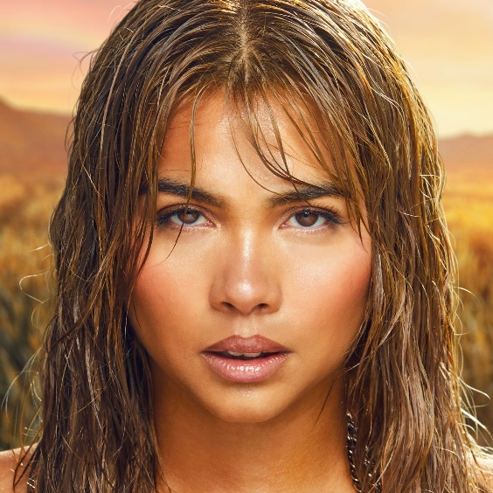
(Download Hi-Res Single + Album Artwork // Credit: Trevor Flores)

Trailblazing pop star Hayley Kiyoko has released her bass-boosted new single “For The Girls” off her highly anticipated sophomore album, Panorama, out July 29 via Atlantic Records. Produced by German (Justin Bieber, Katy Perry) and co-written by Kiyoko, Marc Lomax (Justin Bieber, Ava Max) and Michelle Buzz (Kylie Minogue, Bebe Rexha), “For The Girls” is available now at all DSPs and streaming services – listen HERE and pre-order Panorama HERE.

Complete with chaotic reality melodrama, a cameo from Hayley’s dad himself and a surprise appearance from a past reality show contestant, the new single’s self-directed music video sees Kiyoko starring in a romantic queer parody of America’s favorite dating show. Following its broadcast premiere on MTV Live, MTVU, and Nick Music, the video is available to watch now on Hayley’s official YouTube channel HERE.

“I love being a woman, and women have always been a massive influence on my life,” says Hayley. “‘For The Girls’ is an anthem celebrating that love, highlighting our strength, beauty, and vulnerability. The music video is meant to reflect that celebration with a sense of humor and an expansive take on whose romantic story gets told. It was so much fun to direct, especially since it’s a nod to one of my favorite reality shows of all time. I wanted the music video to give representation to all of us searching for love while not taking ourselves too seriously. Being surrounded by queer people of many different gender identities and making art that feels relevant to us was the greatest gift. It was a reminder of how resilient this community is and how strong and confident we feel being our authentic selves together. No matter how you identify or who you love, I hope this summer bop makes you feel sexy and empowered.”

“For The Girls” joins Kiyoko’s most recent releases, the catchy, effervescent “Found My Friends” and romantic, hopeful “Chance” all set to be featured on Panorama. Following her 2018 landmark debut album EXPECTATIONS, Hayley created Panorama with frequent collaborators, Pat Morrissey and Kill Dave, in addition to new kindred creative spirit and executive producer, Danja (Justin Timberlake, Britney Spears).

To celebrate the release of Panorama, Hayley will join Lauv as special guest on his “All 4 Nothing Tour,” kicking off August 11 with stops at New York’s Hammerstein Ballroom on August 26 and 27 as well as LA’s Greek Theatre on September 9. For complete details and ticket information, please visit hayleykiyoko.lnk.to/LauvTour.

Hayley continues to make meaningful impact as she visited the White House this past week to celebrate AAPI heritage month and will co-headline London’s Pride festivities at Proud and Loud: Celebrating 50 Years Of Pride at Royal Albert Hall on June 4 with tickets still available for purchase. She will also headline The Infatuation’s EEEEEATSCON presented by Chase Sapphire at the Barker Hangar (Santa Monica, CA) engaging in a conversation surrounding authentic representation moderated by Angie Báez (VP of Diversity, Equity, Inclusion at The Infatuation and Zagat) on Sunday, May 22.

Kiyoko has become one of the most celebrated pop artists since releasing EXPECTATIONS, which — according to Rolling Stone, placed her “at the forefront of an unapologetically queer pop movement.” In #20GAYTEEN, the multihyphenate performer was nominated for two VMAs and won “Push Artist Of The Year.” Since her 2015 debut, Hayley has amassed nearly 1B global streams and over 2.2M YouTube subscribers, accrued over 817M lifetime YouTube views, and sold out numerous venues across the country and abroad. Lauded as one of “The 21st Century's Most Influential Women Musicians” by NPR, Hayley inspires her community through nuanced storytelling and lyricism, encouraging hope as her resounding message.

Last year, Hayley launched her first-ever gender-inclusive fragrance, Hue, available to order at huebyhayley.com. An audacious scent designed as an expression of liberation, freedom, and self-empowerment, Hue is a 2022 finalist for the Fragrance Foundation’s “Universal Prestige Award” and has received coverage from Vogue, Allure, NYLON, Glamour, Cosmopolitan, and more.

(Download Hi-Res Press Photos // Credit: Trevor Flores)

HAYLEY KIYOKO ON TOUR 2022

JUNE
4 – London, UK – Proud and Loud: Celebrating 50 Years Of Pride – Royal Albert Hall

AUGUST
11 – Minneapolis, MN – The Armory
12 – Chicago, IL – Byline Bank Aragon Ballroom
13 – Detroit, MI – Meadow Brook
15 – Toronto, ON – RBC Echo Beach
16 – Montreal, QC – Place Bell
17 – Boston, MA – Leader Bank Pavilion
19 – Philadelphia, PA – The Met Philadelphia
20 – Pittsburgh, PA – Stage AE
21 – Cincinnati, OH – ICON (Rockstar Energy Drink Stage at Smale Park)
23 – Columbus, OH – KEMBA Live!
25 – Washington, DC – The Anthem
26 – New York, NY – Hammerstein Ballroom
27 – New York, NY – Hammerstein Ballroom
28 – Asbury Park, NJ – Stone Pony Summer Stage
30 – Charlotte, NC – Charlotte Metro Credit Union Amphitheater
31 – Atlanta, GA – Coca-Cola Roxy

SEPTEMBER
1 – Nashville, TN – Ryman Auditorium
3 – Houston, TX – 713 Music Hall
4 – Dallas, TX – Pavilion at Toyota Music Factory
6 – Denver, CO – Mission Ballroom
7 – Ogden, UT – Ogden Amphitheater
9 – Los Angeles, CA – Greek Theatre
11 – San Diego, CA – Cal Coast Credit Union Open Air Theatre
12 – Phoenix, AZ – Arizona Federal Theatre
15 – Berkeley, CA – Greek Theatre @ UC Berkeley
17 – Vancouver, BC – Doug Mitchell Thunderbird Sports Centre
20 – Seattle, WA – WaMu Theater

CONNECT WITH HAYLEY KIYOKO:
WEBSITE | FACEBOOK | TWITTER | INSTAGRAM | TIKTOK | YOUTUBE | PRESS ASSETS

PRESS CONTACT:
Andrew George / Atlantic Records
andrew.george@atlanticrecords.com

