**PORTUGAL THE MAN ARE BACK WITH NEW SINGLE “WHAT, ME WORRY?”**

[**DOWNLOAD/STREAM**](https://ptm.lnk.to/WhatMeWorryPR) **|** [**WATCH MUSIC VIDEO**](https://ptm.lnk.to/WhatMeWorryVideo)

***NEW SINGLE PRODUCED BY JEFF BHASKER + RYAN TEDDER MARKS FIRST RELEASE OFF FORTHCOMING ALBUM – DUE OUT THIS JUNE***

***SET TO PERFORM ON JIMMY KIMMEL LIVE! ON FEBRUARY 23***

***Acclaimed Rockers Unveil “***[***PTM’s NIGHT OUT***](https://www.tunespeak.com/tour/61f00cbadbe50f00017f9cb7?p=61f00cbbdbe50f00017f9cbe)***” Initiative – Supporting Disabled Fans Requiring ADA Access On Upcoming North American Tour***

***34-Show Trek Alongside alt-J Kicks Off February 25***

***Grammy-Winning Band First Announced New Single Last Week With Groundbreaking Cryptocurrency Pre-Save Campaign***

[**DOWNLOAD SINGLE ART**](https://warnermusicgroup.app.box.com/s/jnlgdj6wxd053f9vr7brbbhewyjgmf1f)

**(New York, NY – February 9, 2022)** Multi-platinum, GRAMMY Award-winning rock band **Portugal The Man** are back with new single, “**What, Me Worry?**” – out [everywhere](https://ptm.lnk.to/WhatMeWorryPR) today!

Produced by **Jeff Bhasker** (Kanye West, Harry Styles) and **Ryan Tedder** (Adele, Beyoncé), “**What, Me Worry?**” marks the first official release from the band’s long-awaited 9th studio album, produced by Bhasker and due out this June.

The driving new single arrives with a cinematic official video starring the band and directed by **Los Güeyes** (Aaron Brown & Josué Rivas). **Watch** [**here**](https://ptm.lnk.to/WhatMeWorryVideo). Later this month (**Feb 23**), the band will appear on **Jimmy Kimmel Live!** for the track’s high-energy television debut.

On the inspiration behind “**What, Me Worry?**”, guitarist and lead singer **John Gourley** shares:

*"While recording this album and hanging in LA, we got into a conversation with Jeff Bhasker and Ryan Tedder about how much we missed laughter. The last few years it’s been so easy to forget the fun in what we do. We talked about childhood memories of laughing at the world and ourselves while flipping through Mad Magazine. We missed those days and remembered that we all make music. So we took that afternoon to make a song about it.”*

Last week, the band launched a groundbreaking, limited pre-save campaign, which rewarded fans who pre-saved “What, Me Worry?” with 1 $PTM of [**PTM Coin**](https://nam04.safelinks.protection.outlook.com/?url=https%3A%2F%2Frally.io%2Fcreator%2FPTM%2F&data=04%7C01%7CLibby.Kober%40atlanticrecords.com%7Cf561427ad2874b16d23608d9eb0b4e33%7C8367939002ec4ba1ad3d69da3fdd637e%7C0%7C0%7C637799256052651585%7CUnknown%7CTWFpbGZsb3d8eyJWIjoiMC4wLjAwMDAiLCJQIjoiV2luMzIiLCJBTiI6Ik1haWwiLCJXVCI6Mn0%3D%7C3000&sdata=pcELDLLY8AIp0yHDtdL12GQXdkmCH6fWrbjY582IQLg%3D&reserved=0), the band's community-built social token (a type of cryptocurrency). In partnership with [Rally](https://nam04.safelinks.protection.outlook.com/?url=https%3A%2F%2Frally.io%2F&data=04%7C01%7CLibby.Kober%40atlanticrecords.com%7Cf561427ad2874b16d23608d9eb0b4e33%7C8367939002ec4ba1ad3d69da3fdd637e%7C0%7C0%7C637799256052651585%7CUnknown%7CTWFpbGZsb3d8eyJWIjoiMC4wLjAwMDAiLCJQIjoiV2luMzIiLCJBTiI6Ik1haWwiLCJXVCI6Mn0%3D%7C3000&sdata=5IeJTdMCeJ8jFvELzJu1n42NMmhbqBa%2FpLGlPHWbHgo%3D&reserved=0), the band first launched **PTM Coin** last summer – providing fans with access to a number of exclusive perks and experiences, as well as potential shared value created by the PTM economy. Alongside the debut of the coin, the band [penned an op-ed](https://nam04.safelinks.protection.outlook.com/?url=https%3A%2F%2Fwww.rollingstone.com%2Fpro%2Ffeatures%2Fportugal-the-man-cryptocurrency-ptm-coin-1129477%2F&data=04%7C01%7CLibby.Kober%40atlanticrecords.com%7Cf561427ad2874b16d23608d9eb0b4e33%7C8367939002ec4ba1ad3d69da3fdd637e%7C0%7C0%7C637799256052651585%7CUnknown%7CTWFpbGZsb3d8eyJWIjoiMC4wLjAwMDAiLCJQIjoiV2luMzIiLCJBTiI6Ik1haWwiLCJXVCI6Mn0%3D%7C3000&sdata=7KezDL%2FIK5kS3wCWMc5oMHwUs5OfxlPYXK5P5618NsI%3D&reserved=0) for **Rolling Stone** detailing the motivations behind developing their own unique cryptocurrency.

Today’s new single arrives as the Alaska-born, Portland-based rockers prepare for their upcoming 34-date North American tour alongside **alt-J**,set to kick off Feb 25 with support from **Sir Chloe** and **Cherry Glazerr** (routing below). The tour includes a stop at **LA’s Crypto.com Arena** on **March 27**, as well as a show at New York’s legendary **Madison Square Garden** on **April 11**.

The band is celebrating the upcoming run with the launch of their **PTM’s NIGHT OUT** initiative – supporting disabled fans requiring ADA access. In select markets, pairs of winning ticket holders will be treated as VIP guests of the band – provided with transportation to and from the show and concierge escorts throughout the venue, as well as gifted merchandise and a special meet-and-greet. Fans can enter to win [here](https://www.tunespeak.com/tour/61f00cbadbe50f00017f9cb7?p=61f00cbbdbe50f00017f9cbe).

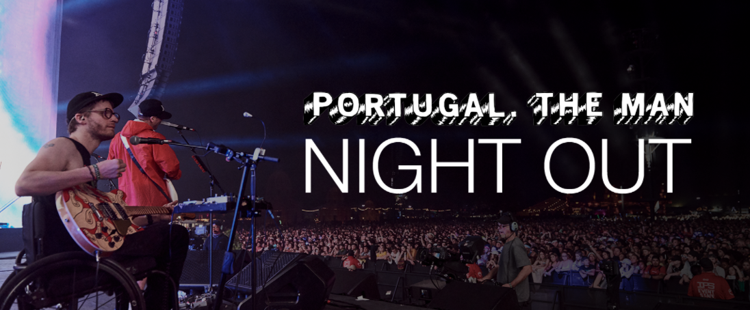

[**download hi-res image**](https://www.dropbox.com/sh/jpqsn8l7l997cq5/AABM4xeRQc20IvpUDIVvRo9xa?dl=0&preview=PTM+Night+Out+Banner.psd)

In [a video message to fans](https://youtu.be/aCrfRdiAX6E) announcing the program, guitarist **Eric Howk** shared:

*“I toured the country on two legs for 10 years of my life without ever giving a single thought to accessibility. I played basements and balconies, pavilions, and grandstands. I dragged amplifiers up and down stairs and took access for granted. Then, at 25, I fell down a hole and became a complete t4 paraplegic in an instant.*

*Since that moment, many things in my life have changed, but touring has remained a constant in my life. As a wheelchair user, and a believer that music is the great equalizer in humanity, I have come to understand that many of the venues that I play are not accessible or welcoming to people across the disability spectrum.*

*In many situations, I have found that sourcing accessible tickets to events is prohibitively difficult, and even then, merely the tip of the iceberg of considerations that must be made. Transportation to and from the venue, access to water and concessions, access to restrooms, obstructions to lines-of-sight from audience to stage – these are just a few of the logistics that many people in the disability community juggle each time they plan on seeing their favorite artists.*

*Wouldn’t it be nice if somebody was out there making sure that all these factors were considered? Wouldn’t it be great just to relax and enjoy the show?”*

**PTM’s NIGHT OUT** is a product of Portugal The Man’s continued dedication to social justice, which they further solidified in 2020 with the creation of **PTM Foundation**, a non-profit organization focused on universal issues related to human rights, community health, and the environment, with an emphasis on causes directly impacting Indigenous Peoples.

All the above arrives following the stellar success of the band’s 2017 **RIAA gold-certified** album, ***Woodstock***, highlighted by the inescapable, **6x platinum-certified** hit, **“Feel It Still,”** which earned the band their first **GRAMMY Award** for “Best Pop Duo/Group Performance” and dominated airwaves – hitting #1 at Top 40 radio and breaking the Alternative radio record for longest running number #1 of all time at 20 weeks. *Woodstock*also delivered the **Gold-certified** single “**Live In The Moment**,” which also hit #1 at Alternative radio and broke the record for most plays in a single week at the format.

[*download hi-res press image here*](https://warnermusicgroup.app.box.com/s/gcwyb9udvpdya99g3pf4noemd4d5spf7) *| credit: Henry Ramsey*

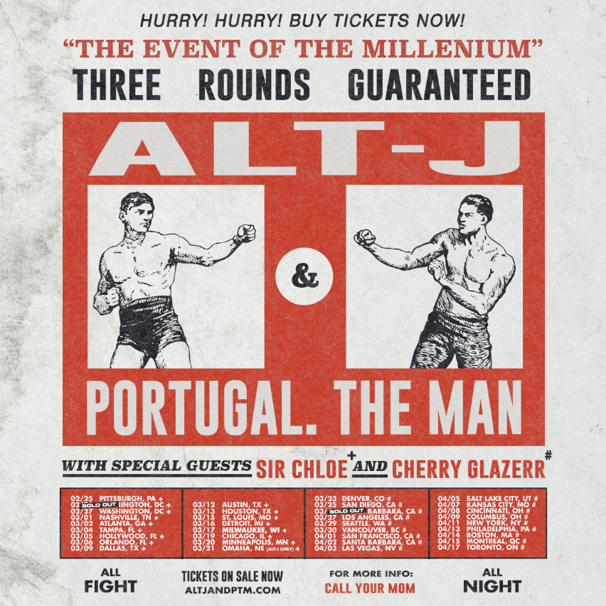

[**download hi-res admat here**](https://wmg.sharepoint.com/:i:/s/US.Atlantic.Publicity/EXKroIHT_QBKiSZCklxt-1sB3pOK9aqIBW9Jz0a-cI5aqQ?e=4DXr0i)

**Portugal The Man & alt-J Tour Routing:**

February 25, 2022 – Pittsburgh, PA – Petersen Events Center *\**

February 26, 2022 – Washington, DC – The Anthem *\**

February 27, 2022 – Washington, DC – The Anthem *\**

March 1, 2022 – Nashville, TN – Nashville Municipal Auditorium *\**

March 2, 2022 – Atlanta, GA – State Farm Arena *\**

March 4, 2022 – Tampa, FL – Yuengling Center*\**

March 5, 2022 – Fort Lauderdale, FL – Hard Rock Live*\**

March 6, 2022 – Orlando, FL – Central Florida Fairgrounds *\**

March 9, 2022 – Dallas, TX – The Factory in Deep Ellum *\**

March 12, 2022 – Austin, TX – Germania Insurance Amphitheater *\*#*

March 13, 2022 – Houston, – White Oak Music Hall *\**

March 15, 2022 – St Louis, MS – Chaifetz Arena *\**

March 16, 2022 – Detroit, MI - Masonic Temple Detroit *\**

March 17, 2022 – Milwaukee, WI – UW-Milwaukee Panther Arena *\**

March 19, 2022 – Chicago, IL – Credit Union 1 Arena at UIC *\**

March 20, 2022 – Minneapolis, MN – The Armory *\**

March 23, 2022 – Denver, CO – 1STBANK Center *\*#*

March 25, 2022 – San Diego, CA – Pechanga Arena San Diego *\*#*

March 26, 2022 – Santa Barbara, CA – Santa Barbara Bowl *\*#*

March 27, 2022 – Los Angeles, CA – Crypto.com Arena *\*#*

March 29, 2022 – Seattle, WA – WAMU Theater *\*#*

March 30, 2022 – Vancouver, VA – Pacific Coliseum *\*#*

April 1, 2022 – San Francisco, CA – Bill Graham Civic Auditorium *#*

April 2, 2022 – Santa Barbara, CA – Santa Barbara Bowl #

April 3, 2022 - Las Vegas, NV – The Theater at Virgin Hotels Las Vegas *#*

April 5, 2022 – Salt Lake City, UT – UCCU Center *#*

April 7, 2022 – Kansas City, KS – Cable Dahmer Arena *#*

April 8, 2022 – Cincinnati, OH – PromoWest Pavilion at Ovation *#*

April. 9, 2022 – Columbus, OH – Schottenstein Center *#*

April 11, 2022 – New York, NY – Madison Square Garden *#*

April 13, 2022 – Philadelphia, PA – TD Pavilion at the Mann *#*

April 14, 2022 – Boston, MA – Agganis Arena *#*

April 15, 2022 – Montreal, QC – Place Bell *#*

April 17, 2022 – Toronto, ON – Coca-Cola Coliseum *#*

*\* Dates with Sir Chloe*

*# Dates with Cherry Glazerr*

**Press Contacts:**

Jason Davis | [Jason.Davis@atlanticrecords.com](mailto:Jason.Davis@atlanticrecords.com)

Libby Kober | [Libby.Kober@atlanticrecords.com](mailto:Libby.Kober@atlanticrecords.com)

* * *

**ABOUT PORTUGAL THE MAN:**Over the past decade, Portugal The Man has established themselves as one of rock’s most prized possessions and a live phenomenon, with over 1,600 shows under their belts and a storied reputation as festival favorites.   
  
Originally heralding from Alaska, the Portland-based band – comprised of John Gourley, Zach Carothers, Kyle O’Quin, Eric Howk, Jason Sechrist and Zoe Manville – soared to new heights in 2017 with the release of their RIAA certified-gold album, *Woodstock*. The album was marked by the astounding success of their infectious single, “Feel It Still,” which earned the group a plethora of new accolades – including a GRAMMY award for “Best Pop Duo/Group Performance,” a 6x RIAA platinum certified single certification, a record setting 20-week residency at #1 on alternative radio, and an inescapable presence on the Top 40 airwaves.    
  
Alongside the shine of their myriad musical accomplishments lies the group’s long-standing passion for social justice. In fact, this is precisely the intersection on which Portugal The Man thrives; throughout their career, the band has consistently exemplified how to deeply commit to both artistry and activism. This dynamic inspired them to officially launch their PTM Foundation in 2020, focused on universal issues related to human rights, community health, and the environment, with an emphasis on causes directly impacting Indigenous Peoples.   
  
Their continued passion for activism has also led to recent partnerships with organizations such as the National Coalition Against Censorship, The Skatepark Project (helping communities build public skate parks for youth in underserved communities), March for Our Lives (Gun Reform), Keep Oregon Well (Mental Health), and Protect Our Winters (Climate Change), to name just a few.

# # #