FOR IMMEDIATE RELEASE
APRIL 29, 2022

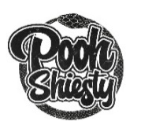

POOH SHIESTY RELEASES EXPANEDED DELUXE SHIESTY SEASON: CERTIFIED

ARRIVES WITH NEW VIDEO FOR “GONE MIA” & 9 ACCOMPANYING VISUALIZERS THAT INCLUDE NEVER-BEFORE-SEEN FOOTAGE
APPEARANCES FROM GUCCI MANE, GUNNA, MONEYBAGG YO, EST JEE, JACK HARLOW, LIL UZI VERT, 42 DUGG AND MORE
SHIESTY SEASON: CERTIFIED AVAILABLE NOW VIA GUCCI MANE’S THE NEW 1017/ATLANTIC RECORDS
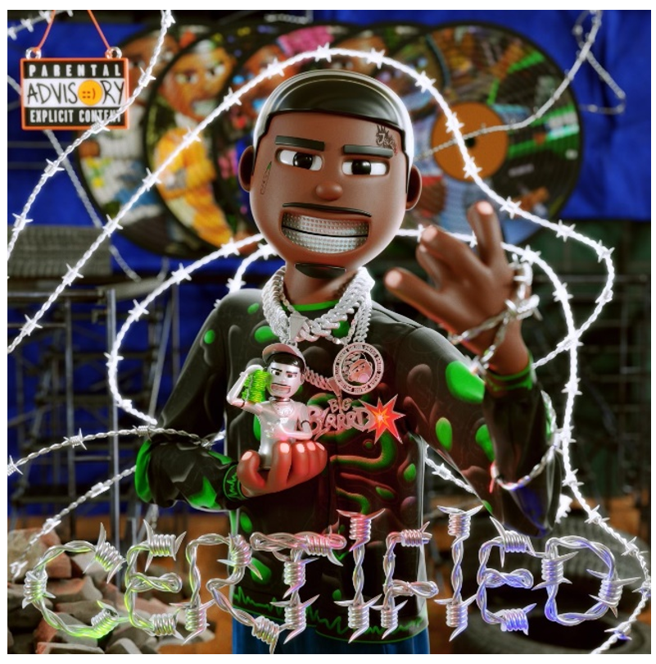
DOWNLOAD HI-RES ART HERE

Multi-platinum rap phenom, Pooh Shiesty, is back with his newly expanded deluxe, SHIESTY SEASON: CERTIFIED. After the success of both his debut mixtape, SHIESTY SEASON, and it’s deluxe, SHIESTY SEASON – SPRING DELUXE, the Memphis sensation is back to shake things up again. SHIESTY SEASON: CERTIFIED is available now via Gucci Mane’s The New 1017 and Atlantic Records.
With the addition of 10 new tracks, the expanded deluxe includes appearances from the likes of Gucci Mane, Gunna, Moneybagg Yo, EST Gee, Jack Harlow, Lil Durk, Lil Uzi Vert, 42 Dugg and more. The release, which is now also available in spatial audio, also arrives alongside 9 new visualizers that include never-before-seen footage of Shiesty. The official visual for “No Clues” feat Big Scarr is also available today.
Shiesty also recently announced the Smilesss x Shiesty Season NFT collection in partnership with prominent digital artist Waheed Zai, the co-creator of the web 3 streetwear brand Smilesss, and artist behind the original SHIESTY SEASON cover art . 250/each of the four Shiesty Season alternate covers (winter, summer, spring, and fall) were made available to mint (1,000 pieces in total) and there was also a 24-hour 1-of-1 auction of the official SHIESTY SEASON mixtape cover exclusively on OpenSea and video prints made available to the first 20 collectors in partnership with Infinite Objects .
On his certified platinum debut mixtape, the chart-topping SHIESTY SEASON, Shiesty captivated with his undeniably catchy, southern flows. The highly anticipated project topped Apple Music’s pre-add chart for 2 weeks straight and later debuted at #1 on Billboard’s Top Rap Albums while peaking at #3 on the Billboard 200. He also simultaneously held 3 spots on the Hot 100 with the 2x platinum earworm “Back In Blood” leading the way and peaking at #13. The official visual topped YouTube’s “Top Music Videos” earning over 245M views.

As he continued to top several charts including Billboard’s “Emerging Artists” and “Artist 100” charts and the #1 spot on Rolling Stone’s “Breakthrough 25,” Pooh went on to make his TV debut on The Tonight Show Starring Jimmy Fallon with a performance of “Back In Blood” and earn his first award show nomination for Best New Artist at the 2021 BET Awards, later followed by multiple nominations at the 2021 BET Hip-Hop Awards (Best New Hip-Hop Artist, Song of the Year, Best Collaboration) and the 2022 Billboard Music Awards (Top New Artist). He was also seen on the cover of XXL’s 2021 Freshman Class Issue and crowned as “Rookie Of The Year” by RapCaviar.

###
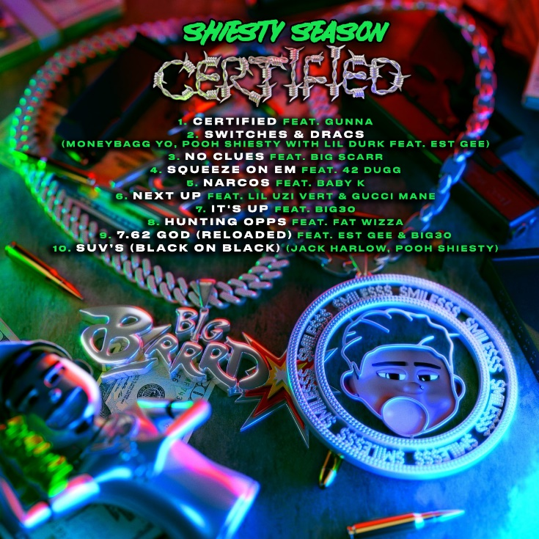

- Certified feat. Gunna
- Switches & Dracs – Pooh Shiesty, Moneybagg Yo with Lil Durk feat EST Gee
- No Clues feat. Big Scarr
- Squeeze On Em feat. 42 Dugg
- Narcos feat. Baby K
- Next Up feat. Lil Uzi Vert & Gucci Mane
- It's Up feat. BIG30
- Hunting Opps feat. Fat Wizza
- 7.62 God (Reloaded) feat. EST Gee & BIG30
- SUV’s (Black on Black) -Jack Harlow, Pooh Shiesty
- Switch It Up feat. G Herbo & No More Heroes
- Welcome To The Riches feat. Lil Baby
- See Me Comin
- Murder Skool
- Shiesty Season Intro
- Back In Blood feat. Lil Durk
- Guard Up
- Ugly feat. Gucci Mane
- Neighbors feat. BIG30
- 50 Shots
- No Chorus
- Box of Churches feat. 21 Savage
- Making A Mess feat. BIG30 & Veeze
- Choppa Way
- Take A Life feat. Foogiano
- Gone MIA
- Big 13 Gang feat. Lil Hank & Choppa Wop
- Drop Some Shit
- See Red
- Master P (feat. Tay Keith)
- Twerksum

# # #

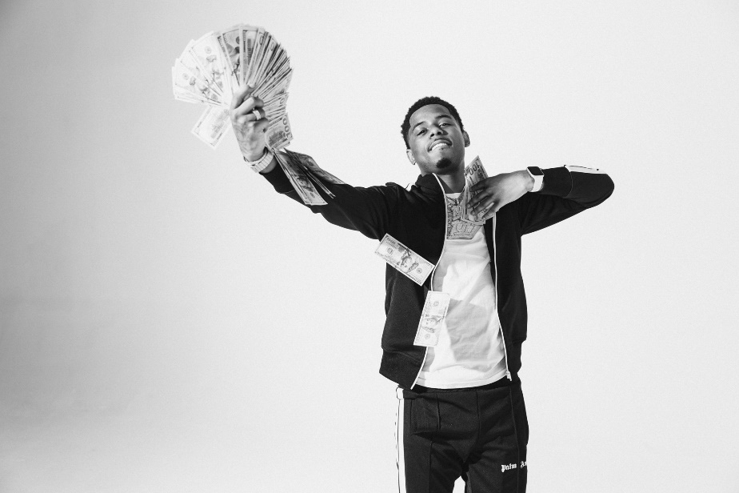
DOWNLOAD HI-RES PRESS IMAGES HERE

CONNECT:
WEBSITE | INSTAGRAM | TWITTER | FACEBOOK | SOUNDCLOUD | AUDIOMACK

POOH SHIESTY PRESS CONTACT:
SELAM.BELAY@ATLANTICRECORDS.COM

