FOR IMMEDIATE RELEASE
APRIL 8, 2022

ROYAL & THE SERPENT PROCLAIMS IT’S HAPPIER IN HELL

RIAA CERTIFIED GOLD ARTIST RELEASES FOLLOW UP TRACK TO
ACCALIMED EP IF I DIED WOULD ANYONE CARE

CURRENTLY ON TOUR WITH GRANDSON + SLATED TO PLAY BOTTLEROCK FESTIVAL, LOUDER THAN LIFE FETIVAL AND WHEN WE WERE YOUNG FESTIVAL

LISTEN TO HAPPIER IN HELL HERE
WATCH THE MUSIC VIDEO HERE
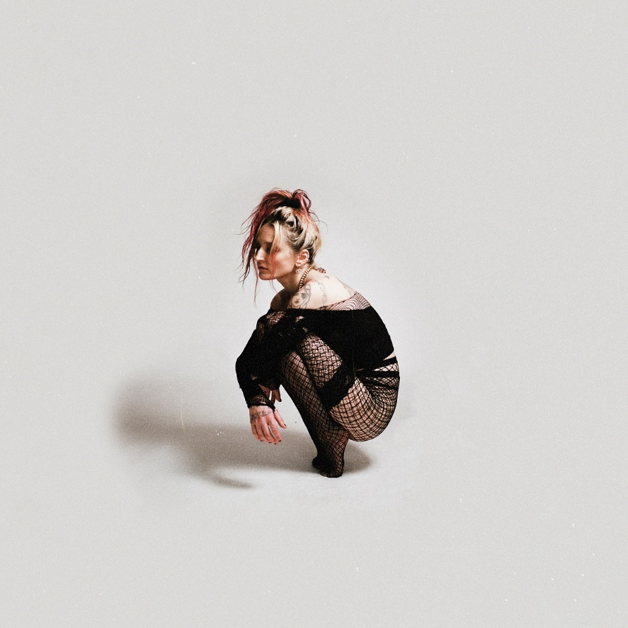
DOWNLOAD ARTWORK HERE

“…one of the most spirited songwriters of 2020.” -BILLBOARD

“A talented, evocative singer and songwriter, Ryan’s project Royal & the Serpent showcases her assertive sound and distinctively girlish yet bluesy voice.” – LA WEEKLY

“Dangerously addictive” -REFINERY 29

RIAA certified Gold, LA singer/songwriter Royal & the Serpent has released her latest personal, alternative rock single “Happier in Hell” – available now HERE. The track premiered earlier this week on ALTNATION / SiriusXM and was co-written and produced w/ Beauty School Dropout. “Happier in Hell” joined by an official music video, streaming now HERE.

Royal shard, “this song was one of the hardest things I’ve ever written. i’ve never felt so vulnerable, so exposed. i had no idea anyone else could relate. i’m saddened but intensely moved by the amount of people experiencing such similar frustrations. the more i uncover and share my truths, the less alone i feel. thank you for keeping me alive. i love you.”

“Happier in Hell” follows Royal’s highly anticipated EP IF I DIED WOULD ANYONE CARE. The project featured standout singles “PHUCKBOI REJECTS,” “I’M NOT SORRY” and “BETTER.” The project arrived earlier this year and received praise from LA Weekly, PAPER, NYLON, Ones to Watch, CelebMix and more.

True to the wild complexity that’s always animated her music, the sonic landscape of IF I DIED WOULD ANYONE CARE shifts from frenetic and blistering to moody and delicate, tapping into such disparate genres as hyperpop, pop-punk, and experimental alt-rock. And as Royal reveals, that unrestrained sound reflects a heightened confidence in her artistry—as well as a newfound clarity on her overall mission. “Instead of making music I thought other people would like, I focused on making something I really loved,” she says. “It’s the first time I fully let my walls down and got completely honest, which hopefully is helpful for anyone who’s going through something similar. Depression isn’t something to take lightly, and I hope these songs remind everyone to be gentle with themselves and with the people in their lives, and to take good care of each other.”

Royal & the Serpent first made waves with her viral Atlantic Records debut, “Overwhelmed,” which spent 22 weeks on Billboard’s Alternative Airplay chart and is now RIAA- certified gold. Named one of SiriusXM’s class of 2021, Royal & the Serpent is an acclaimed live performer, wrapping her first cross-America this past fall. Supporting PVRIS and playing at Firefly festival and EMO NITE Vegas, Royal is quickly becoming known for her show stopping, high energy live performance. Royal just wrapped supporting grandson on his DEATH OF A TOUR 2022 tour and will play sets at the When We Were Young festival in Las Vegas, Bottlerock festival in Napa Valley, and Louder than Life Festival in Louisville, KY. See full routing below and visit www.royalandtheserpent.com for more details and tickets.

DOWNLOAD PRESS PHOTOS HERE

CONNECT WITH ROYAL & THE SERPENT:
OFFICIAL I INSTAGRAM I YOUTUBE I FACEBOOK I TWITTER

Press contacts:
Corey Brewer / Corey.Brewer@atlanticrecords.com
Jessica Nall / Jessica.Nall@atlanticrecords.com
Gabby Reese / gabrielle.reese@atlanticrecords.com

