**TIËSTO TO UNVEIL EXCLUSIVE NFT AT ELECTRIC DAISY CARNIVAL LAS VEGAS**

**Available for PURCHASE ON LGND.ART DURING EDC FESTIVAL THIS WEEKEND ONLY, MAY 20-22**

**LINK TO BUY** [**HERE**](https://tiesto.lnk.to/AAANFT)

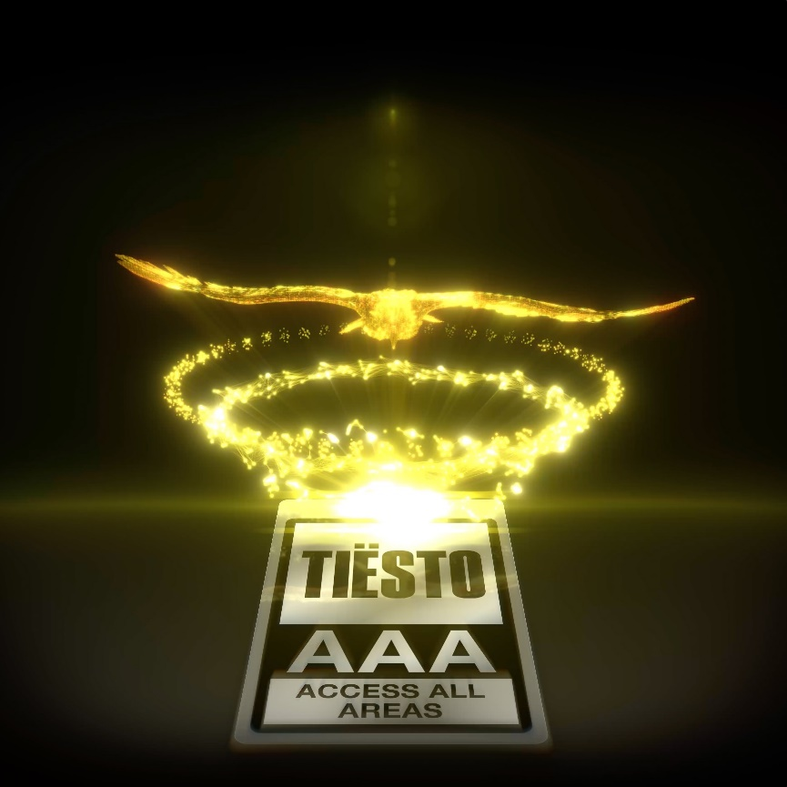

Tiësto to unveil exclusive NFT at Electric Daisy Carnival (EDC) Las Vegas, heralding his forthcoming Genesis NFT project “EAGLE” – the first phase and introduction in his digital roadmap alongside his Musical Freedom imprint. Link to pre-register/purchase EDC exclusive [HERE](https://nam04.safelinks.protection.outlook.com/?url=https%3A%2F%2Ftiesto.lnk.to%2FAAANFT&data=05%7C01%7Cpaige.rosoff%40atlanticrecords.com%7Cff9b93bcb18f4c23770c08da39a4415c%7C8367939002ec4ba1ad3d69da3fdd637e%7C0%7C0%7C637885674881260584%7CUnknown%7CTWFpbGZsb3d8eyJWIjoiMC4wLjAwMDAiLCJQIjoiV2luMzIiLCJBTiI6Ik1haWwiLCJXVCI6Mn0%3D%7C3000%7C%7C%7C&sdata=%2BZDLh56%2Bouvw7pRFMtM6QkkEOdS9nto8yPUK9XPIODg%3D&reserved=0) – available starting **Friday, May 20th at 5 pm PT through to Friday, May 27th at 2 pm PT**.

Holders of the NFT for EDC Las Vegas will have VIP priority access to Tiësto’s forthcoming Genesis NFT, “EAGLE,” a preview of unreleased Tiësto music, including “Repeat It” from Musical Freedom, as well as access to other exclusive opportunities! Unlock the known and unknown and don’t miss your chance to be part of the Tiësto digital universe.

*“I’ve been invested in crypto-currency for many years and have been fascinated by all that is happening in the NFT space,”*says**Tiësto***. “I’ve been working on this project with my team for the last year to incorporate the blockchain with my art and music in new and exciting ways. This is only the beginning – as we continue to use this technology to do things that were never before possible. Welcome to the launch of the Tiësto digital universe!”*

The eagle icon featured in the forthcoming NFTs has been a mysterious symbol in Tiësto’s imagery and artwork, seen as a representation of him throughout his career, and a symbol of strength, perseverance, and new beginnings. The eagle that’s seen in the NFT has been featured in his live performance visuals created by Comix, debuting at ULTRA Miami this past March and will be seen on the screens during his performance at EDC this Saturday.

Catch Tiësto’s performance at EDC Las Vegas on Saturday, May 21 at 12:22am on the kineticFIELD stage.

**ABOUT TIËSTO**

Tiësto is a Grammy® Award-winning, platinum-certified, international icon. The DJ and producer is the only artist to ever hold the titles of “The Greatest DJ of All Time” courtesy of Mixmag, and “#1 DJ” according to Rolling Stone. From his underground dance floor bangers to his high-profile Las Vegas residency and crossover success, Tiësto created the blueprint that defines what it means to be a success in today’s dance music world. In Tiësto's true fashion, he continues expand across genres, always evolving his craft. With over 36 million albums sold, 10 billion cumulative streams, and a social platform with an audience exceeding 30 million fans spanning the globe, he continues to revolutionize the dance music landscape. Tiësto’s first release since signing with Atlantic Records, "The Business” has dominated airplay and charts worldwide since its September 2020 release, garnering over 1.4 billion streams to date, and was nominated for Best Dance/Electronic Recording at the 64th Annual GRAMMY Awards. It has also held a steady position on Apple & Spotify’s “Today’s Top Hits” & “Today’s  Hits” playlists, and hit #1 at US Dance Radio. “The Business” is certified Platinum in 15 countries and gold in 8 countries and has held a place on the Top 10 official singles chart in 10 countries as well as Top 50 on Spotify in 31 countries. Tiësto made history with single “Don’t Be Shy” with Karol G, which marked the first English song ever for Karol G, and the first Latin Artist collaboration for Tiësto, and currently has 636M streams, over 1 million TikTok creates, and over 206 million views on the official music video. The third single from Tiësto’s upcoming album, “The Motto” with Ava Max, is out now with 589 million streams to date and sitting at #27 at Top 40 radio.

**ABOUT LGND**

LGND is a platform built by artists, for artists that empowers creators to fulfill their vision in the new landscape of NFTs. Collectors will find some of the best work by leading artists from around the world here. LGND’s mission is to not only facilitate artists to secure their legacy via blockchain, but to reach the largest possible audience and to cultivate a global community. Through a mix of online and IRL events, we aim to lead the field in education and expansion of the medium that is rapidly changing the way art is experienced. Above all, curation is our focus and quality is always the goal.

**ABOUT MUSICAL FREEDOM**

Musical Freedom is an exciting hub of dance music talent handpicked by the ultimate tastemaker in the industry: Tiësto. Founded in 2009 by Tiësto, Musical Freedom is a label that’s had their finger on the pulse of dance music for a solid decade. Over the years Musical Freedom has always worked to feature the most exciting new sounds and artists, breaking genres and conventional release strategies. This has resulted in an array of hits and underground staples including Sandro Silva & Quintino’s Epic, Oliver Heldens’ Gecko, KSHMR’s Wildcard as well as been a solid Tiësto’s club singles, collaborations and elebrated CLUBLIFE album series

**CONNECT WITH TIËSTO:**

[OFFICIAL](https://www.tiesto.com/) | [FACEBOOK](https://www.facebook.com/tiesto) | [TWITTER](https://twitter.com/tiesto) | [INSTAGRAM](https://www.instagram.com/tiesto/) | [SPOTIFY](https://open.spotify.com/artist/2o5jDhtHVPhrJdv3cEQ99Z) | [TIKTOK](https://www.tiktok.com/@tiesto) | [YOUTUBE](https://www.youtube.com/c/tiesto/featured)

**FOR MORE INFORMATION:**

[Paige.Rosoff@atlanticrecords.com](mailto:Paige.Rosoff@atlanticrecords.com)