FOR IMMEDIATE RELEASE

MAY 13, 2022

**Why Don’t We drop summer-ready single “Just Friends”**

[DOWNLOAD HIGH-RES IMAGES](https://press.atlanticrecords.com/why-dont-we)

**STREAM “JUST FRIENDS”:** [LINK](https://whydontwe.lnk.to/JustFriends)

Multi-talented band **Why Don’t We** have dropped their summer-ready new single “**Just Friends**” – available now via **Atlantic** **Records**. Written by the band alongside **JKash** (**Charlie Puth**, **Maroon 5**), **Jakob Hazell** (**Nick Jonas, Charli XCX**), **Svante Halldin** (**Rita Ora, Nick Jonas**)and **Amanda “Kiddo” Ibanez** and produced by **Jack&Coke** (**Nick Jonas**, **Charli XCX**), the release follows “[**Let Me Down Easy (Lie)**](https://youtu.be/5qUfjqksDic)” as the group’s second new song of 2022.

*"’Just Friends’ is the feel-good smash of the summer! We wrote it in Miami a couple months ago and it was one of the most fun day’s we’ve ever had in the studio. The song is about the classic feeling of wanting to be more than friends with someone you’ve known for a while, and all the emotions that come with that. We hope everyone rolls their windows down and blasts this one all summer long!”*

*–* **WHY DON’T WE**

Since their debut in 2016, **Why Don’t We** has amassed over 3 billion global career streams, over 930 million YouTube views, 7 million Instagram followers, two RIAA Platinum-certified singles, five RIAA Gold-certified singles, two Top 20 singles at Pop radio, and two Top 10 albums on the Billboard 200 chart. Taking an innovative and unconventional approach towards releasing new music and actively engaging their rapidly growing fanbase, the band put out their first five EPs within their first year together and followed shortly after with their inaugural full-length ***8 Letters***album in 2018.Soon after, 2019 saw the release of new singles monthly, including standouts “**Big Plans**,” “**I Don’t Belong In This Club**” featuring **Macklemore**, & the **Ed Sheeran**-penned/**Steve Mac**-produced hit “**What Am I**.”

The Los Angeles quintet—**Daniel Seavey**, **Corbyn Besson**, **Jonah** **Marais**, **Jack** **Avery**, and **Zach** **Herron**— went back to basics for their sophomore album, flatlining all social media and picking up their instruments to personally write, record, and produce the music themselves. Led by the band’s inaugural Billboard Hot 100 charting single “**Fallin’ (Adrenaline)**,” ***The Good Times and The Bad Ones***earned their highest debut on the Billboard 200 at #3 and their first #1 album on the album sales chart.

**Why Don’t We** re-emerged with their triumphant single “**Love Back**” in late 2021, sounding refreshed as ever after a turbulent year and marking the beginning an exciting new era. The band also teamed up with multi-Platinum producer **Jonas Blue** for their smash collaboration “**Don’t Wake Me Up**,” further cementing their newly found creative solace and control.

The band has sold out back-to-back North American and global headline tours, in addition to performing on historic stages such as **Radio City Music Hall** (selling out the venue in under two hours) and **Madison Square Garden** (as part of the **iHeartRadio Jingle Ball Tour**). Furthermore, **Why Don’t We** took home the award for “Choice Music Group” at the **2019 Teen Choice Awards**, received a nomination for “Best Group” at the **2019 MTV Video Music Awards**, and has made high profile national television appearances on NBC’s **TODAY Show** (including back-to-back summer concerts in Rockefeller Plaza), ABC’s **Good Morning America**, nationally syndicated **Live with Kelly and Ryan**, **The Ellen DeGeneres Show**, NBC’s **The Kelly Clarkson Show**, CBS’s **The Late Late Show with James Corden**, ABC's **Jimmy Kimmel Live!** and more.

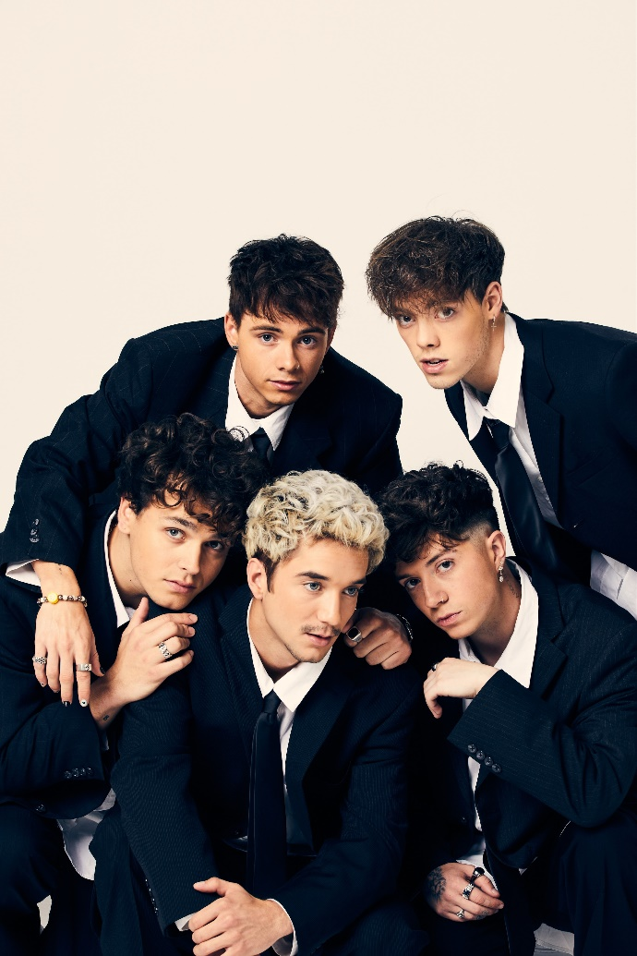

[DOWNLOAD HIGH-RES IMAGES](https://press.atlanticrecords.com/why-dont-we)

**CONNECT**:

[WHYDONTWEMUSIC.COM](http://whydontwemusic.com/) | [TWITTER](http://twitter.com/whydontwemusic) | [INSTAGRAM](https://www.instagram.com/whydontwemusic/) | [FACEBOOK](https://facebook.com/whydontwemusic) | [YOUTUBE](https://www.youtube.com/channel/UCgJMQU7JOIoP-YnrhH_P-bA) | [ASSETS](https://press.atlanticrecords.com/why-dont-we)

**CONTACT**:

TED SULLIVAN (ATLANTIC RECORDS) | [TED.SULLIVAN@ATLANTICRECORDS.COM](mailto:TED.SULLIVAN@ATLANTICRECORDS.COM)