FOR IMMEDIATE RELEASE
JUNE 18, 2021

FENIX FLEXIN SHARES NEW VIDEO SINGLE "NDS"
WATCH | LISTEN

FENIX FLEXIN VOL. 1 – OUT 7/1
PRE-SAVE

"When it comes to Fenix Flexin, he’s back and better than ever" – Lyrical Lemonade

"This is some real lifestyle music that if you get it, you really get it." – Daily Chiefers

"Lyrically, this latest single seems to effectively capture his current headspace." – HotNewHipHop

"Shoreline Mafia frontman Fenix Flexin lives up to his name" – Rap Radar

“Shoreline Mafia’s Fenix Flexin starts a new chapter” – The FADER

"Fenix Flexin is tied into the skate culture of Los Angeles" – All Hip Hop

The Los Angeles born and raised rapper, Fenix Flexin has just shared a new track and video, "NDS" along with the July 1st release date for his long-awaited debut solo mixtape, Fenix Flexin Vol. 1. The new tape includes Fenix's previously released tracks, "For Me" and "10 Toes" as well as new tracks with features from Drakeo The Ruler, Rob Vicious, Bravo The Bagchaser, D-Block Europe, Peso Peso, and SaysoTheMac. It's Fenix's first time on his own as a solo artist and he's taking full advantage of the opportunity by exploring new sounds and working with new artists. He's also dialed in with his fans and the community in L.A. who inspired him to launch Burnt Co, a lifestyle and skateboard apparel company with a team of pro skaters. At the same time, Fenix is excited to reconnect with fans outside of Los Angeles and will be touring his debut mixtape this September on his Fenix Flexin Volume One Tour. Tickets are on sale now and Fenix Flexin Vol. 1 will be out next Thursday, July 1st.

"Blue lips sink ships, pink slips / Wok hard in my cup no tricks / babygirl I need some mo where the tricks / She ain't go no money, we ain't f*****' I'ma dip"

After the overwhelmingly positive response from fans to his solo songs on 2020's Mafia Bidness, including “Hoe Sh*t” and "How We Do It" (feat Wiz Khalifa), as well as his massive hit, "Fell In Love" off 2019's Party Pack Vol. 2, Fenix Flexin is ready to manifest the solo career he's always envisioned. “The group had a bunch of respect, a huge following, and a whole lot of people behind us,” affirms Fenix. “Now, I’m claiming all of those things for myself as an individual, and I’m off to a good start.” In the opening hours of 2021, Fenix released “10 Toes,” a video single which has since achieved nearly five million views, affirming his do-for-self mantra. “In the group, I never really spoke on my trials and tribulations,” admits the charismatic 25-year-old Atlantic Records artist. “Now, I can express all of that in my music.” Carrying his seven-figure streaming audience and viewership with him, Fenix Flexin is moving with lots of momentum. He touts, “I’m as real as it gets, and I’m solid all the way through.”

Please find links to Fenix Flexin's latest track and video for “NDS” below along with the Fenix Flexin Vol. 1 tracklist and pre-save links and Fenix's upcoming tour dates:

FENIX FLEXIN – "NDS"
WATCH | LISTEN

FENIX FLEXIN VOL. 1
PRE-SAVE

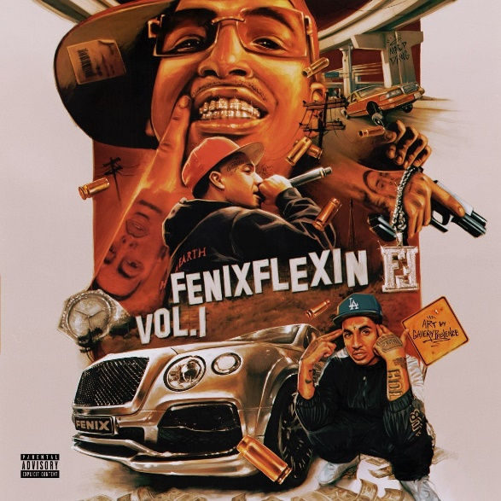

FENIX FLEXIN VOL. 1 - TRACKLISTING
- Risky (prod. Fbeat)
- Respectfully (feat. Drakeo The Ruler) (prod. Cypress Moreno)
- Feds (feat. Rob Vicious) (prod. DJ Flippp & Rappa)
- True 2 This (feat. Bravo The Bagchaser) (prod. Cypress Moreno & E Blessed)
- From The Block (feat. D-Block Europe) (prod. Cuddie Joe)
- NDS (prod. Fbeat)
- Lightshow (prod. Quad)
- 08. For Me (prod. RonRon, LNK, Mario Petersen)
- 09. Wockiana (prod. Bruce24k)
- PesoFlexin (feat. Peso Peso) (prod. Quad)
- On Fig (feat. SaysoTheMac) (prod. Fbeat)
- What's the Move (prod. Milo)
- 10 Toes (prod. Fbeat & LowTheGreat)
- Pain (prod. TerisJay)
- RIP Mac P Dawg (prod. Milo & Tonydahittman)

FENIX FLEXIN VOL. 1 - TOUR DATES
09/14 – Hawthorne – Portland, OR
09/15 – Wow Hall – Eugene, OR
09/16 – Neumos – Seattle, WA
09/18 – Senator – Chico, CA
09/19 – The Complex – Oakland, CA
09/20 – The Catalyst – Santa Cruz
09/21 – Harlow’s – Sacramento, CA
09/23 – Music Alley – Santa Barbara, CA
09/24 – Regent Theater – Los Angeles, CA
09/25 – Aura – Phoenix, AZ

ABOUT FENIX FLEXIN:
Spotify | Instagram | Twitter | Facebook

After a heavy hand in three platinum singles and several acclaimed full-length projects with Shoreline Mafia, Fenix Flexin has stepped away from the group to manifest the solo career he always envisioned. Being on his own is something that is not new to Fenix Rypinski, who is of Black, Mexican, and Polish heritage. While the rapper’s mother and father each battled addiction, he bounced around between his grandmother and siblings’ houses, staying in West LA, East Hollywood, Downey, and Huntington Park.

Along with skating and graffiti, rap was a creative outlet that allowed the kid on the move to make fast friends. For now, Fenix Flexin is focused on branding his individuality, “I have to reclaim that respect and attention.” The founder of the skate-inspired lifestyle company Burnt self-released “10 Toes” to kickstart his 2021 campaign. On his own, Fenix Flexin has a plan. “I’m ready to show people what I’m capable of,” he asserts. That proper introduction will take place across three mixtapes and a solo debut project. Tapping into some Bay area sounds as well as some Midwest production, he says, “It’s all about growth and expansion."

Photo Credit: Ifster Oluyide

PRESS CONTACT
BRITTANY.BELL@ATLANTICRECORDS.COM

