FOR IMMEDIATE RELEASE
JUNE 14, 2022

BRELAND ANNOUNCES DATE FOR HIGHLy ANTICIPATED DEBUT ALBUM
CROSS COUNTRY, due SEPTEMBER 9TH
PRE-save / pre-add TODAY HERE

PLATINUM-SELLING ENTERTAINER PREMIERES NEW SONG “NATURAL”
on nbc’s TODAY with hoda & jenna
stream “natural” here

official video to release on thursday, june 16th

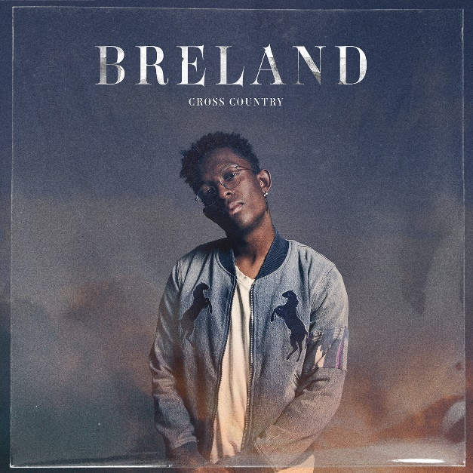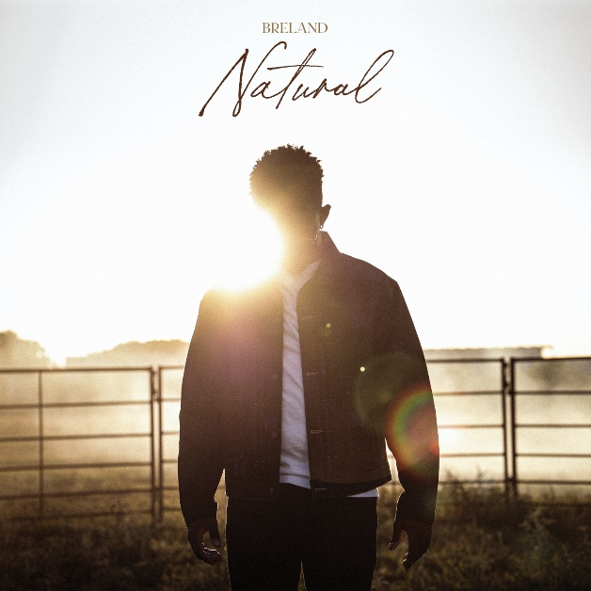
DOWNLOAD ARTWORK ASSET(S) HERE |PHOTO CREDIT: EVAN KAUFMANN

LOS ANGELES, CA. (June 14, 2022) – Bad Realm Records / Atlantic Records / Warner Music Nashville PLATINUM entertainer BRELAND today announced that his highly anticipated debut album CROSS COUNTRY will be released on September 9th. Named for the boundary-pushing, genre-bending style that defines all his output, CROSS COUNTRY firmly establishes BRELAND as a vital new force shaping the future of Country music.

This morning on NBC’S TODAY WITH HODA & JENNA, BRELAND celebrated CROSS COUNTRY’s pre-order launch by premiering his magnetic new single “Natural,” which features an interpolation of Shania Twain’s "Man! I Feel like a Woman!” and produced by Sam Sumser and Sean Small. Blending his new single into a medley of his popular hit “Praise The Lord,” BRELAND magnifies his musical ability. Outfitted in Dickies, check out his high-energy performance HERE and stream “Natural” HERE. The official video is set for release on June 16th.

Expanding on the songwriting chops and star-making appeal first revealed on his breakthrough certified PLATINUM single “My Truck” — as well as its remix with Sam Hunt — CROSS COUNTRY takes its title from an autobiographical, acoustic-guitar-fueled track showcasing BRELAND’s intricately detailed storytelling and warm yet commanding voice. After first sharing “Cross Country” in February 2021, BRELAND returned the following month with a soul-stirring update featuring groundbreaking country phenomenon Mickey Guyton (listen HERE).

Along with “Cross Country,” BRELAND’s debut album also offers up previously released singles like “Throw It Back (feat. Keith Urban),” a feel-good smash that quickly climbed Billboard’s US Hot Country Songs chart. In addition, the album includes BRELAND’s recent release “Praise The Lord (feat. Thomas Rhett)” — debuting at the 2022 ACM Awards in Las Vegas resulting in much critical acclaim from the likes of Taste of Country (who hailed it as a “groovy, upbeat tribute to the simple things that make a country life worth living”).

The CROSS COUNTRY album announcement is just the latest triumph in what’s already proving to be a blockbuster week for the fast-rising star. To that end, BRELAND was recognized yesterday at the illustrious Tribeca Film Festival, which screened the official music video for CROSS COUNTRY’s title track. Meanwhile, Sunday night saw BRELAND wrapping up a stacked week of CMA Fest appearances by taking the stage at Nissan Stadium for a surprise performance with Lady A performing an irresistible rendition of the trio’s hit “Need You Now.”
Fresh off his recent appearances at major festivals like Stagecoach Country Music Festival and Hangout Music Festival, BRELAND is now gearing up to bring his crowd-thrilling live set to TidalWave Music Festival (8/12), with more dates to come. Go HERE to keep up with BRELAND’s tour schedule.

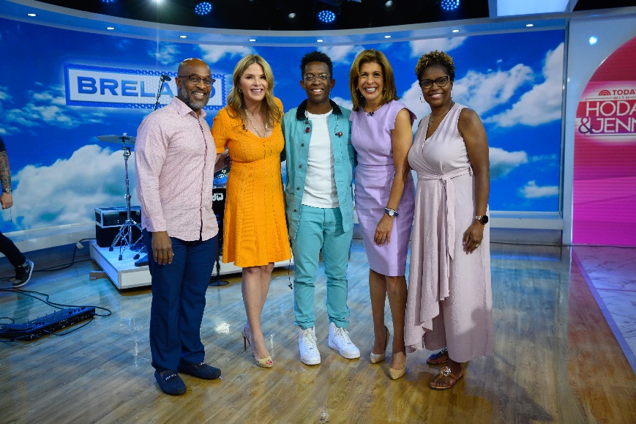
BRELAND WITH HIS PARENTS IN STUDIO AT NBC’S TODAY WITH HODA & JENNA
PICTURED (L-R): GERARD BRELAND, JENNA BUSH HAGER, BRELAND, HODA KOTB,TONYA BRELAND
PHOTO CREDIT: NATHAN CONGLETON | DOWNLOAD HERE
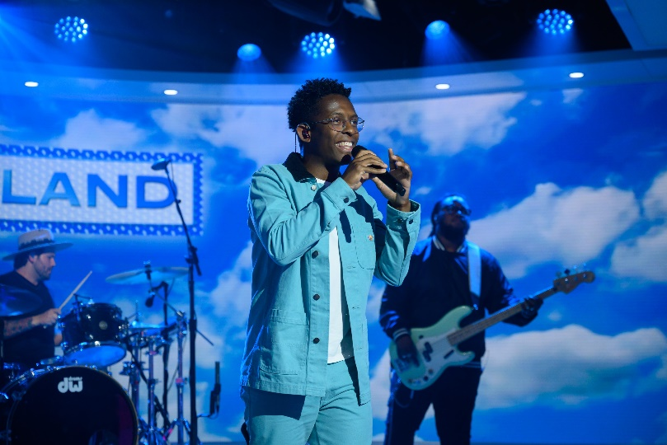
PHOTO CREDIT: NATHAN CONGLETON | DOWNLOAD HERE

ABOUT BRELAND
With his PLATINUM debut “My Truck,” singer / songwriter / producer BRELAND has emerged as a bold new force on today’s music landscape. The newly named Breakthrough Artist by Amazon Music first popped off when the Hip-Hop and Country hybrid hit #1 on Spotify’s Global Viral 50 in 2019, and a remix featuring Sam Hunt landed on best-of-the-year lists from NPR to The New York Times. Hailed as the “symbol of Country music’s ongoing evolution” (Rolling Stone), BRELAND debuted his brand-new song “Praise The Lord (feat. Thomas Rhett)” at the 2022 ACM Awards; the track will be featured on his highly anticipated debut album CROSS COUNTRY, slated for release September 9, 2022, with the title track’s official music video recently recognized at 2022 Tribeca Film Festival. Featured on Dierks Bentley’s #1 single with HARDY, “Beers On Me,” BRELAND also teamed up with Keith Urban for the buzzy track “Throw It Back.” Since signing to Bad Realm Records / Atlantic Records / Warner Music Nashville, he has collaborated with heavy-hitters such as Gary LeVox of Rascal Flatts, Nelly, Blanco Brown, Lauren Alaina, and Chase Rice, and scored high profile looks on The Kelly Clarkson Show, ABC’s 2021 CMA Awards, ABC’s CMA Summer Jam, CMT Crossroads, ABC’s Jimmy Kimmel Live!, ABC’s Good Morning America, CBS’ New Year’s Eve Live: Nashville’s Big Bash, YouTube’s Artist on The Rise, and a Chevy campaign that launched during NFL’s season opener. Coined “1,000 percent the whole package” by Rolling Stone, he had three nominations for the fan-voted 2022 CMT Music Awards and had his debut CMT Music Awards solo performance with “Praise The Lord.” Following his run on Russell Dickerson’s ALL YOURS, ALL NIGHT TOUR, he will hit the road this summer with stops at high-profile stages such as Tortuga Music Festival, Stagecoach Country Music Festival, Hangout Music Festival, and TidalWave Festival. BRELAND is also recognized in the Country Music Hall of Fame® and Museum’s brand-new exhibit, American Currents: State of the Music.

CONNECT WITH BRELAND
WEBSITE | INSTAGRAM | FACEBOOK | TWITTER | YOUTUBE | SOUNDCLOUD

FOR BRELAND
Fairley McCaskill / Fairley.McCaskill@atlanticrecords.com
Jensen Sussman / jensen@sweettalkpr.com
Mary Catherine Rebrovick / MaryCatherine@wmg.com

